JewelBug -- Annotating bp 40900 - 50341 (Genes 67 - 90)

# Table of Contents

Table of Contents 1

Feature 79 2

Feature 80 11

Feature 81 18

Feature 82 29

Feature 83 39

Feature 84 48

Feature 85 53

Feature 86 62

Feature 87 73

Feature 88 79

Feature 89 88

Feature 90 95

|  |  |
| --- | --- |
|  |  |
|  |  |
|  |  |
|  |  |
|  |  |
|  |  |
|  |  |
|  |  |
|  |  |
|  |  |
|  |  |
|  |  |

# Feature 79

**Table 14: Feature 79 Data**

|  |  |  |  |  |  |  |  |  |  |
| --- | --- | --- | --- | --- | --- | --- | --- | --- | --- |
| **Feature:** 79 | **3' End:** 46646 | **5' End:** 46843 | | | **Length:** 198 | | **Original Call:** | **Glimmer:** 46843 | |
| **GeneMark:** 46843 | |
| **Start / Stop Codon (SSC):** | | | | | | **Start:** GTG | | | |
| **Stop:** TGA; REV | | | |
| **Longest Open Reading Frame (LO):** 336 bp | | | | | | | | | Not Longest |
| **Shine Dalgarno (SD):** -1.907 / -3.509 | | | | | | | | | Highest |
| **Start Choice Source (SCS):** | | | | **Called by Glimmer:** Yes, 46843 | | | | | |
| **Called by GeneMark**: Yes, 46843 | | | | | |
| **Coding Potential (CP):** almost all covered | | | | | | | | | |
| **Gap / Overlap:** 3 bp overlap with feature 80 | | | | | | | | | |
| **BLASTp:** hypothetical protein PBI_VOHMINGHAZI_92; bp 1 aligns with bp 1 | | | | | | | | | |
| **Function (F):** No known function | | | | | | | | | |
| **Function Source (FS):** | | | **Phamerator:** No noted functions in similar phages | | | | | | |
| **BLASTp:** gp 90 from EricB (unknown function) | | | | | | |
| **HHPred:** No significant results found | | | | | | |
| **Comments:** The original start site was kept as the BLAST results showed 100% similarity, identity, and alignment. The majority, but not all, of the coding potential is captured. | | | | | | | | | |

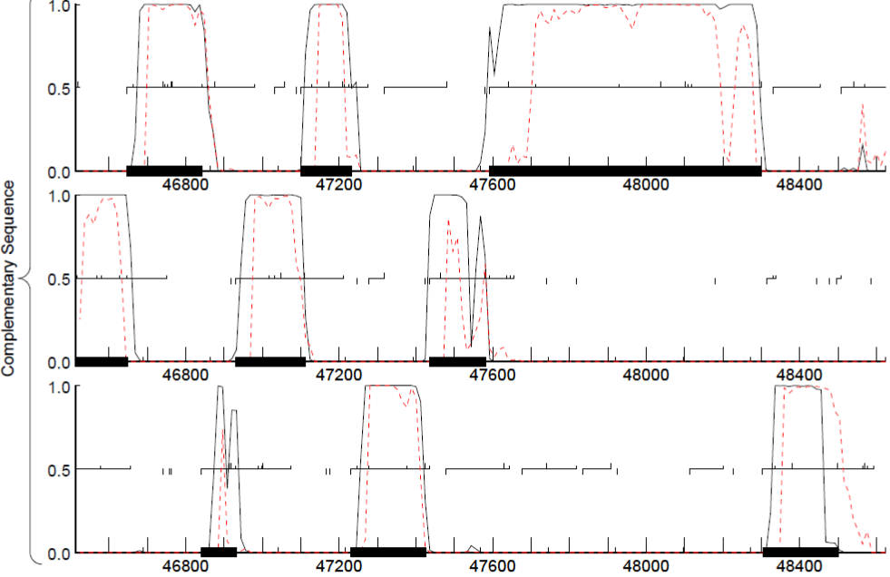

**Figure 183: Feature 79, GeneMark Map**

The top frame of the complementary strand shows Gene 79 from 46843 to 46646 although there is coding potential in the upper 46800s. We chose not to extend the start site into that coding potential since it’d overlap too much with gene 80, which is a very viable gene and does not warrant deletion in order to extend 79.

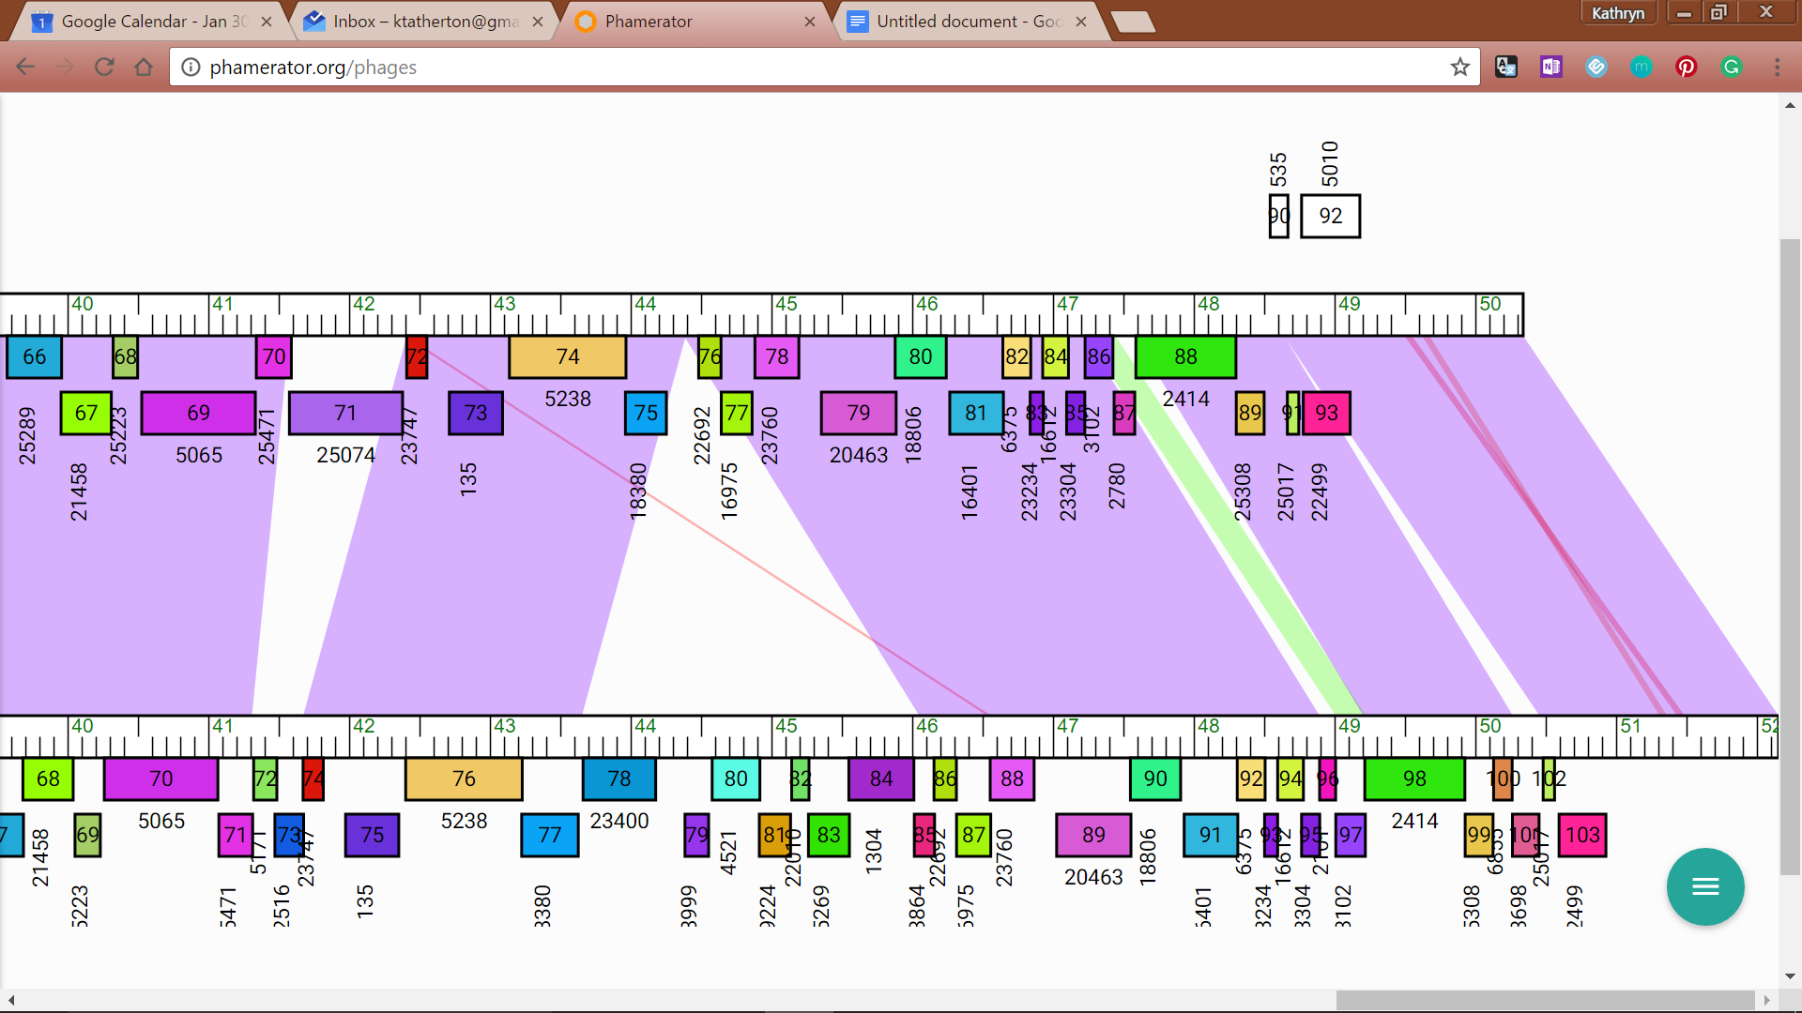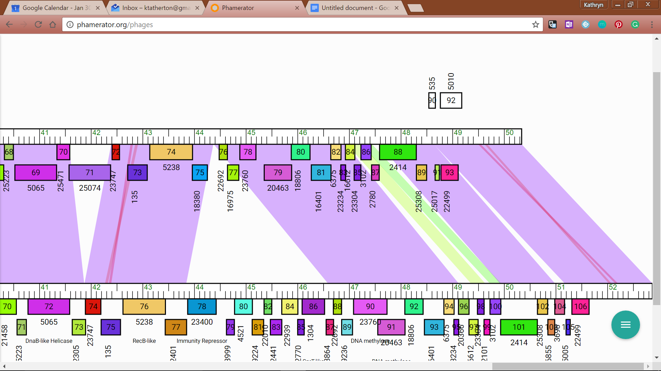

**Figure 184: Feature 79, JewelBug Phamerator Maps**

Feature 79, Phamerator: In the left image, JewelBug is on top, and VohminGhazi is on the bottom. In the right image, JewelBug is on top being compared to CloudWang3 on bottom.

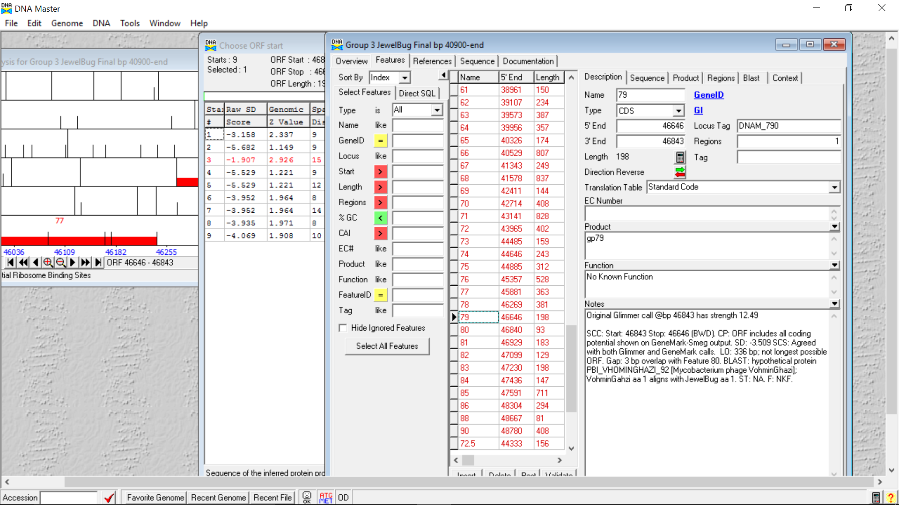

**Figure 185: Feature 79, Feature Window**

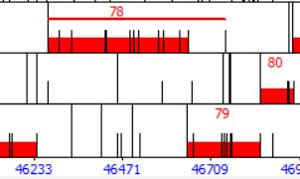

**Figure 186: Feature 79, Frame Window**

Shows 3bp overlap with genes 78 and 80 each.

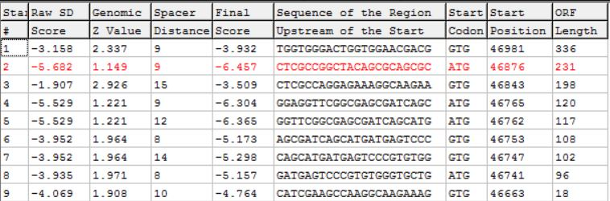

**Figure 187: Feature 79, Choose Start Window**

The GTG start site at 46843 has the lowest SD scores and the third longest ORF.

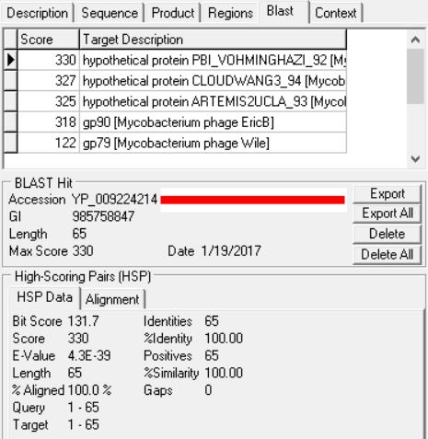

**Figure 188: Feature 79, HSP Data**

The top result has 100% identity, similarity, and alignment with a hypothetical protein from VohminGhazi.

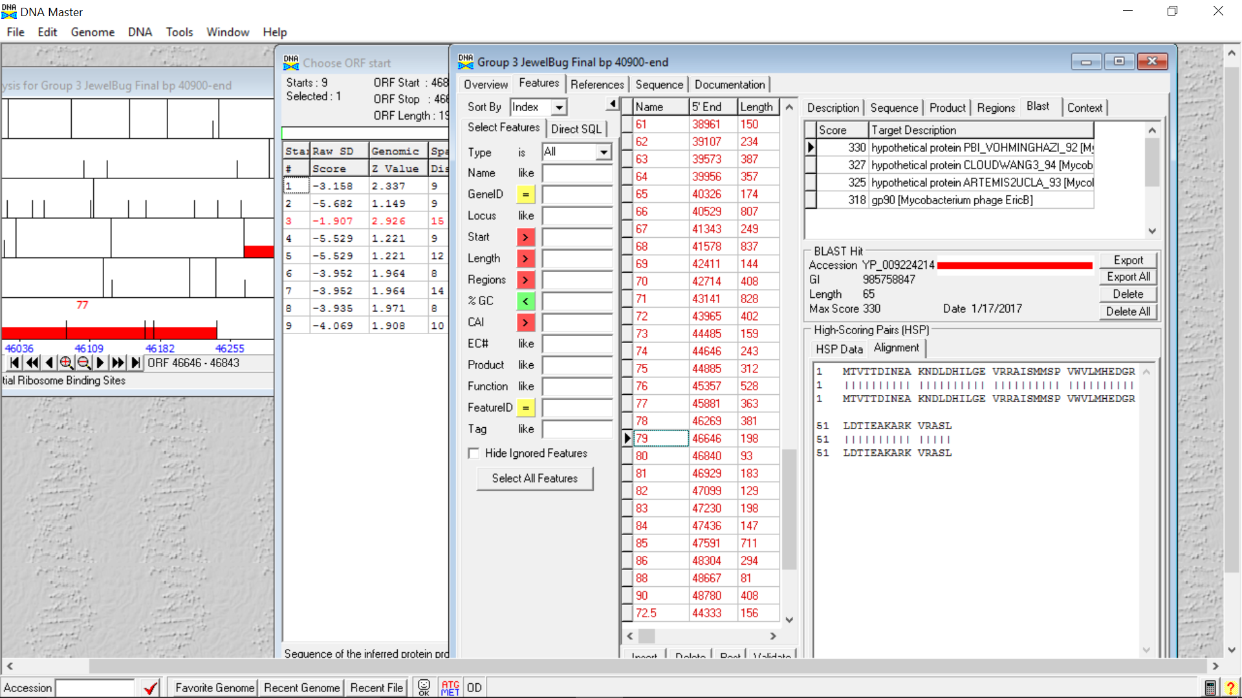

**Figure 189: Feature 79, Alignment**

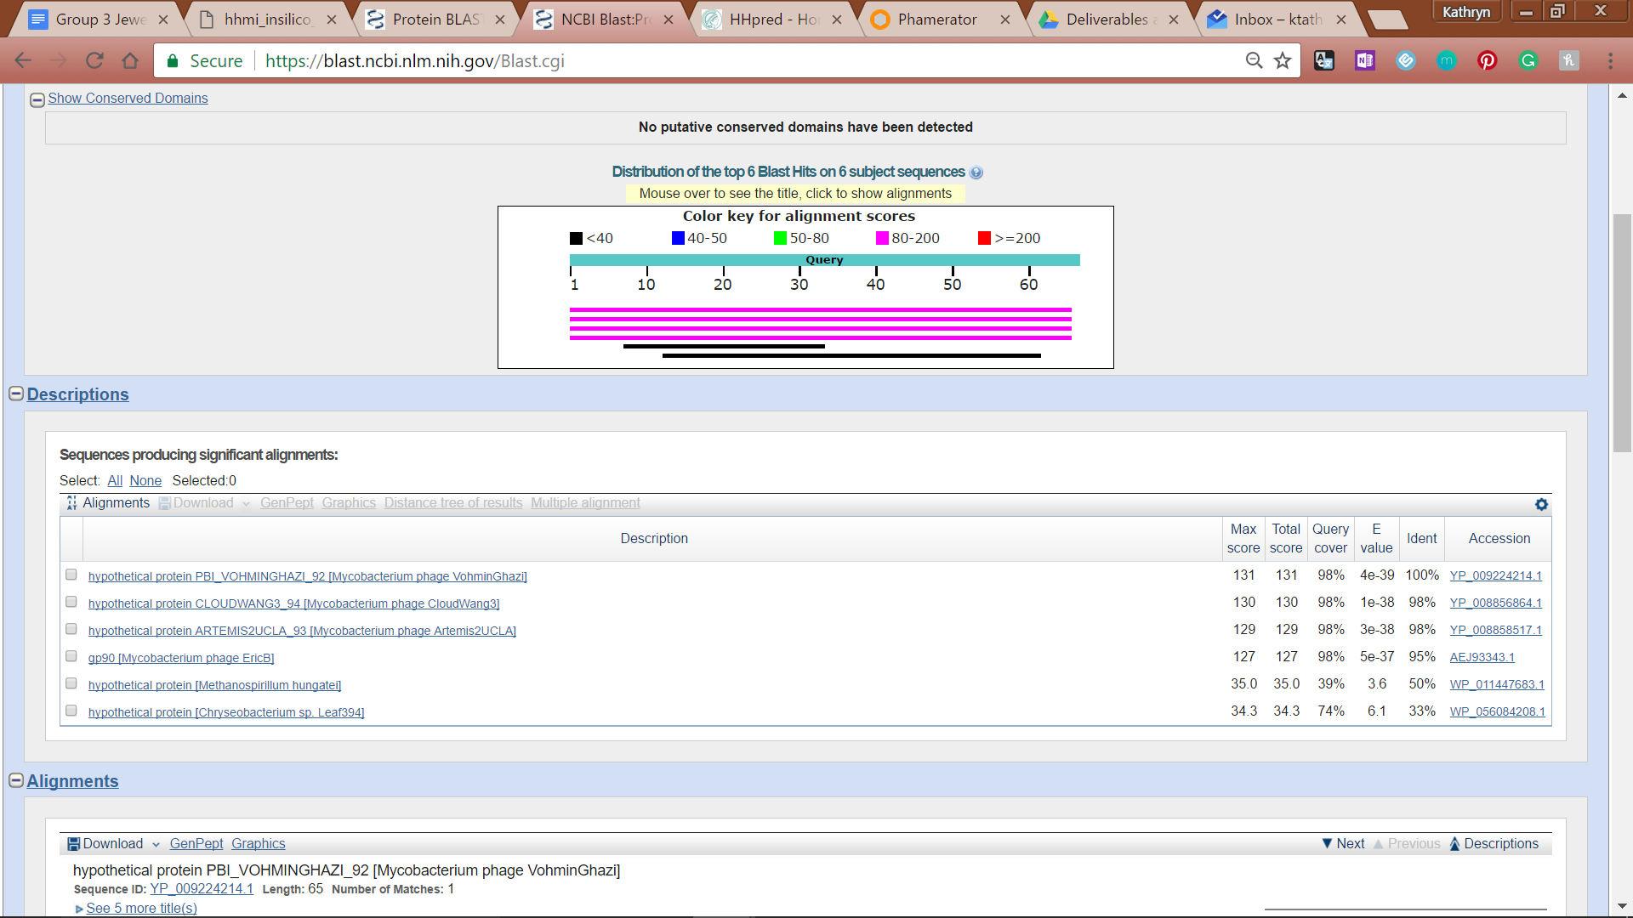

**Figure 190: Feature 79, Conserved Domain**



**Figure 191: Feature 79, BLASTp Hits Distribution Table**



**Figure 192: Feature 79, BLASTp E-Values**

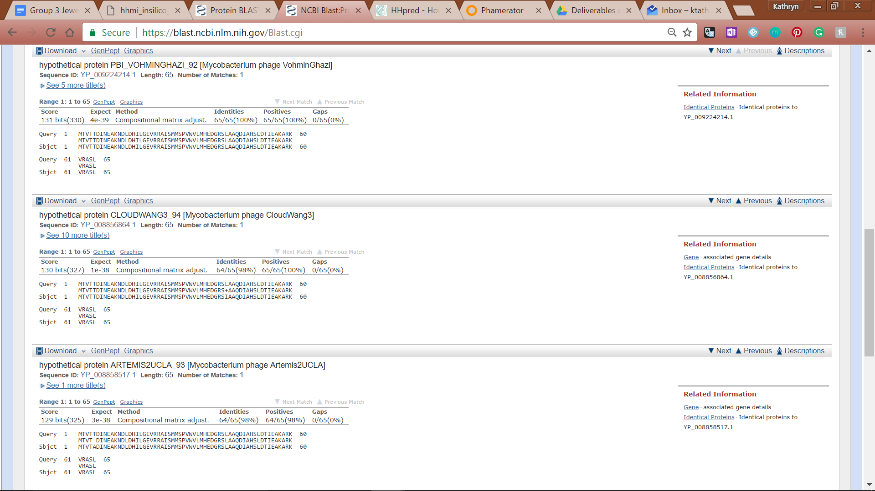

**Figure 193: Feature 79, BLASTp Alignments**

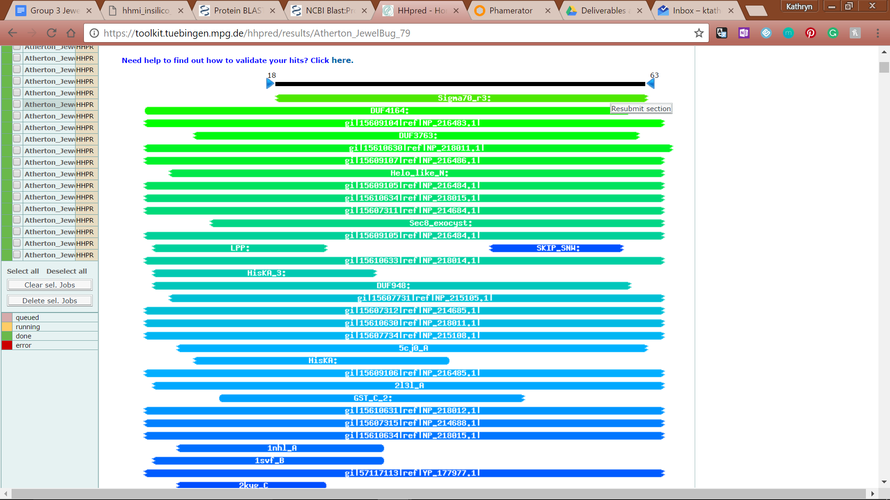

**Figure 194: Feature 79, HHPred Distribution List**

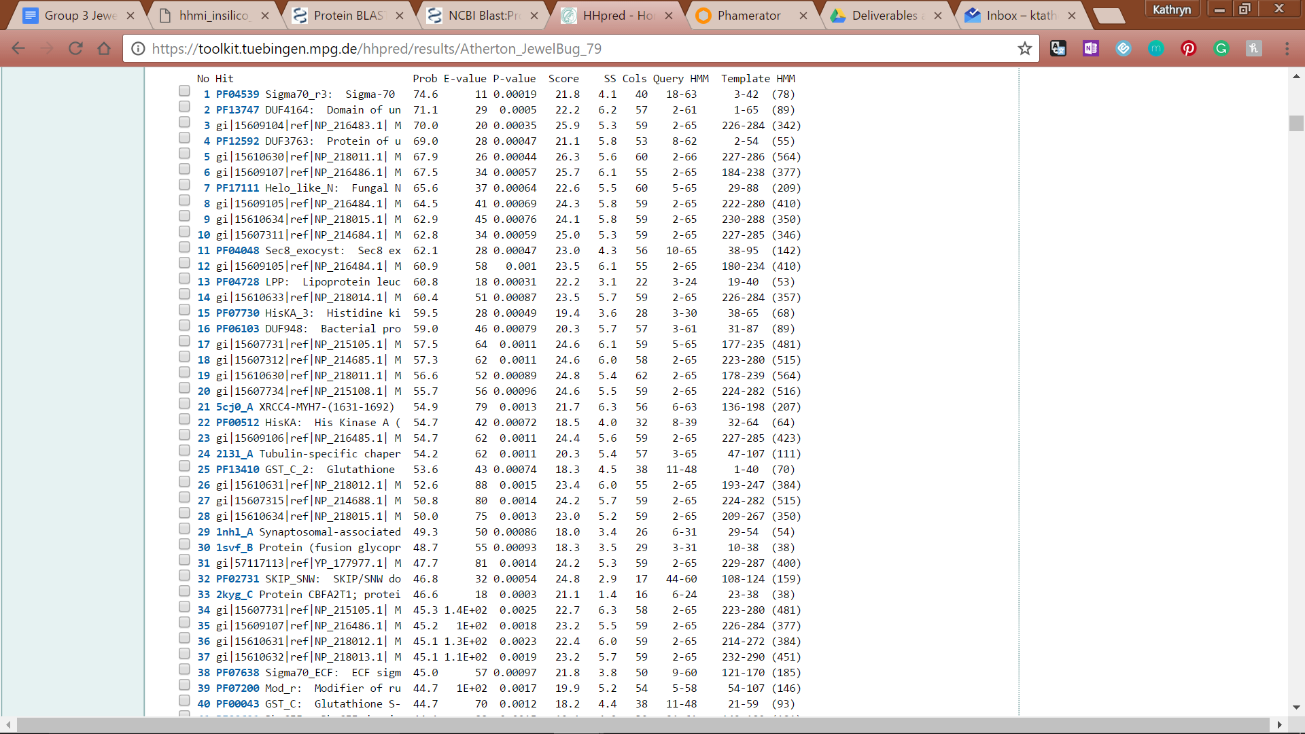

**Figure 195: Feature 79, HHPred Probabilities and Descriptions**

# Feature 80

**Table 15: Feature 80 Data**

|  |  |  |  |  |  |  |  |  |  |
| --- | --- | --- | --- | --- | --- | --- | --- | --- | --- |
| **Feature:** 80 | **3' End:** 46840 | **5' End:** 46932 | | | **Length:** 93 bp | | **Original Call:** | **Glimmer:** 46932 | |
| **GeneMark:** 46932 | |
| **Start / Stop Codon (SSC):** | | | | | | **Start:** GTG | | | |
| **Stop:** TGA; REV | | | |
| **Longest Open Reading Frame (LO):** 237 bp | | | | | | | | | Not Longest |
| **Shine Dalgarno (SD):** -3.042/ -4.264 | | | | | | | | | Highest |
| **Start Choice Source (SCS):** | | | | **Called by Glimmer:** Yes, 46932 | | | | | |
| **Called by GeneMark**: Yes, 46932 | | | | | |
| **Coding Potential (CP):** about 95% covered (see figure 196) | | | | | | | | | |
| **Gap / Overlap:** 3 bp overlap with feature 81 | | | | | | | | | |
| **BLASTp:** Hypothetical protein in VohminGahzi: 6.6 E-12; bp 1 aligns with bp 1 | | | | | | | | | |
| **Function (F):** No known function | | | | | | | | | |
| **Function Source (FS):** | | | **Phamerator:** no noted functions in similar phages | | | | | | |
| **BLASTp:** gp 91 from EricB (unknown function) | | | | | | |
| **HHPred:** No significant results found | | | | | | |
| **Comments:** Although the ORF is small, the SD values are lowest. Any longer ORG would overlap too much with other genes. | | | | | | | | | |

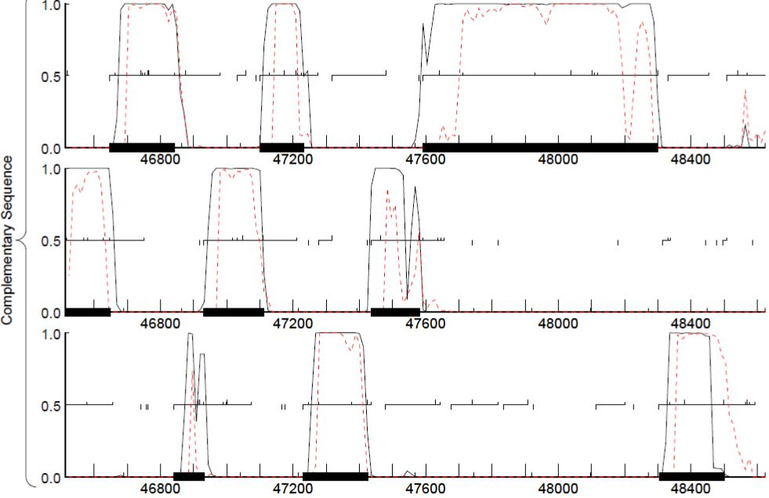

**Figure 196: Feature 80, GeneMark Map**

The bottom frame of the complementary strand shows coding potential from 46932 to 46840.

**Figure 197: Feature 80, JewelBug vs. VohminGhazi Phamerator Map**

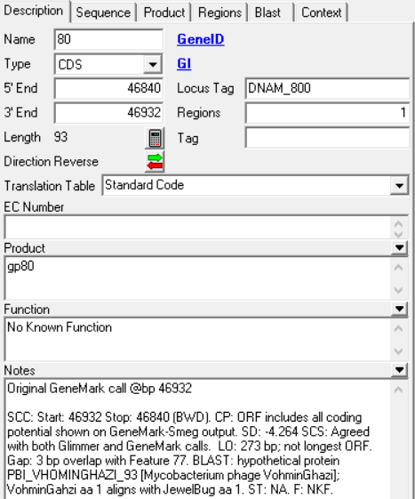

**Figure 198: Feature 80, Feature Window**

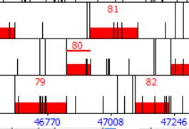

**Figure 199: Feature 80, Frame Window**

The open reading frame shows a 3bp overlap with features 79 and 81.

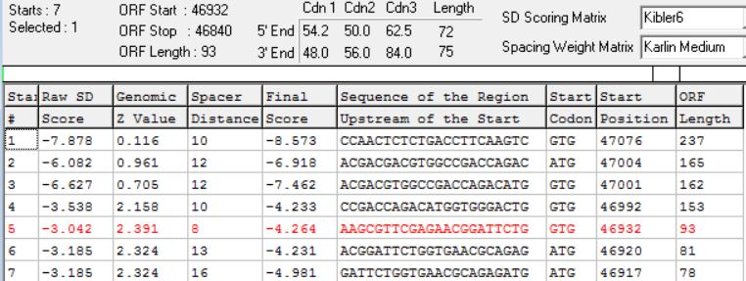

**Figure 200: Feature 80, Choose Start Window**

Although the ORF is only 93bp for the start at 46932, the SD scores are low relative to the other starts. Any longer ORF would overlap too much with genes 81 and beyond.

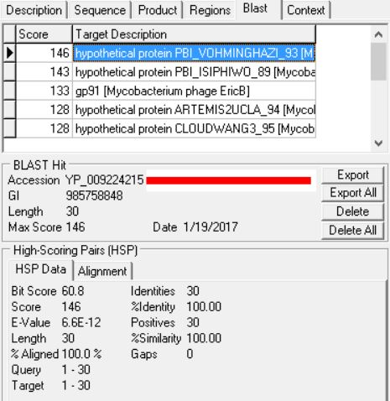

**Figure 201: Feature 80, HSP Data**

Like feature 79, the top BLAST result was a hypothetical protein in VohminGhazi.

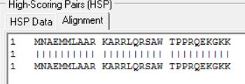

**Figure 202: Feature 80, Alignment**

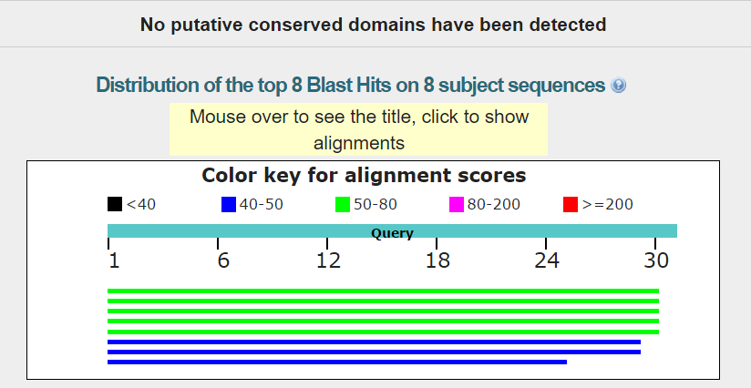

**Figure 203: Feature 80, Conserved Domain**



**Figure 204: Feature 80, BLASTp Hits Distribution Table**

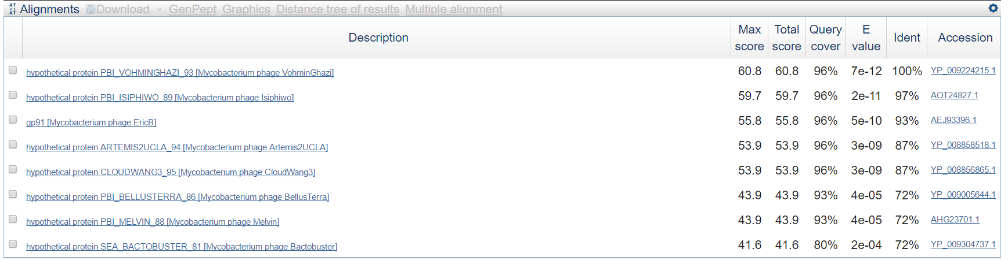

**Figure 205: Feature 80, BLASTp E-Values**

The top BLAST hit, a hypothetical protein, has 100% identity. The top 5 hits have a 96% query cover.

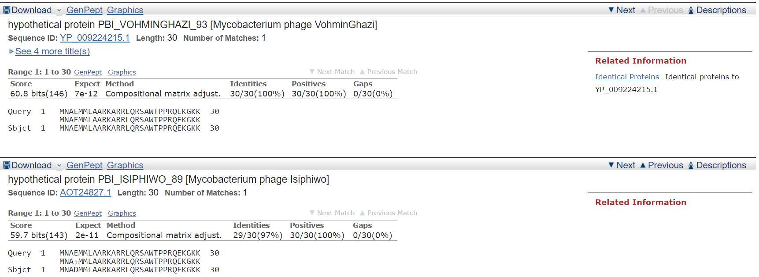

**Figure 206: Figure 80, BLASTp Alignments**

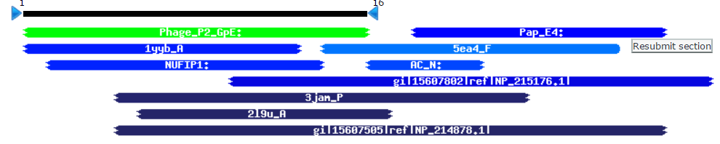

**Feature 207: Feature 80, HHPred Distribution List**

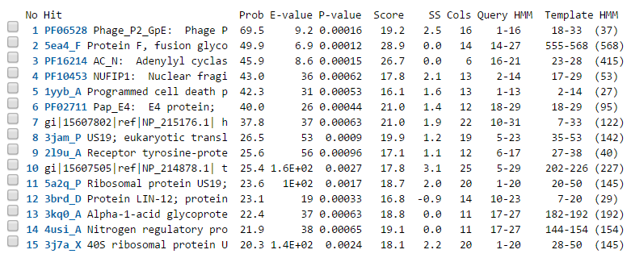

**Feature 208: Feature 80, HHPred Probabilities and Descriptions**

# Feature 81

**Table 16: Feature 81 Data**

|  |  |  |  |  |  |  |  |  |
| --- | --- | --- | --- | --- | --- | --- | --- | --- |
| **Feature:** 81 | **3' End:** 46929 | **5' End:** 47111 | | | **Length:** 183 | | **Original Call:** | **Glimmer:** 47111 |
| **GeneMark:** 47111 |
| **Start / Stop Codon (SSC):** | | | | | | **Start:** ATG | | |
| **Stop:** TGA; REV | | |
| **Longest Open Reading Frame (LO):** 285 bp | | | | | | | | Not Longest |
| **Shine Dalgarno (SD):** -2.814 / -3.571 | | | | | | | | Highest |
| **Start Choice Source (SCS):** | | | | **Called by Glimmer:** Yes, 47111 | | | | |
| **Called by GeneMark**: Yes, 47111 | | | | |
| **Coding Potential (CP):** All covered | | | | | | | | |
| **Gap / Overlap:** 12 bp overlap with feature 82 | | | | | | | | |
| **BLASTp:** hypothetical protein PBI_VHOMINGHAZI_94 ; bp 1 aligns with bp 1 | | | | | | | | |
| **Function (F):** No known function | | | | | | | | |
| **Function Source (FS):** | | | **Phamerator:** no noted functions in similar phages | | | | | |
| **BLASTp:** gp85 [Mycobacterium phage Jeffabunny]; (unknown function) | | | | | |
| **HHPred:** No significant results found | | | | | |
| **Comments:** All evidence supports the original call at bp 47111. | | | | | | | | |
|  |  |  |  |  |  |  |  |  |

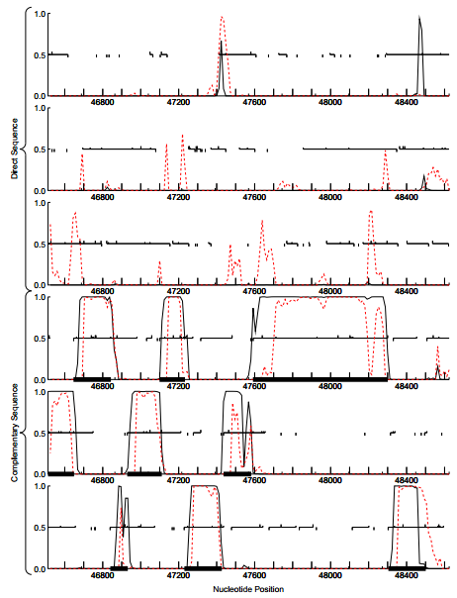

**Figure 209: Feature 81, GeneMark Map**

The original call captures all of the coding potential predicted by GeneMark in the middle complementary sequence row. This potential overlaps two other areas of significant coding potential in two distinct ORFs on either side. Therefore, any call that lengthens or shortens the gene by more than 50 bp will be disregarded.

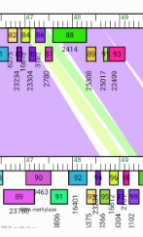

**Figure 210: Feature 81, JewelBug vs. Artimes2UCLA Phamerator Map**

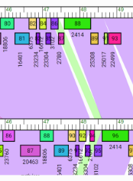

**Figure 211: Feature 81, JewelBug vs. DaVinci Phamerator Map**

5 / 15 significant matches (colored purple) appear between Gene 84 (corresponds to Feature 81) and phages with complete genome annotations in the A6 cluster. Above left is an example of a poor match (colored white) comparing JewelBug (top) to Artimes2UCLA. Above right is an example of a significant match (colored purple) comparing JewelBug (top) to DaVinci.

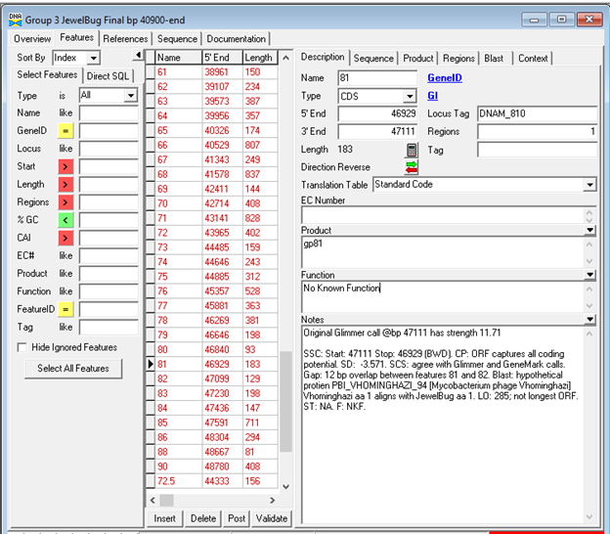

**Figure 212: Feature 81, Feature Window**

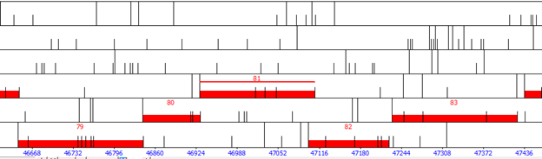

**Figure 213: Feature 81, Frame Window**

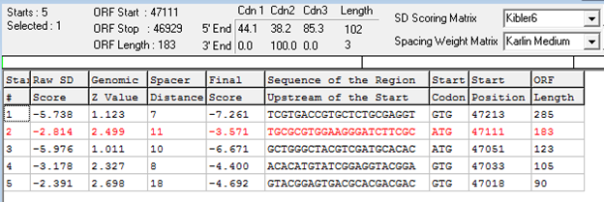

**Figure 214: Feature 81, Choose Start Window**

The original call at Start 2 appears to be the best option given the data discussed above as well as having the lowest SD score. While Start 1 has the longest open reading frame, it significantly encroaches on the coding potential captured by Feature 82. Start 3 fails to capture all of the coding potential and goes against the guiding principle of gene density. Start 1 will be further evaluated based on BLAST data, but is likely to be discarded as an option.

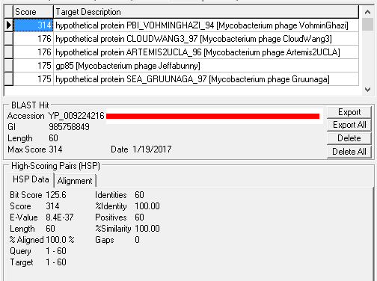

**Figure 215: Feature 81, HSP Data for Start 2**

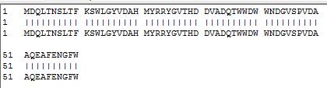

**Figure 216: Feature 81, Alignment for Original Call**

The original call at Start 2 (bp 47111), has 100.0 % similarity and 100.0% alignment with hypothetical protein PBI_VOHMINGHZI_94 [Mycobacterium phage VohminGhazi] with aa 1 aligning with aa 1 of both phages. This protein had the only significant score out of the 29 proteins referenced by the BLAST.

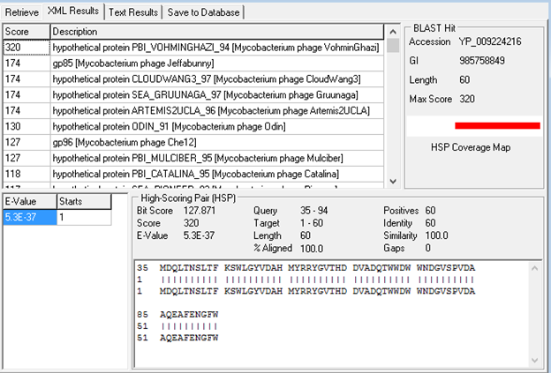

**Figure 217: Feature 81, HSP Data & Alignment**

The BLAST data from Start 1 (bp 47213) supports the previous assumptions. While more proteins were referenced during this BLAST, the majority were called after amino acid 30. Those that were called below amino acid 30 were called at amino acid 15 and had nonsignificant match scores. The most significant match is still with hypothetical protein PBI_VOHMINGHZI_94 [Mycobacterium phage VohminGhazi] which has only changed in bp alingment start. Therefore, the original call is supported by this data as well.



**Figure 218: Feature 81, Conserved Domains**

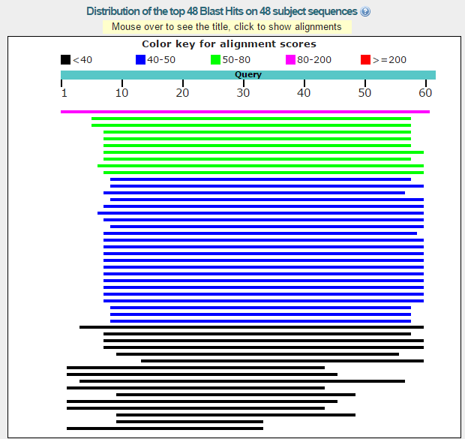

**Figure 219: Feature 81, BLASTp Hits Distribution Table**

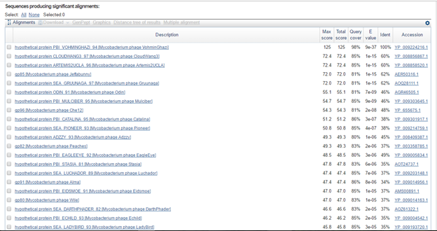

**Figure 220: Feature 81, BLASTp E-Values**

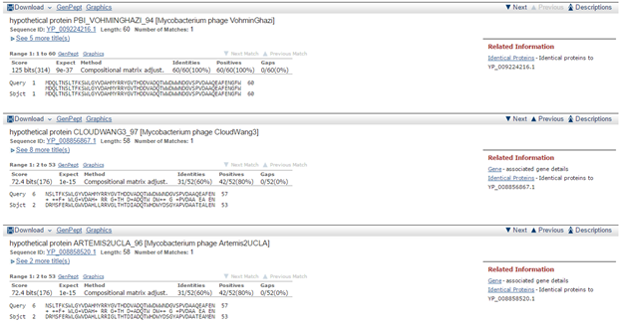

**Figure 221: Feature 81, BLASTp Alignments**

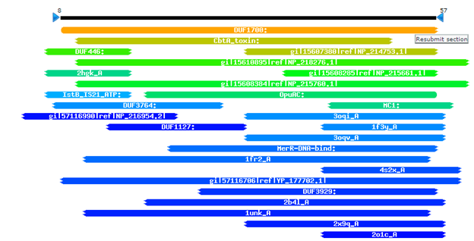

**Figure 222: Feature 81, HHPred Distribution List**

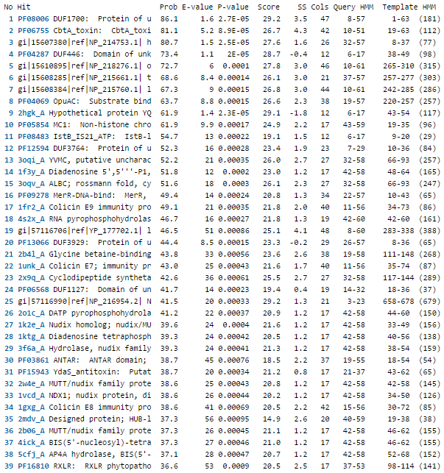

**Figure 223: Feature 81, HHPred Probabilities and Descriptions**

HHPred: Protein with the best probability is PF08006 DUF1700: Protein of unknown function (DUF1700) Probab=86.06 E-value=1.6, yet this E-val is not significant enough to make a conclusion. The next most similar protein is PF06755 CbtA_toxin: CbtA_toxin of type IV toxin-antitoxin system, which is a toxin that is involved with the lysis of bacterial and abacterial organisms. While the E-val and probability are not significant enough to assign this function (Probab=81.05 E-value=5.2), further investigation into a function as a toxin is warranted.

# Feature 82

**Table 17: Feature 82 Data**

|  |  |  |  |  |  |  |  |  |  |
| --- | --- | --- | --- | --- | --- | --- | --- | --- | --- |
| **Feature:** 82 | **3' End:** 47099 | **5' End:** 47227 | | | **Length:** 129 | | **Original Call:** | **Glimmer:** 47227 | |
| **GeneMark:** 47233 | |
| **Start / Stop Codon (SSC):** | | | | | | **Start:** GTG | | | |
| **Stop:** TGA; REV | | | |
| **Longest Open Reading Frame (LO):** 177 bp | | | | | | | | | Not Longest |
| **Shine Dalgarno (SD):** -1.259 / -2.095 | | | | | | | | | Highest |
| **Start Choice Source (SCS):** | | | | **Called by Glimmer:** Yes, 47227 | | | | | |
| **Called by GeneMark**: Yes, 47233 | | | | | |
| **Coding Potential (CP):** nearly all covered | | | | | | | | | |
| **Gap / Overlap:** 3 bp gap following gene | | | | | | | | | |
| **BLASTp:** hypothetical protein PBI_VOHMINGHAZI_95, bp 1 aligns with bp 1 | | | | | | | | | |
| **Function (F):** No Known Function | | | | | | | | | |
| **Function Source (FS):** | | | **Phamerator:** no noted functions in similar phages | | | | | | |
| **BLASTp:** gp150 from Wildcat (unknown function) | | | | | | |
| **HHPred:** No significant results found | | | | | | |
| **Comments:** Start 3 (47227) as called originally by Glimmer has been selected as the best call. It has the best SD score and best BLAST results. It captures nearly all of the coding potential and has an acceptable gap of 3 bp before Feature 83. The BLAST results compared to PBI_VOHMINGHZI_95 [Mycobacterium phage VohminGhazi] indicate a perfect match, which remains the most significant match (but with lower scores) for Start 2 (47233) and Start 1 (47275). | | | | | | | | | |



**Figure 224: Feature 82, GeneMark Map**

The coding potential corresponding to Feature 82 (in the upper complementary open reading frame) is wedged between two other sections of significant coding potential in two distinct ORFs. Therefore starts that lengthen or shorten the call by more than 50 bp will be discarded as valid options. Both original calls appear to capture all of the coding potential, so further investigation of both is still warranted.

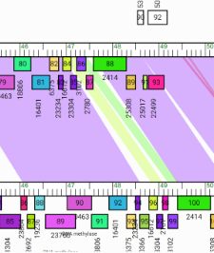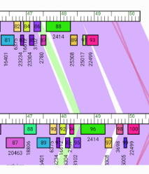

**Figure 225: Feature 82, JewelBug Phamerator Maps**

Gene 85 on the Phamerator map for the draft of JewelBug corresponds to Feature 82. Out of the 15 non-draft only 5 show a significant match (colored purple). Above left is an example of a poor match (colored yellow) comparing JewelBug (top) to Artimes2UCLA. Above right is an example of a significant match (colored purple) comparing JewelBug (top) to DaVinci.

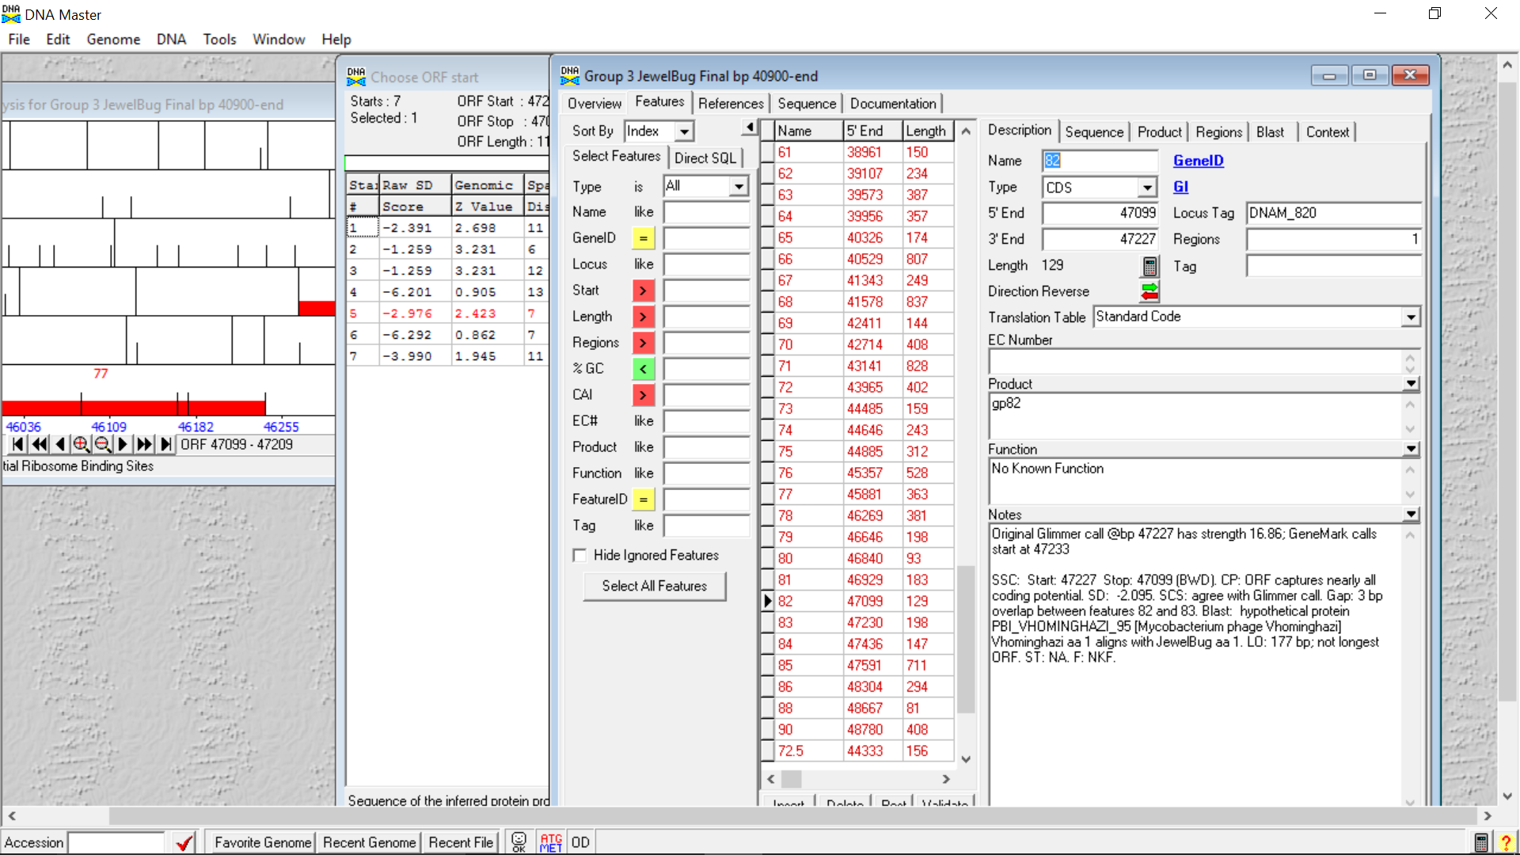

**Figure 226: Feature 82, Feature Window**

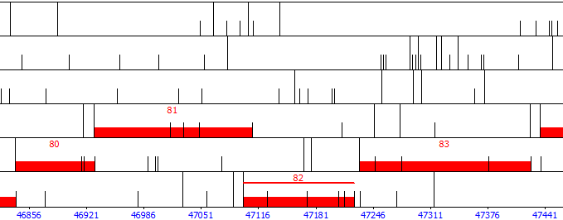

**Figure 227: Feature 82, Frame Window**

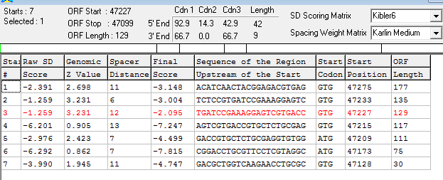

**Figure 228: Feature 82, Choose Start Window**

The Glimmer’s original call at 47227 (Start 3) and GeneMark original call at 47233 (Start 2) will both be evaluated. Start 1 (47275) will also be evaluated since it has the longest ORF. Start 4 will not be evaluated since it has the worst SD score and cuts off coding potential. Starts shorter than 4 will also not be evaluated since they cut off coding potential as well.

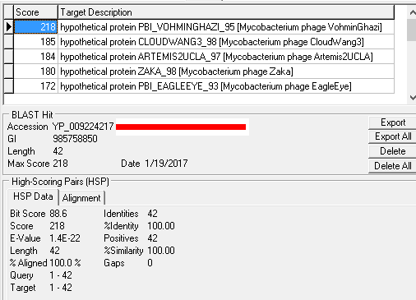

**Figure 229: Feature 82, HSP Data for Start 3**

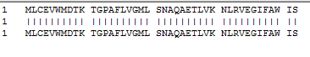

**Figure 230: Feature 82, Alignment for Start 3**

Out of the twelve proteins referenced by the BLAST at Start 3 (47227) ten are aligned with bp 1 of JewelBug aligning with the bp 1 of the comparison protein. The best match for Start 3 is the hypothetical protein PBI_VOHMINGHZI_95 [Mycobacterium phage VohminGhazi] with 100.0% identity, similartiy, and alignment with bp 1 of JewelBug aligned with bp 1 of PBI_VOHMINGHZI_95.

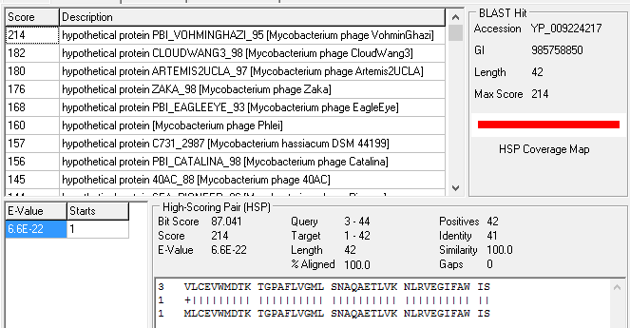

**Figure 231: Feature 82, HSP Data and Alignment for Start 2**

Of the thirteen proteins referenced by the BLAST of Start 2 (47233), none start before amino acid 3 or bp 10. The most significant match is still PBI_VOHMINGHZI_95 [Mycobacterium phage VohminGhazi], the only difference being the move from a match of bp 1 to bp 1 of both proteins to bp 10 of JewelBug corresponding with bp 1 of PBI_VOHMINGHZI_95.

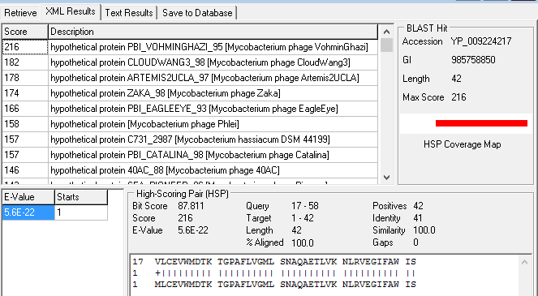

**Figure 232: Feature 82, HSP Data and Alignment for Start 1**

Feature 82, BLAST: Of fifteen references compared to Start 1 (47275), thirteen of the references start at amino acid 17 of JewelBug or above One started at amino acid 7 and one at amino acid 4, but these were not significant matches. The BLAST data from Start 1 and Start 2 indicate that Start 3 is the best option.

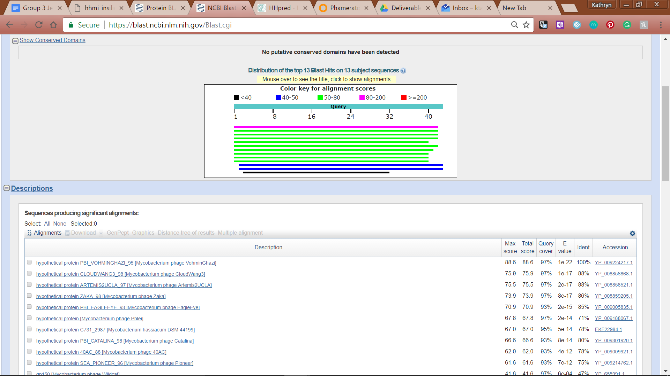

**Figure 233: Feature 82, Conserved Domain**



**Figure 234: Feature 82, BLASTp Hits Distribution Table**

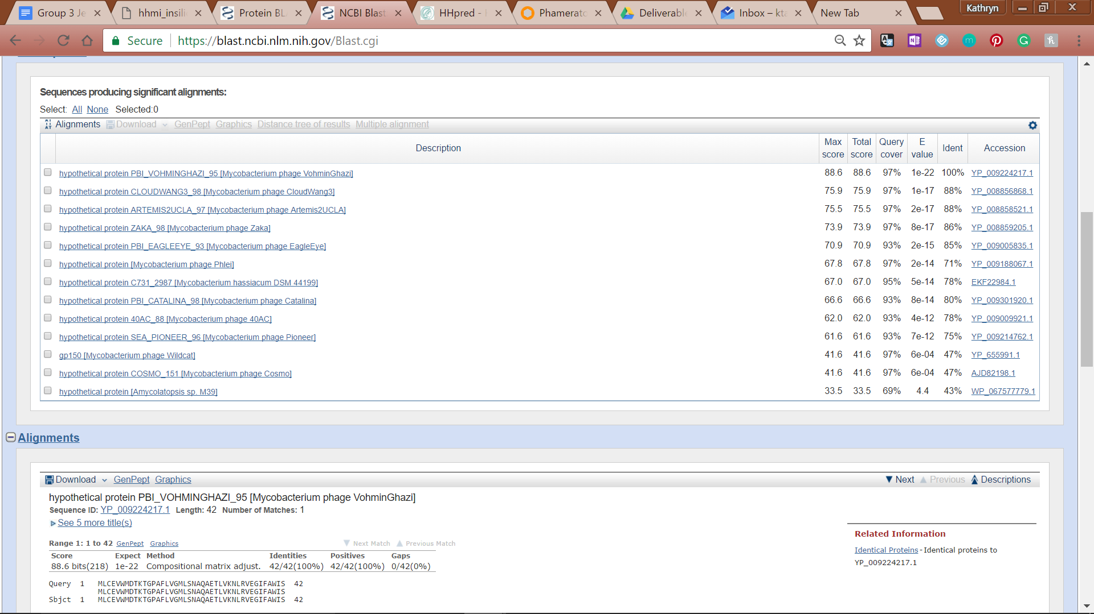

**Figure 235: Feature 82, BLASTp E-Values**

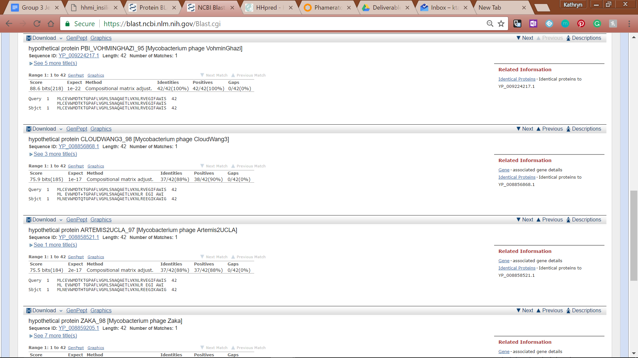

**Figure 236: Feature 82, BLASTp Alignments**

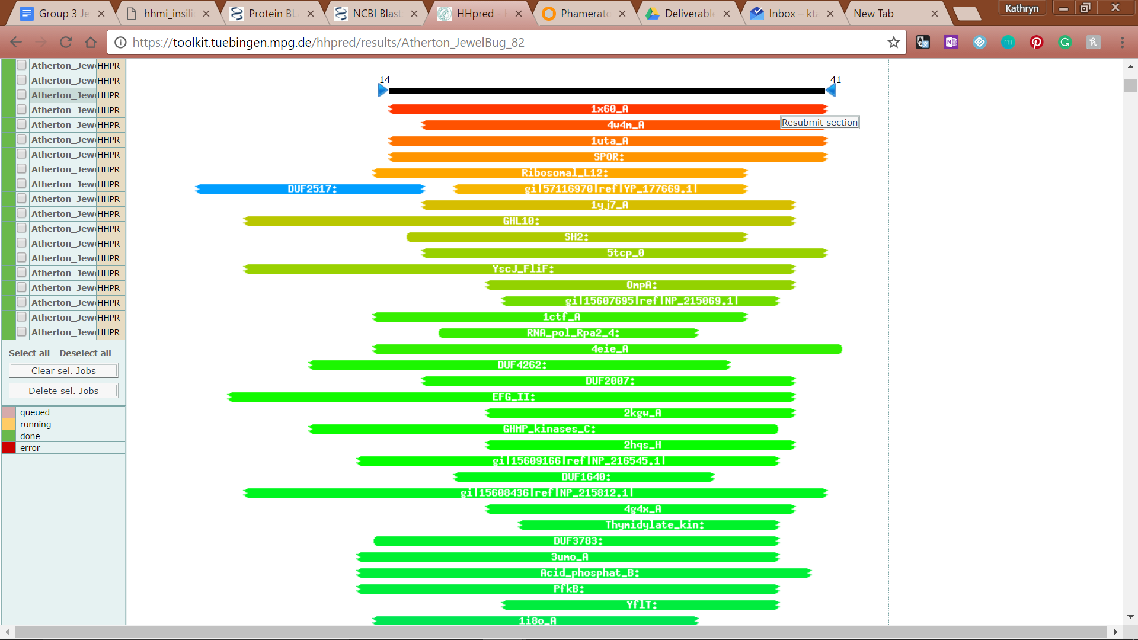

**Figure 237: Feature 82, HHPred Distribution List**

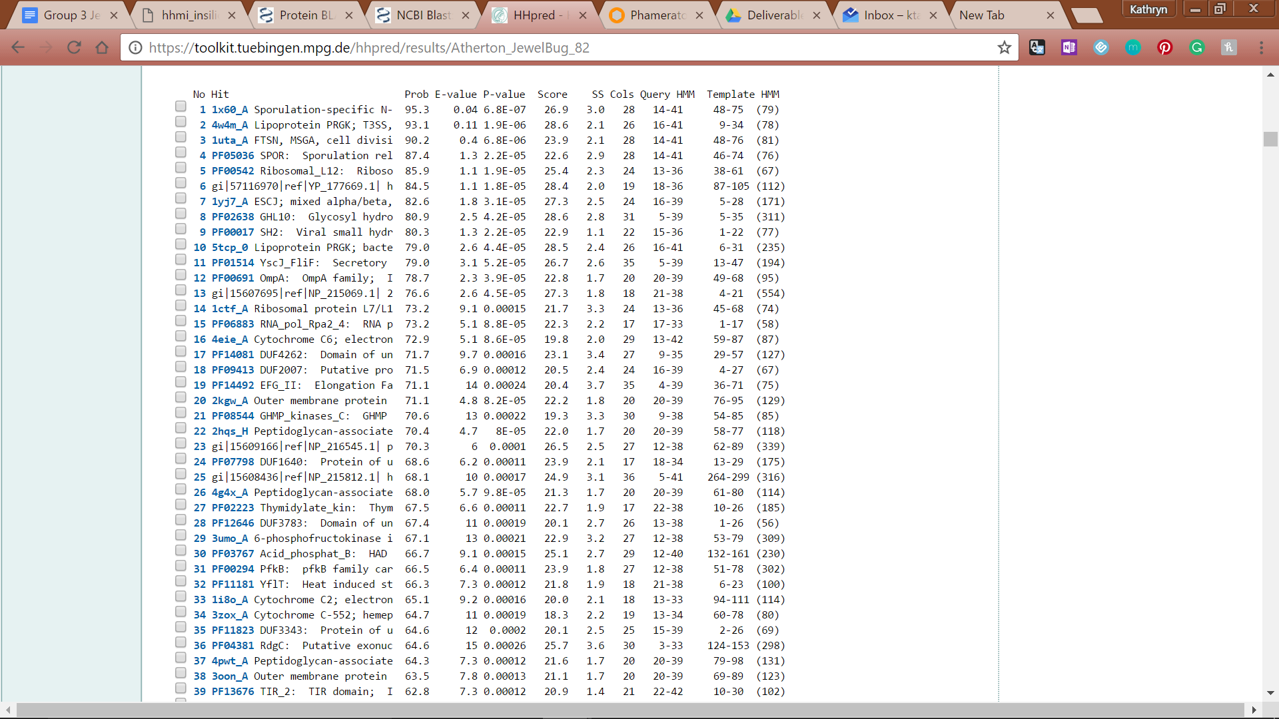

**Figure 238: Feature 82, HHPred Probabilities and Descriptions**

# Feature 83

**Table 18: Feature 83 Data**

|  |  |  |  |  |  |  |  |  |  |
| --- | --- | --- | --- | --- | --- | --- | --- | --- | --- |
| **Feature:** 83 | **3' End:** 47230 | **5' End:** 47427 | | | **Length:** 198 | | **Original Call:** | **Glimmer:** 47427 | |
| **GeneMark:** 47427 | |
| **Start / Stop Codon (SSC):** | | | | | | **Start:** ATG | | | |
| **Stop:** TGA; REV | | | |
| **Longest Open Reading Frame (LO):** 210 bp | | | | | | | | | Not Longest |
| **Shine Dalgarno (SD):** -3.880 / -5.101 | | | | | | | | | Not Highest |
| **Start Choice Source (SCS):** | | | | **Called by Glimmer:** Yes, 47427 | | | | | |
| **Called by GeneMark**: Yes, 47427 | | | | | |
| **Coding Potential (CP):** all covered | | | | | | | | | |
| **Gap / Overlap:** 9 bp gap following gene | | | | | | | | | |
| **BLASTp:** hypothetical protien PBI_MULCIBER_94, bp 1 aligns with bp 1 | | | | | | | | | |
| **Function (F):** No known function | | | | | | | | | |
| **Function Source (FS):** | | | **Phamerator:** No noted functions in similar phages | | | | | | |
| **BLASTp:** gp95 from DaVinci (unknown function) | | | | | | |
| **HHPred:** No significant matches found | | | | | | |
| **Comments:** While Start 1 has the longest ORF and an acceptable overlap of 3 pb, Start 2 is supported by the Glimmer and GeneMark database, captures all of the coding potential, and is supported by initial bp alignment with confirmed proteins found in phages from the A6 cluster. | | | | | | | | | |



**Figure 239: Feature 83, GeneMark Map**

The original call is supported by the coding potential generated by GeneMark despite the lack of correlation between Feature 83 and the rest of the non-draft genomes in the A6 cluster. Since this coding potential nestled between two other areas of significant potential in two different ORFs, calls that lengthen or shorten the call by more than 50 bp will be discarded.

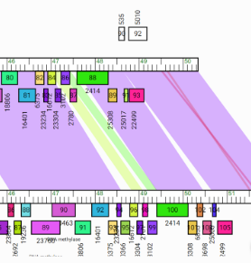

**Figure 240: Feature 83, JewelBug vs. Artemis2UCLA Phamerator Map**

All fifteen of the non-draft genomes in the A6 cluster have only a mildly significant correlation to Gene 86 (Feature 83) and are thusly colored green. Above is an example with JewelBug (top) compared to Artemis2UCLA.

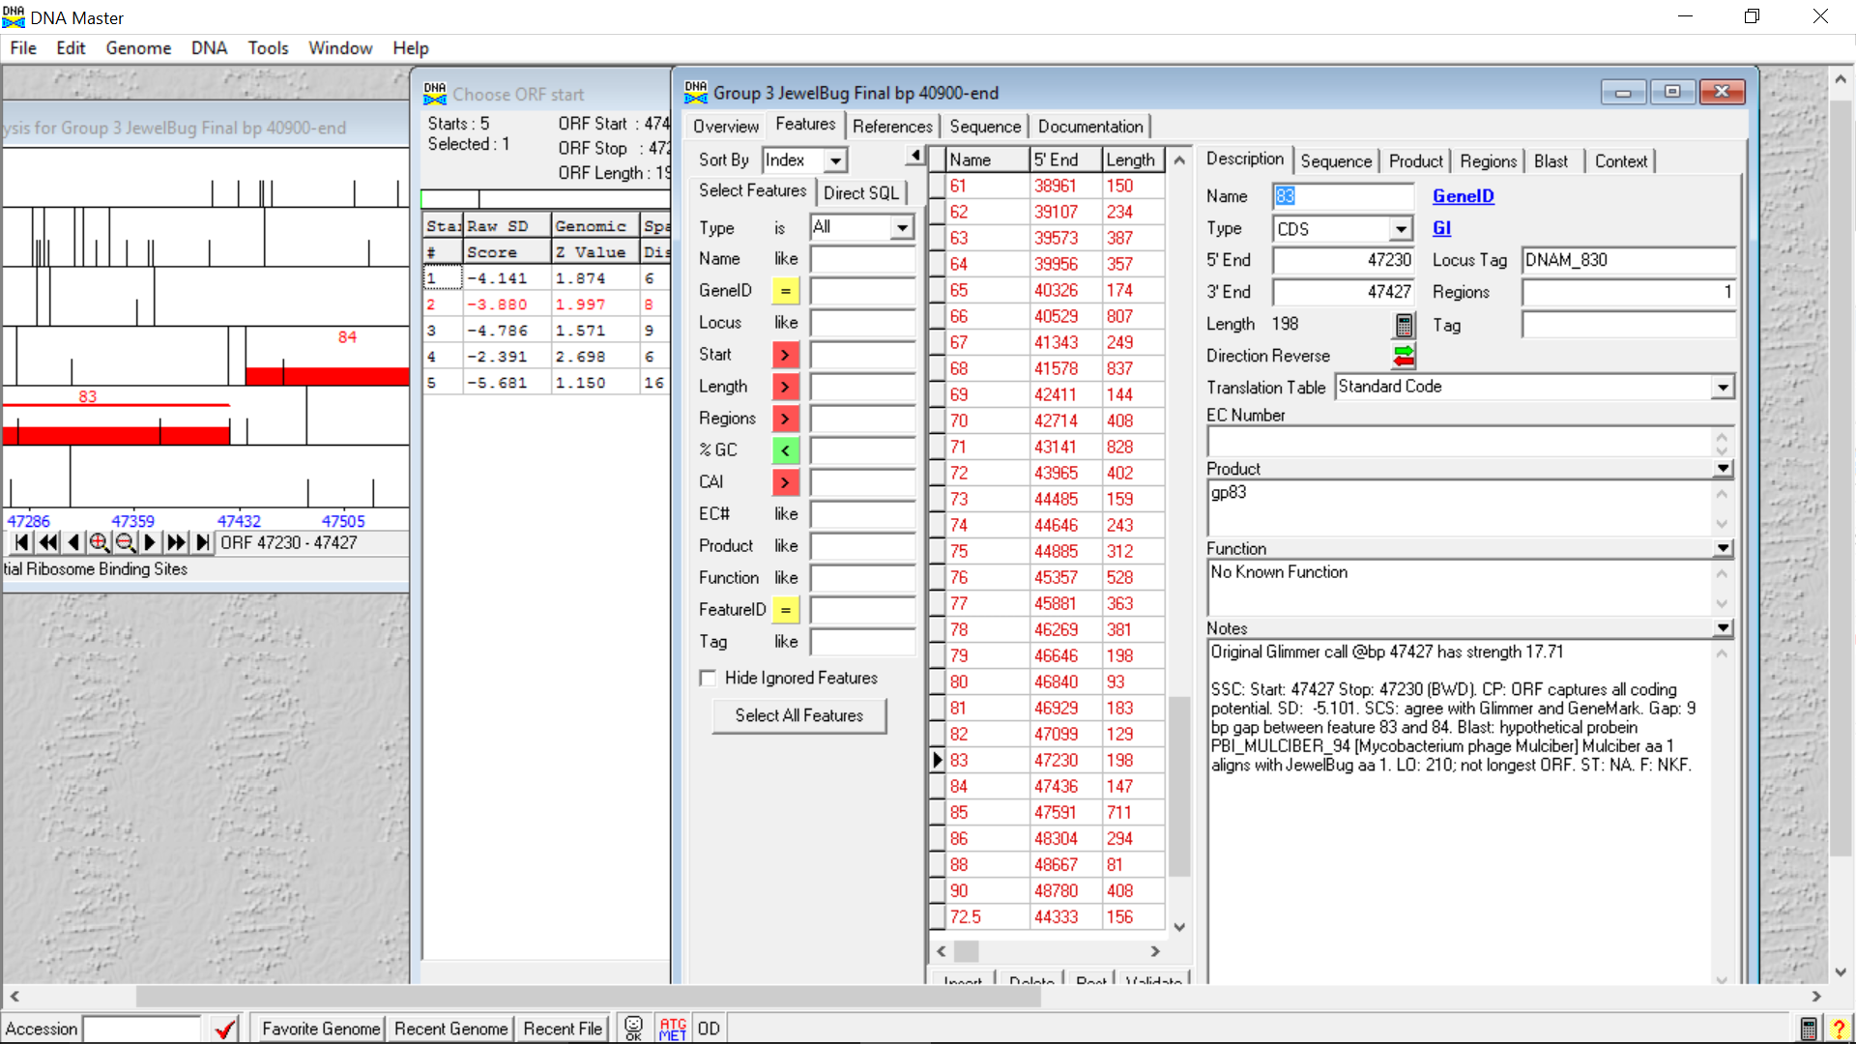

**Figure 241: Feature 83, Feature Window**

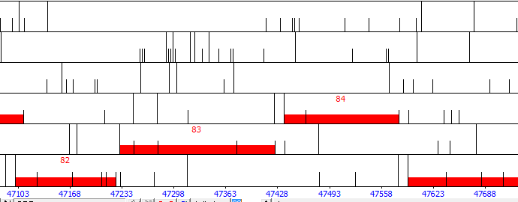

**Figure 242: Feature 83, Frame Window**

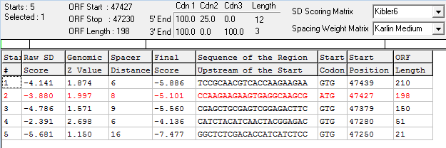

**Figure 243: Feature 83, Choose Start Window**

Starts 2 and 1 will be considered since they both have an acceptable bp gap / overlap with the Feature 84. Both satisfactorily capture the coding potential as well. Starts 3, 4, and 5 with be discarded since they leave coding potential uncaptured and are below the average considered length for a gene, even though start 4 has the best SD score.

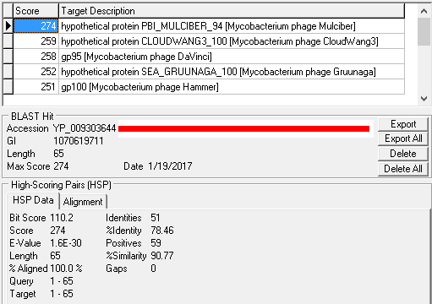

**Figure 244: Feature 83, HSP Data for Original Call**

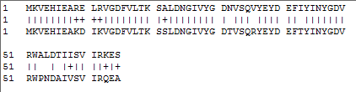

**Figure 245: Feature 83, Alignment for Original Call**

The BLAST results for the original call at Start 2 (47427) produces convincing evidence for this start. The most similar reference is hypothetical protein PBI_MULCIBER_94 [Mycobacterium phage Mulciber] with an alignment of 100.0 %, 78.46 % identity, and a similarity of 90.77 %. At this start, bp 1 of Feature 83 aligns with bp 1 of hypothetical protein PBI_MULCIBER_94 [Mycobacterium phage Mulciber]. This start location is further supported by gp95 [Mycobacterium phage DaVinci], gp100 [Mycobacterium phage Hammer], and gp101 [Mycobacterium phage Blue7], which all have alignments of 100.0 %, identities above 70.0 %, and similarities above 80.0 % with bp 1 corresponding to bp 1 of both proteins.

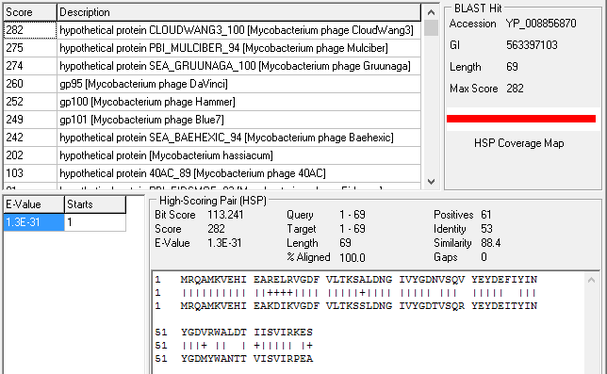

**Figure 246: Feature 83, HSP Data and Alignment for Start 1**

For the BLAST results Start 1 (47439), only two references out of thirteen have bp 1 of the reference aligning with bp 1 of Feature 83 called at this start. While hypothetical protein CLOUDWANG3_100 [Mycobacterium phage CloudWang3] does align with bp 1 of Feature 83 called at this location, its similarity is less than the highest scoring reference found comparing to Start 2; although, its overall score of 282 is higher than the score of 274 from the highest reference from the BlAST of Start 2. At this Start, the gp mentioned above all have their 1st bp correspond with the 13th bp of the Feature. Since these are not hypothetical proteins, they have more significance when considering the verification of the start site. Therefore, these results also support the original call.

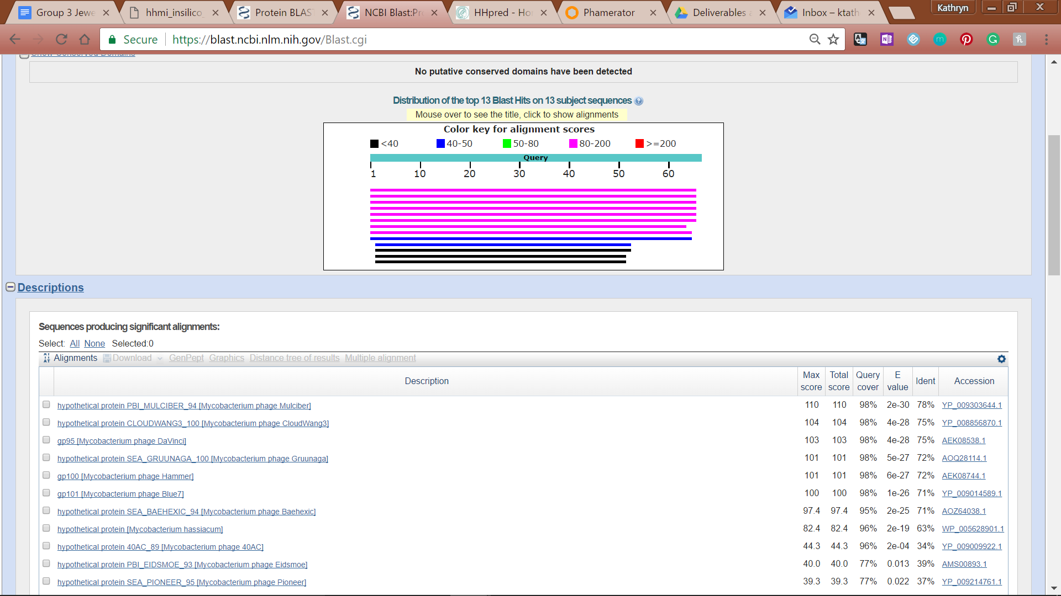

**Figure 247: Feature 83, Conserved Domain**



**Figure 248: Feature 83, BLASTp Hits Distribution Table**

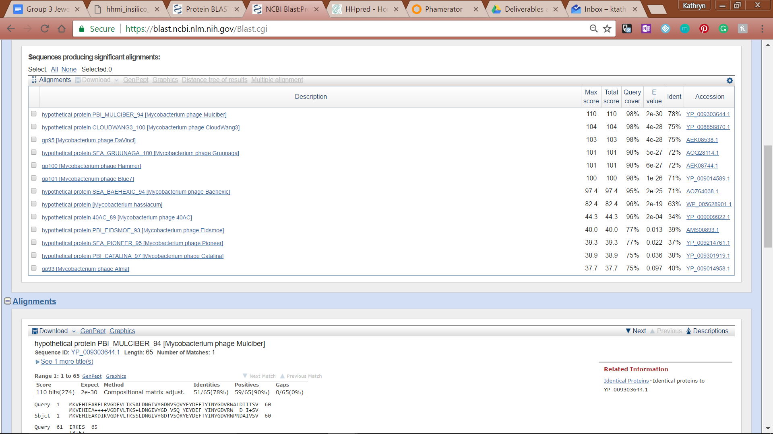

**Figure 249: Feature 83, BLASTp E-Values**

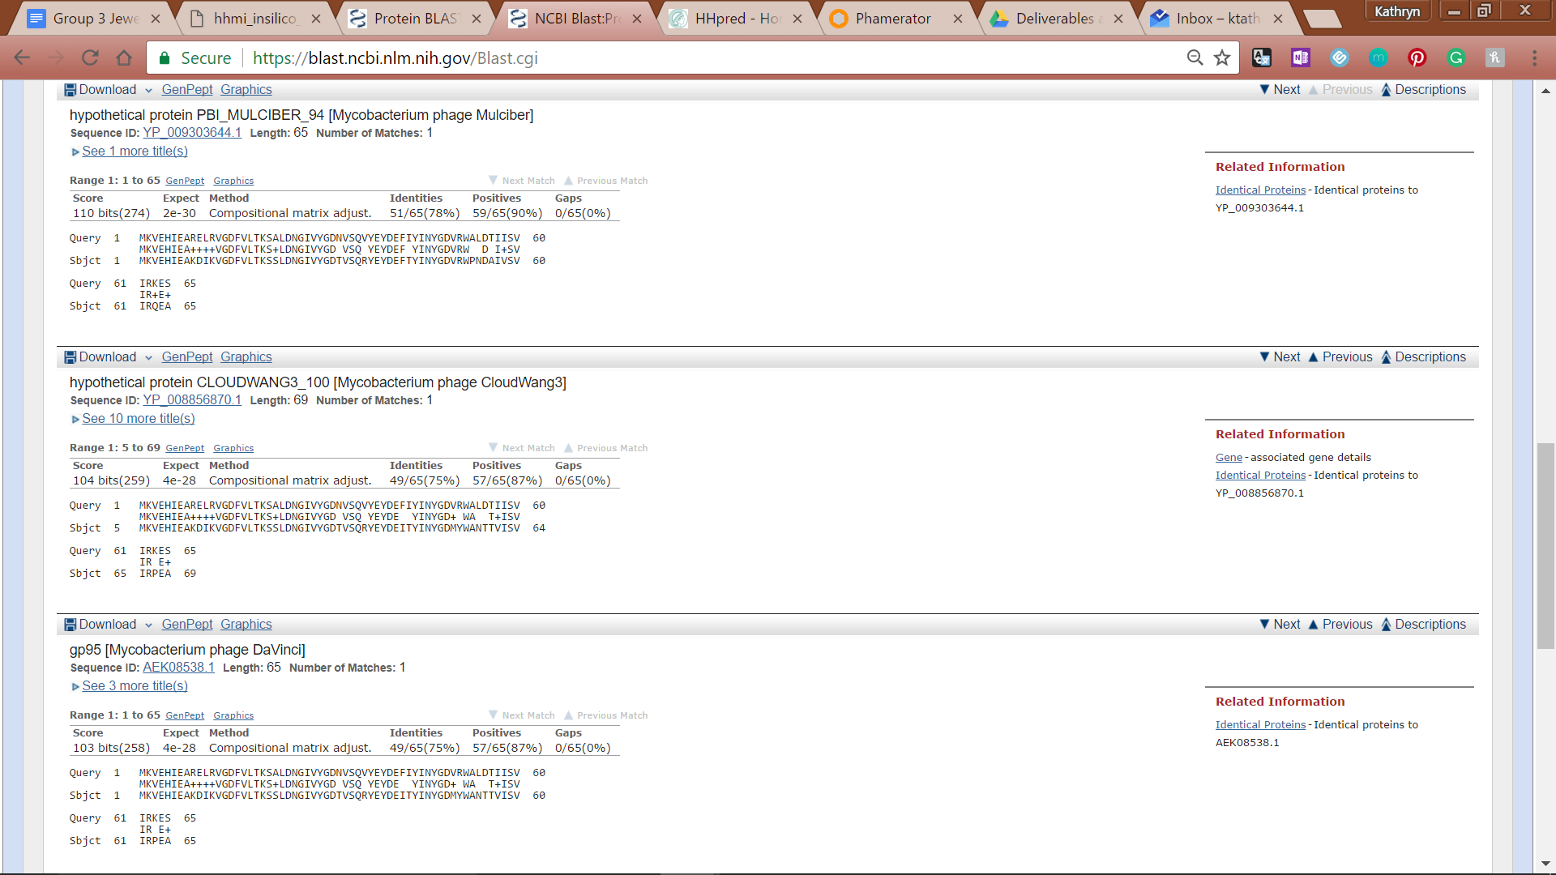

**Figure 250: Feature 83, BLASTp Alignments**

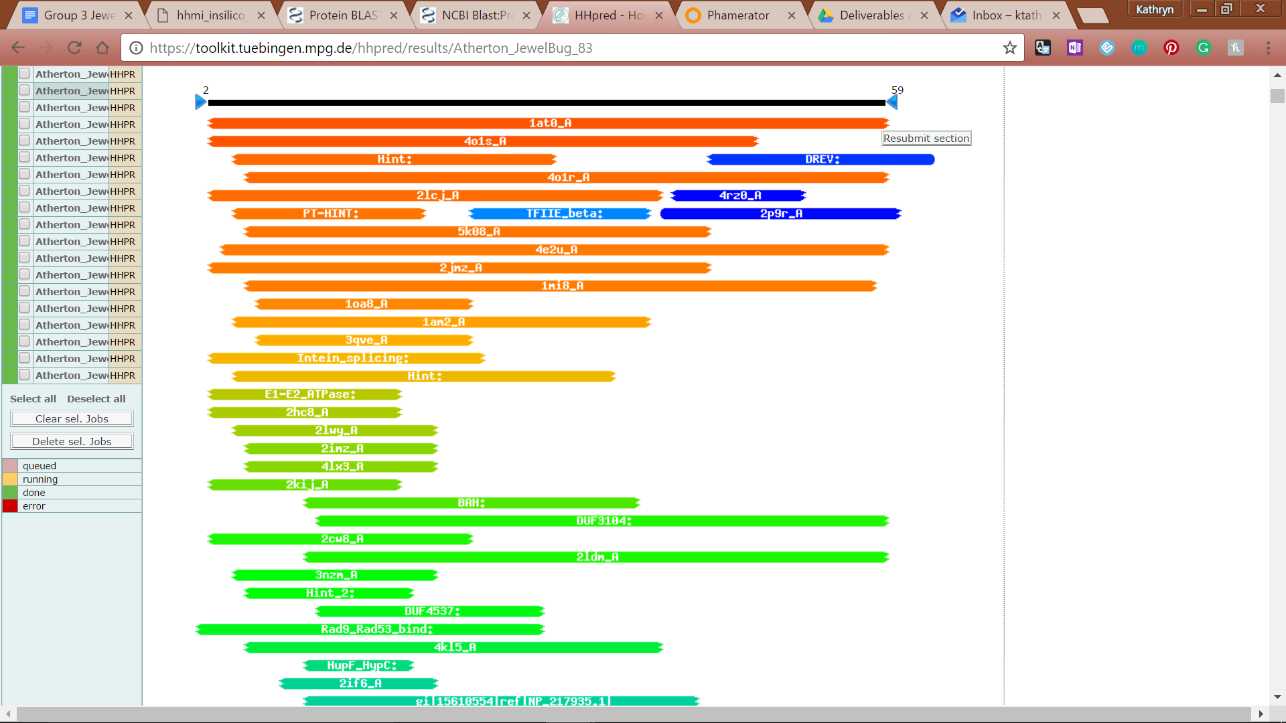

**Figure 251: Feature 83, HHPred Distribution List**

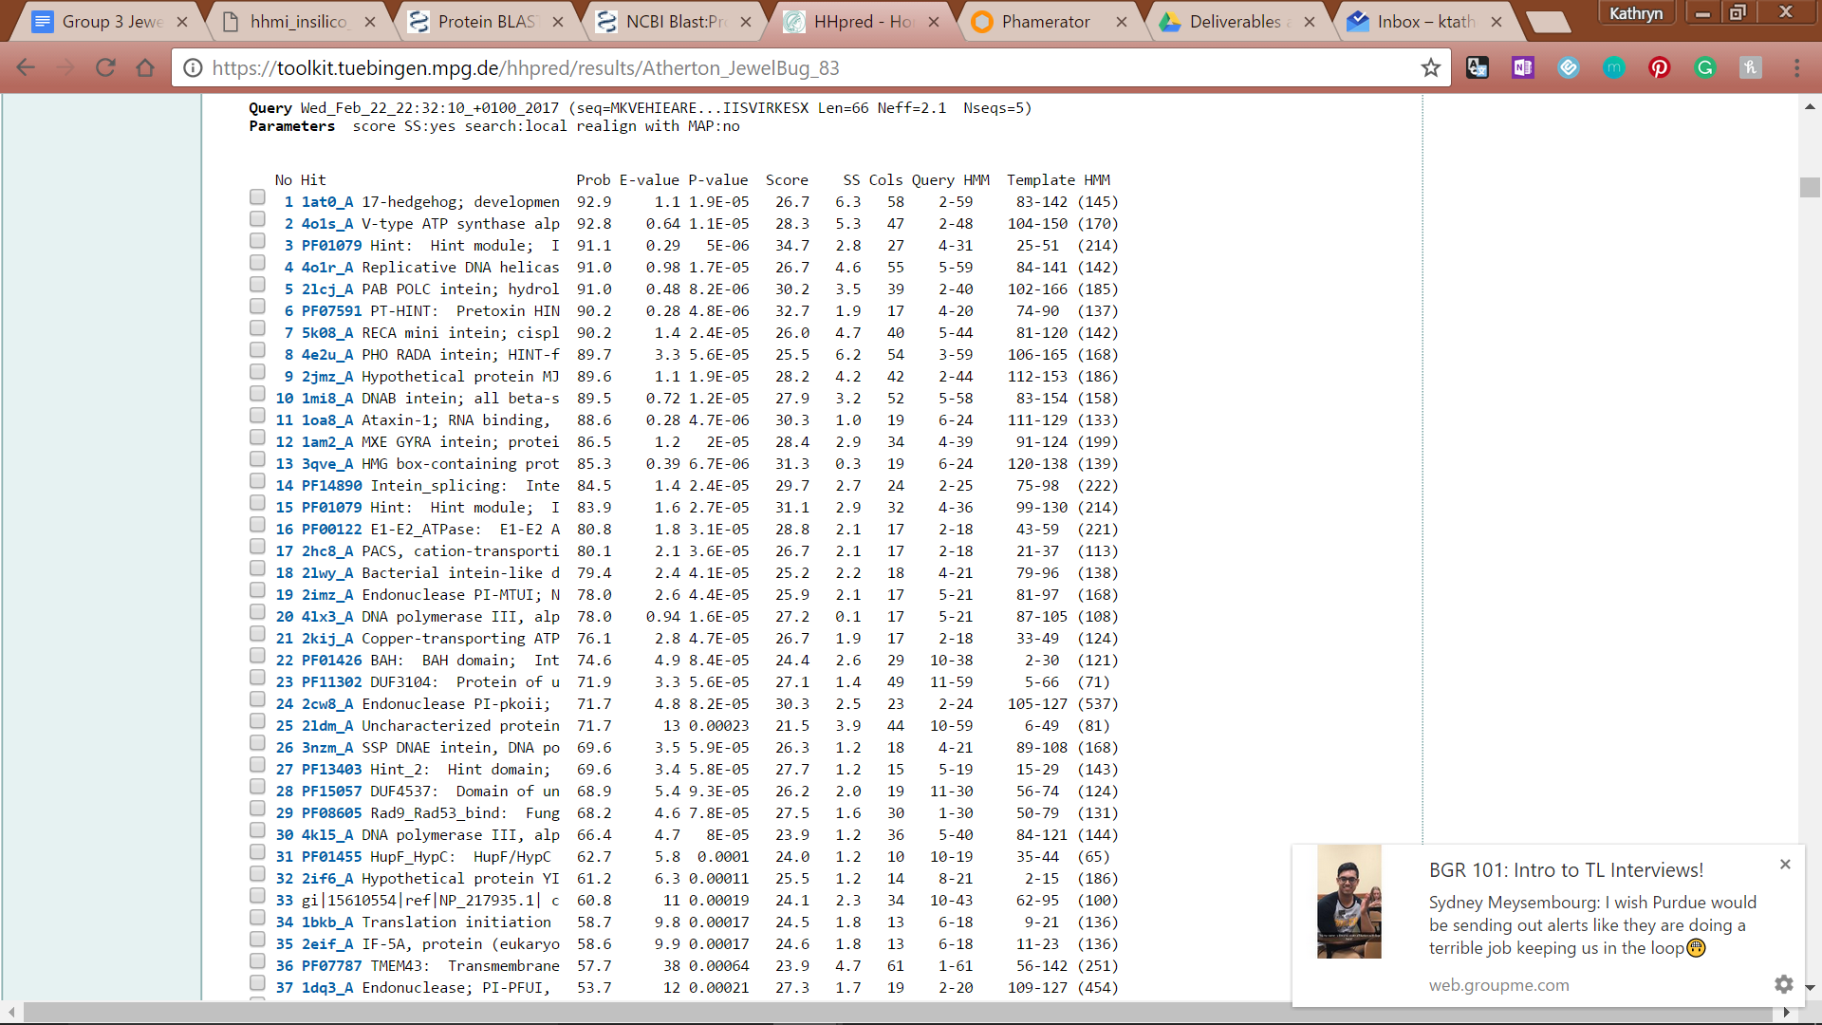

**Figure 252: Feature 83, HHPred Probabilities and Descriptions**

# Feature 84

**Table 19: Feature 84 Data**

|  |  |  |  |  |  |  |  |  |  |
| --- | --- | --- | --- | --- | --- | --- | --- | --- | --- |
| **Feature:** 84 | **3' End:** 47436 | **5' End:** 47582 | | | **Length:** 147 | | **Original Call:** | **Glimmer:** 47582 | |
| **GeneMark:** 47582 | |
| **Start / Stop Codon (SSC):** | | | | | | **Start:** ATG | | | |
| **Stop:** TGA; REV | | | |
| **Longest Open Reading Frame (LO):** 222 bp | | | | | | | | | Not Longest |
| **Shine Dalgarno (SD):** -3.880 / -5.101 | | | | | | | | | Not Highest |
| **Start Choice Source (SCS):** | | | | **Called by Glimmer:** Yes, 47582 | | | | | |
| **Called by GeneMark**: Yes, 47582 | | | | | |
| **Coding Potential (CP):** all captured | | | | | | | | | |
| **Gap / Overlap:** 9 bp gap following gene | | | | | | | | | |
| **BLASTp:** No blast results obtained | | | | | | | | | |
| **Function (F):** No known function | | | | | | | | | |
| **Function Source (FS):** | | | **Phamerator:** No noted functions in similar phages | | | | | | |
| **BLASTp:** No BLAST results present | | | | | | |
| **HHPred:** No significant results found | | | | | | |
| **Comments:** While there are no matches indicated by non-draft genomes compared in Phamerator, the coding potential supports the existence of the gene call at Start 2 of Feature 84. | | | | | | | | | |

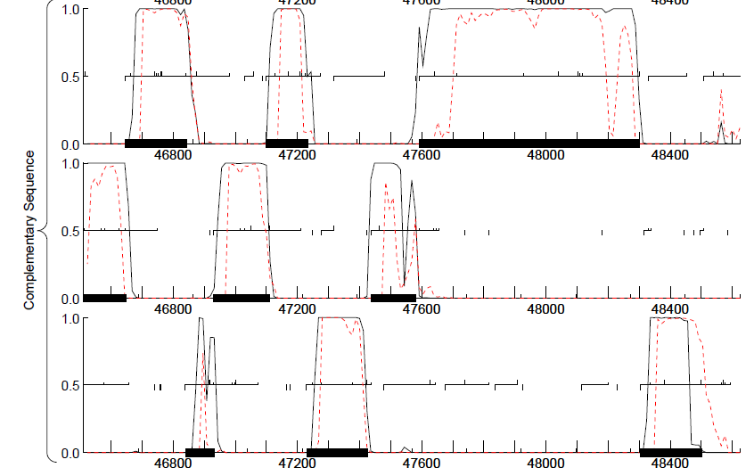

**Figure 253: Feature 84, GeneMark Map**

The coding potential for feature 84 is all captured in the second complementary open reading frame from 47582 to 47436.

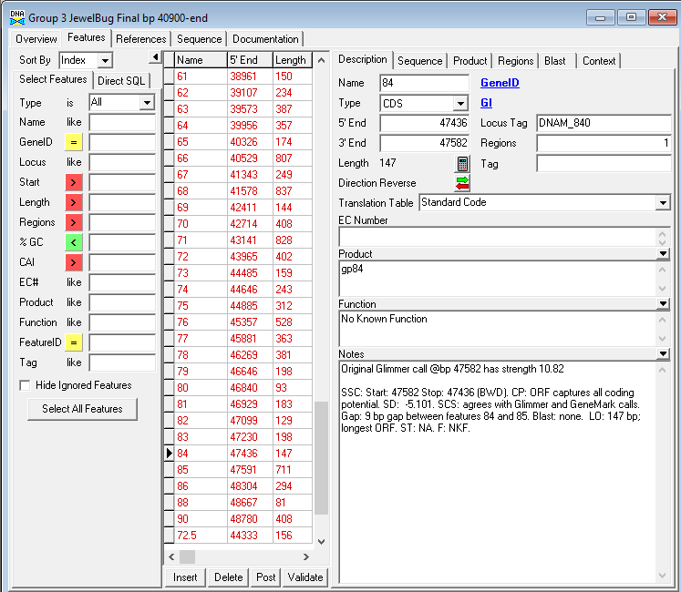

**Figure 254: Feature 84, Feature Window**

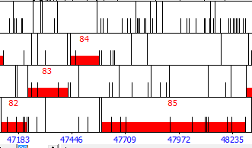

**Figure 255: Feature 84, Frame Window**

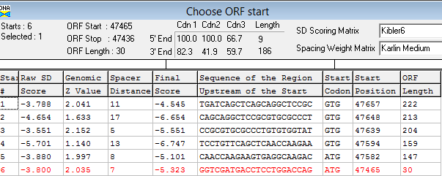

**Figure 256: Feature 84, Choos Start Window**

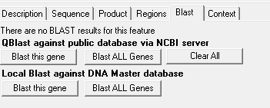

**Figure 257: Feature 84, HSP Data**

There are no BLAST results for feature 84.

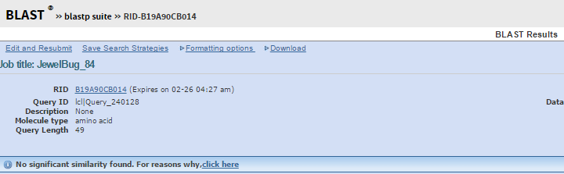

**Figure 258: Feature 84, BLASTp Results**

There are no BLASTp results for feature 84.

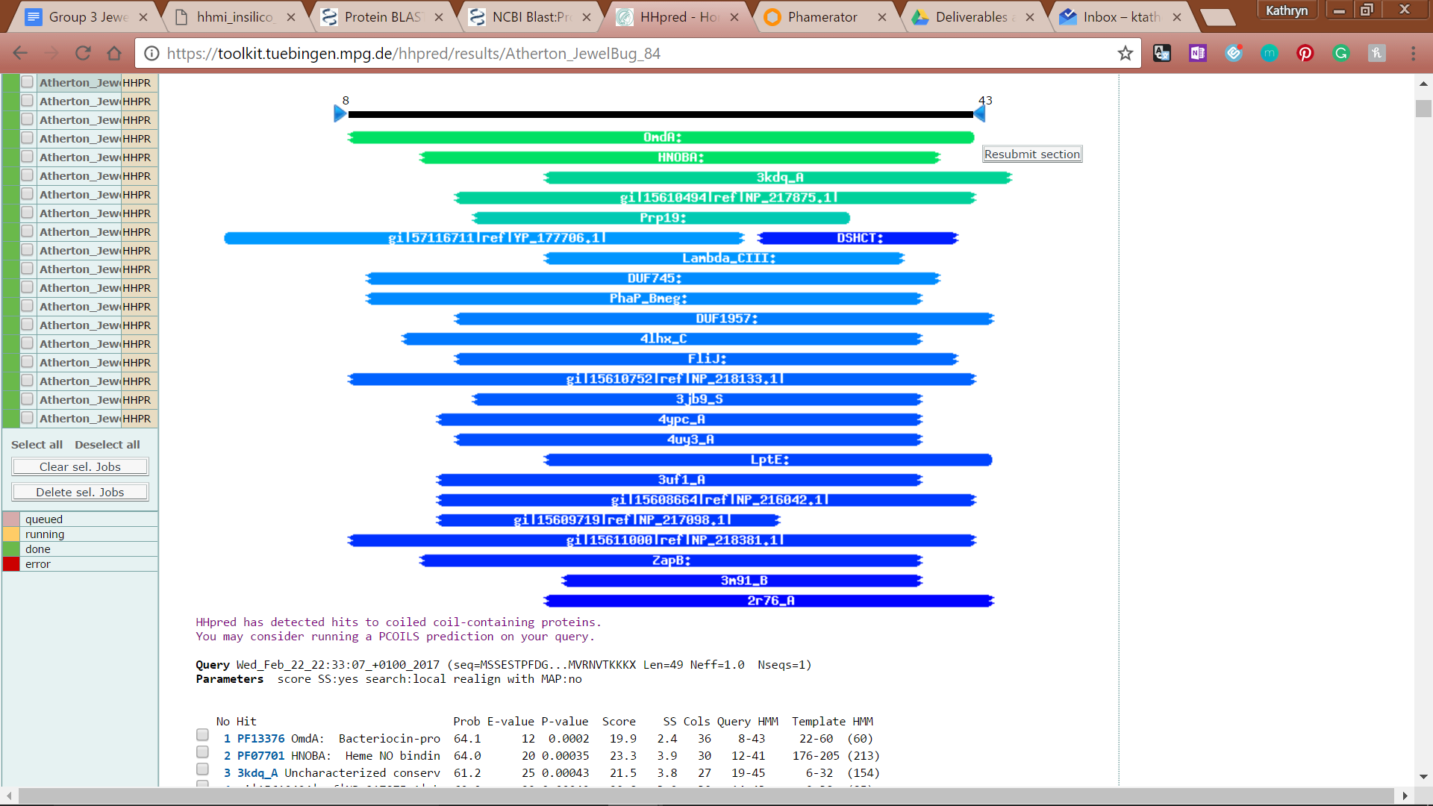

**Figure 259: Feature 84, HHPred Distribution List**

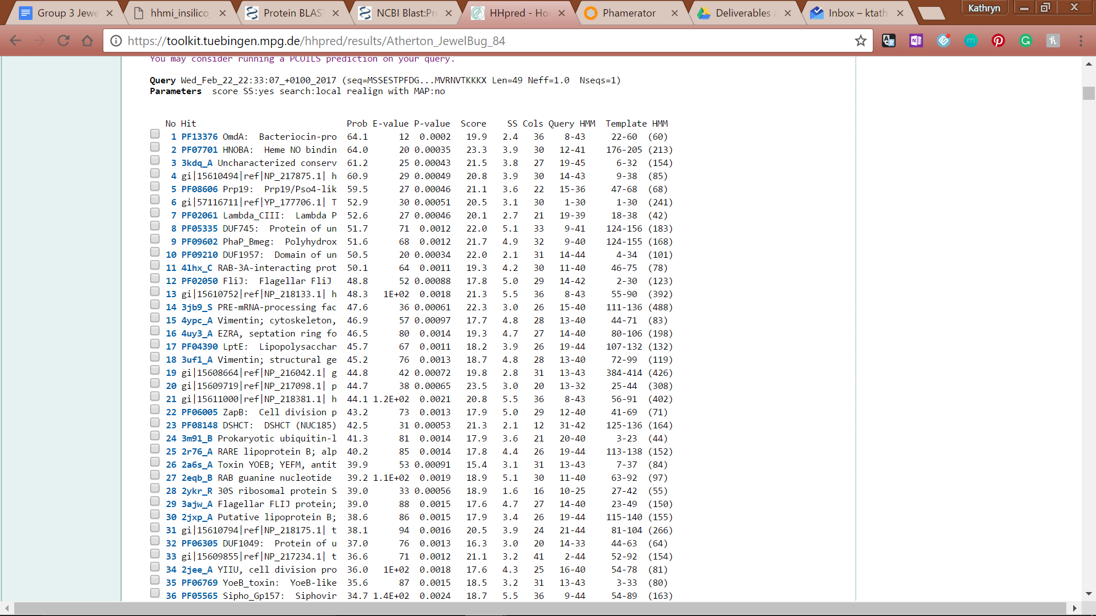

# 

# 

**Figure 260: Feature 84, HHPred Probabilities and Descriptions**

# 

# Feature 85

**Table 20: Feature 85 Data**

|  |  |  |  |  |  |  |  |  |  |
| --- | --- | --- | --- | --- | --- | --- | --- | --- | --- |
| **Feature:** 85 | **3' End:** 47591 | **5' End:** 48301 | | | **Length:** 711 | | **Original Call:** | **Glimmer:** 48301 | |
| **GeneMark:** 48301 | |
| **Start / Stop Codon (SSC):** | | | | | | **Start:** ATG | | | |
| **Stop:** TGA; REV | | | |
| **Longest Open Reading Frame (LO):** 711 bp | | | | | | | | | Longest |
| **Shine Dalgarno (SD):** -4.297 / -5.054 | | | | | | | | | Not Highest |
| **Start Choice Source (SCS):** | | | | **Called by Glimmer:** Yes, 48301 | | | | | |
| **Called by GeneMark**: Yes, 48301 | | | | | |
| **Coding Potential (CP):** all captured | | | | | | | | | |
| **Gap / Overlap:** 3 bp gap following gene | | | | | | | | | |
| **BLASTp:** hypothetical protein PBI_CLOUDWANG3_101 | | | | | | | | | |
| **Function (F):** No known function | | | | | | | | | |
| **Function Source (FS):** | | | **Phamerator:** no function noted in similar phages | | | | | | |
| **BLASTp:** gp102 from Blue7 (unknown function) | | | | | | |
| **HHPred:** no significant results found | | | | | | |
| **Comments:** this start site was chosen because it has the longest ORF and it eliminates the most gaps (the next longest ORF would have had over 50 bp gap with feature 84). In addition the BLAST results were the best for this ORF with 100% alignment and high similarity and identity as well. | | | | | | | | | |

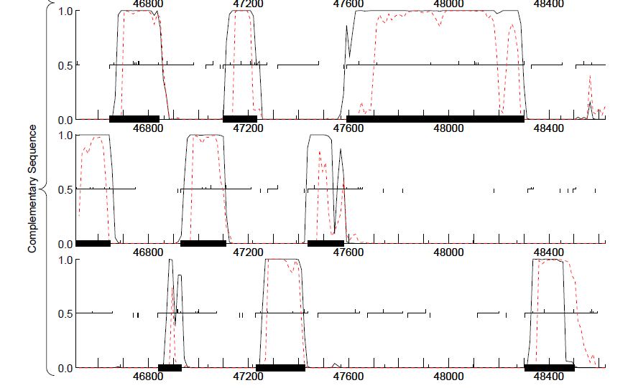

**Figure 261: Feature 85, GeneMark Map**

Feature 85 GeneMark is found in the first complementary sequence ORF from the GeneMark map. All of the coding potential is captured and there are no significant gaps or overlaps between ORFs.



**Figure 262: Feature 85, JewelBug vs. CloudWang3 Phamerator Map**

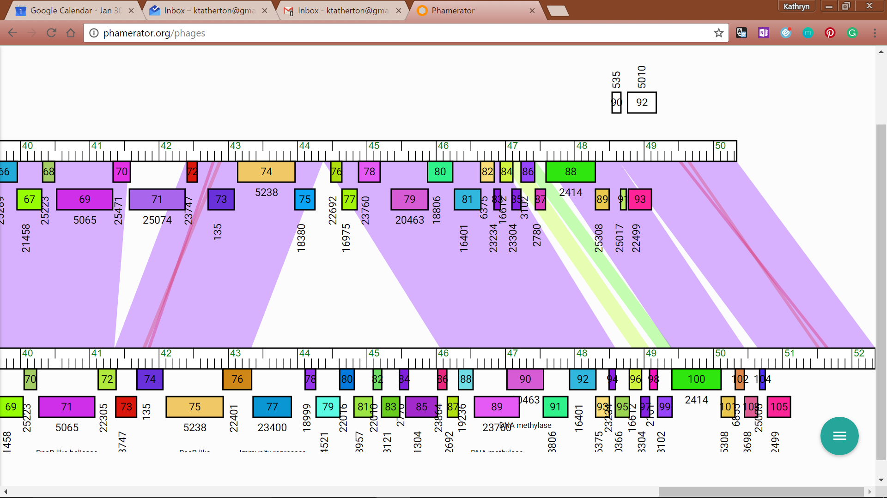

**Figure 263: Feature85, JewelBug vs. Artemus2UCLA Phamerator Map**

Gene 88 in Phamerator, JewelBug in the Phamerator map has 100% alignment with feature 101 in CloudWang3 (left), feature 100 in Artemus2UCLA (right), and others in the same family (not pictured).

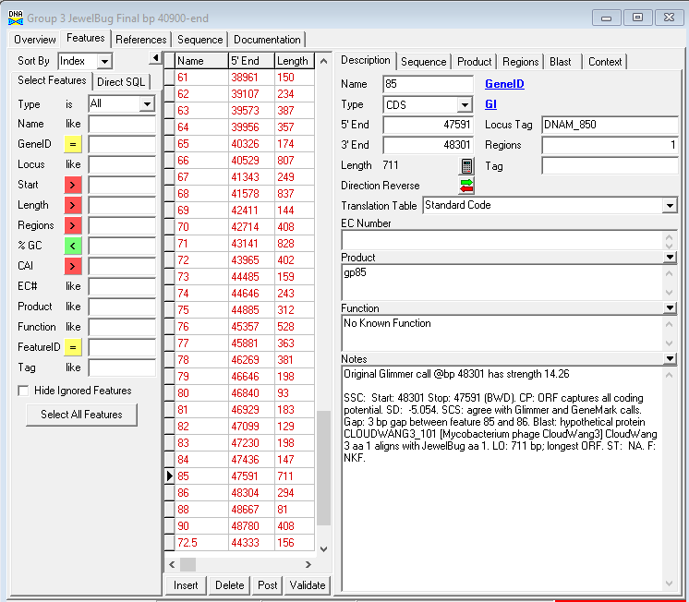

**Figure 264: Feature 85, Feature Window**

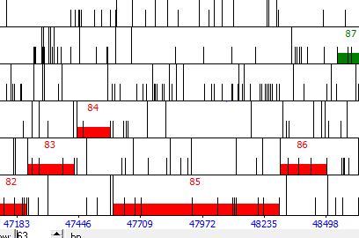

**Figure 265: Feature 85, Frame Window**

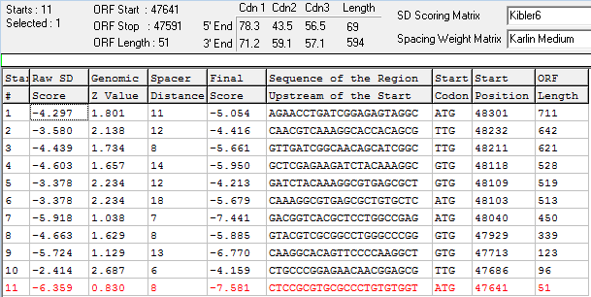

**Figure 266: Feature 85, Choose Start Window**

There are 11 potential start sites for this feature, the original call was for start site 1 which is the longest ORF.

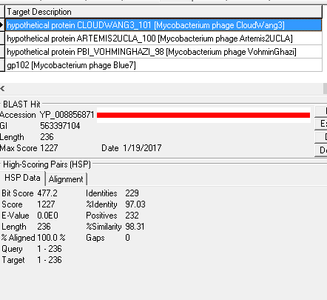

**Figure 267: Feature 85, HSP Data**

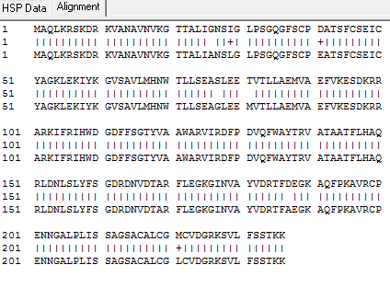

**Figure 268: Feature 85, Alignment**

The BLAST shows 100% alignment for the first several hits and high identity and similarity to hypothetical proteins from CloudWang3, Artemis2UCLA, and VominGhazi.

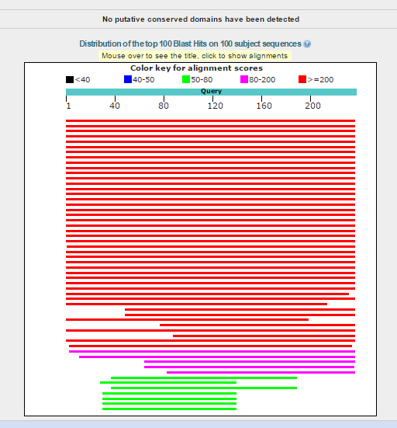

**Figure 269: Feature 85, BLASTp Conserved Domain**



**Figure 270: Feature 85, BLASTp Hits Distribution Table**

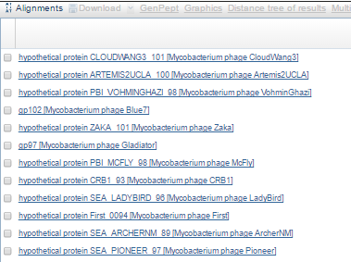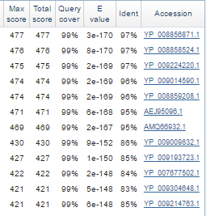

**Figure 271: Feature 85, BLASTp E-Values**

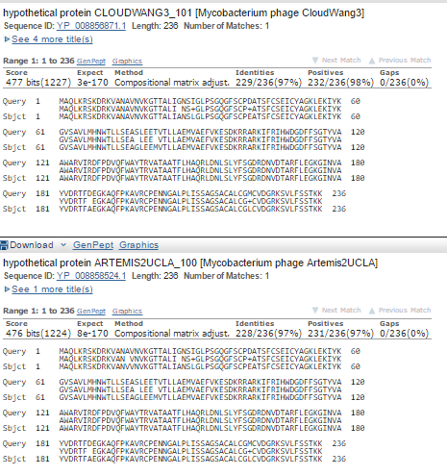

**Feature 272: Feature 85, BLASTp Alignments**

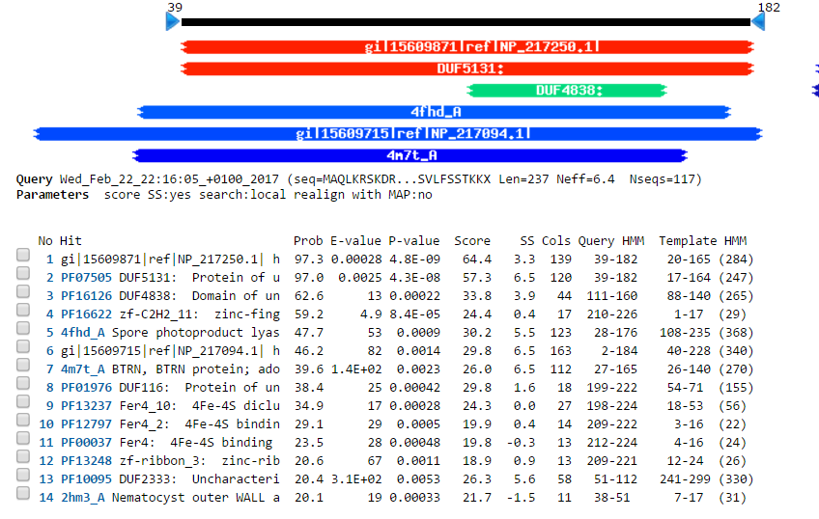

**Figure 273: Feature 85, HHPred Distribution List, Probabilities, and Descriptions**



**Figure 274: Feature 85, HHPred Probabilities and Descriptions**

# Feature 86

**Table 21: Feature 86 Data**

|  |  |  |  |  |  |  |  |  |  |
| --- | --- | --- | --- | --- | --- | --- | --- | --- | --- |
| **Feature:** 86 | **3' End:** 48304 | **5' End:** 48501 | | | **Length:** 198 | | **Original Call:** | **Glimmer:** 48501 | |
| **GeneMark:** 48501 | |
| **Start / Stop Codon (SSC):** | | | | | | **Start:** ATG | | | |
| **Stop:** TAG; REV | | | |
| **Longest Open Reading Frame (LO):** 198 bp | | | | | | | | | Not Longest |
| **Shine Dalgarno (SD):** -4.189 / -4.946 | | | | | | | | | Not Highest |
| **Start Choice Source (SCS):** | | | | **Called by Glimmer:** Yes, 48501 | | | | | |
| **Called by GeneMark**: Yes, 48501 | | | | | |
| **Coding Potential (CP):** all captured | | | | | | | | | |
| **Gap / Overlap:** 166 bp gap following gene | | | | | | | | | |
| **BLASTp:** hypothetical protein PBI_ARTEMIS2UCLA_101 | | | | | | | | | |
| **Function (F):** No known function | | | | | | | | | |
| **Function Source (FS):** | | | **Phamerator:** no noted functions in similar phages | | | | | | |
| **BLASTp:** gp93 from PackMan (unknown function) | | | | | | |
| **HHPred:** no significant results found | | | | | | |
| **Comments:** The BLAST data best supports the original call by Glimmer and GeneMark. | | | | | | | | | |

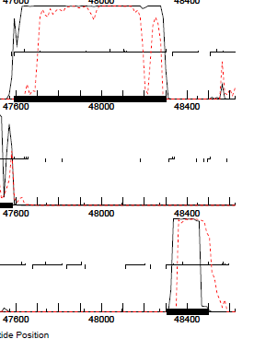

**Figure 275: Feature 86, GeneMark Map**

The coding potential for feature 86 is all captured from 48597 to 48304.



**Figure 276: Feature 86, JewelBug vs. Artemis2UCLA Phamerator Map**

In the Phamerator Map feature 89 of JewelBug matches with feature 101 of Artemis2UCLA

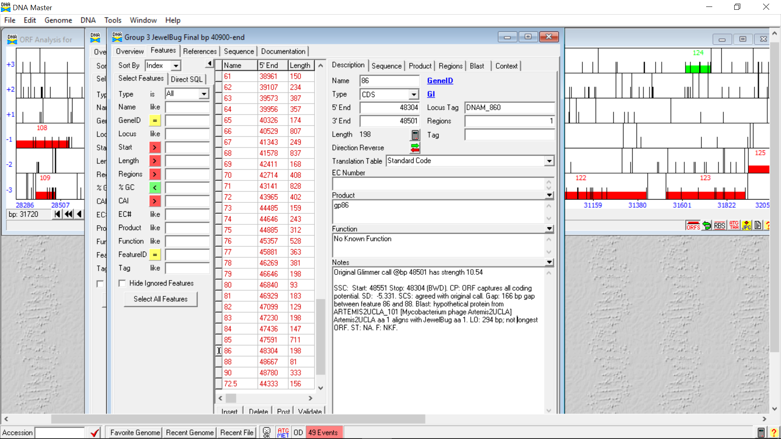

**Figure 277: Feature 86, Feature Window**

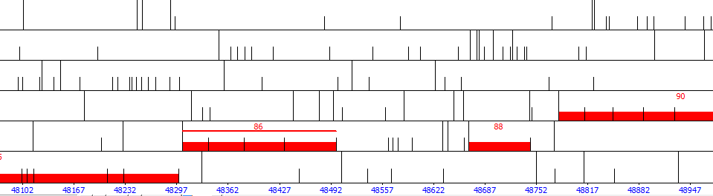

**Figure 278: Feature 86, Frame Window**

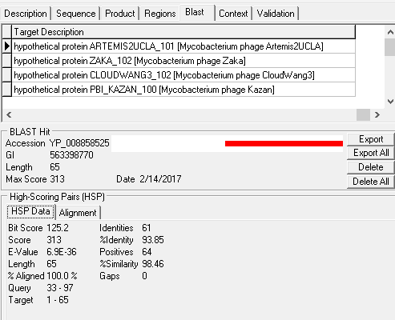

**Figure 279: Feature 86, HSP Data**

There is high identity and similarity with a theoretical protein from Artemis2UCLA.

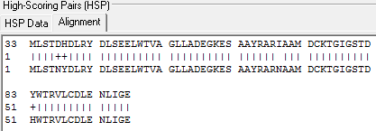

**Figure 280: Feature 86, Alignment**

Residue 33 of JewelBug feature 86 aligns with residue 1 of Artemis2UCLA hypothetical protein, suggesting that shorter start sites should be considered.

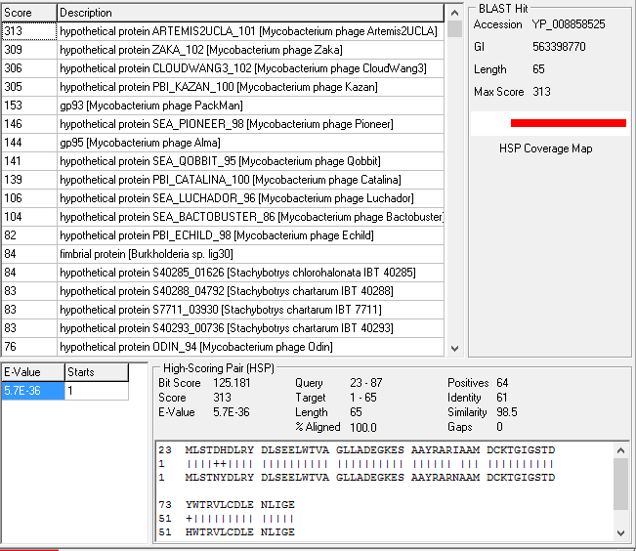

**Figure X: Feature 86, BLAST: Start 4**

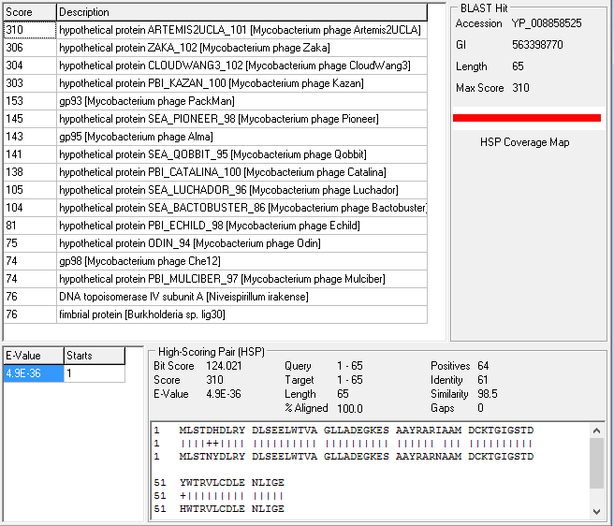

**Figure X: Feature 86, BLAST: Start 5**

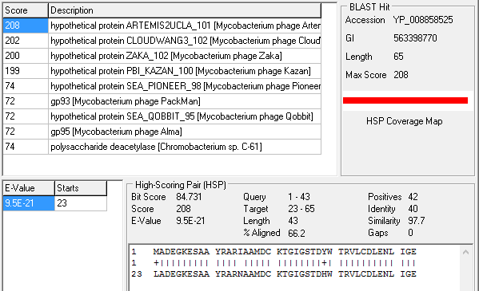

**Figure X: Feature 86, BLAST: Start 6**

The BLAST best support start 5. When BLASTing starts 1 – 6, the top four BLAST hits remain the same, four proteins from phages in the A6 cluster. All four of these proteins have aa 1 aligning with aa 1 of Feature 86 of JewelBug when called at Start 5. This suggests that extending the start site beyond the coding potential to increase gene density is not supported by proteins in the same cluster.



**Figure 281: Feature 86, Conserved Domain**

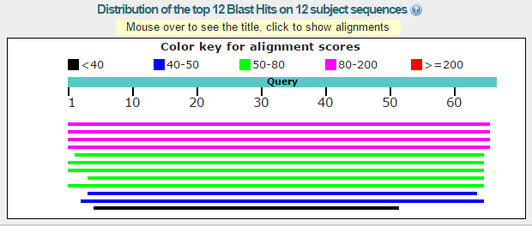

**Figure 282: Feature 86, BLASTp Hits Distribution Table**

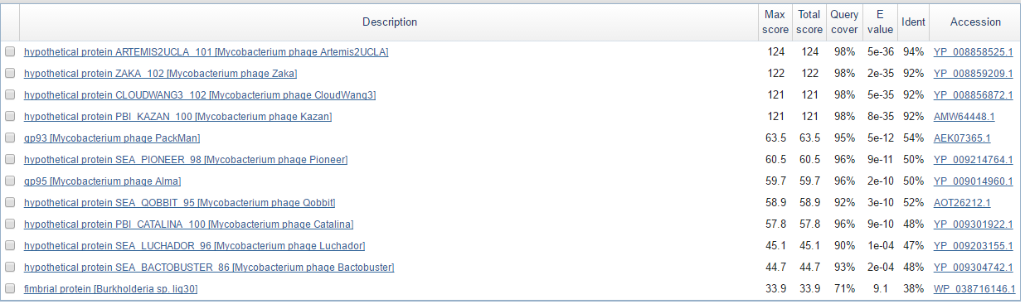

**Figure 283: Feature 86, BLASTp E-Values**

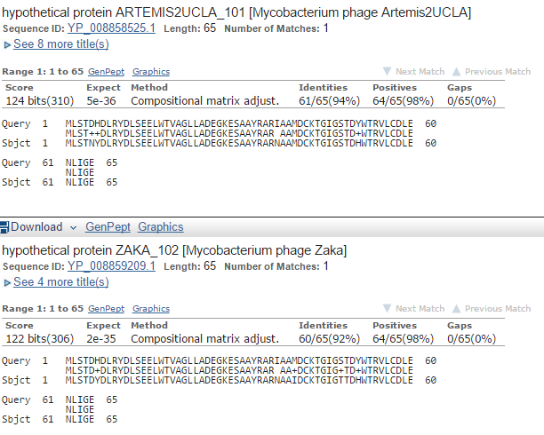

**Figure 284: Feature 86, BLASTp Alignments**

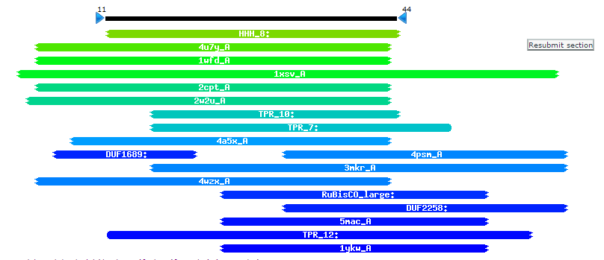

**Figure 285: Feature 86, HHPred Distribution List**

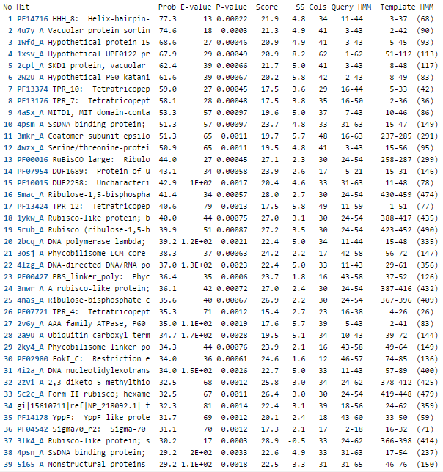

**Figure 286: Feature 86, HHPred Probabilities and Descriptions**

# Feature 87

**Table 22: Feature 87 Data**

|  |  |  |  |  |  |  |  |  |  |
| --- | --- | --- | --- | --- | --- | --- | --- | --- | --- |
| **Feature:** 87 | **3' End:** 48545 | **5' End:** 48670 | | | **Length:** 126 | | **Original Call:** | **Glimmer:** 48545 | |
| **GeneMark:** N/A | |
| **Start / Stop Codon (SSC):** | | | | | | **Start:** GTG | | | |
| **Stop:** TAG; REV | | | |
| **Longest Open Reading Frame (LO):** 306 bp | | | | | | | | | Not Longest |
| **Shine Dalgarno (SD):** -2.814 / -4.416 | | | | | | | | | Not Highest |
| **Start Choice Source (SCS):** | | | | **Called by Glimmer:** Yes, 48545 | | | | | |
| **Called by GeneMark**: No | | | | | |
| **Coding Potential (CP):** no coding potential in the corresponding ORF | | | | | | | | | |
| **Gap / Overlap:** N/A | | | | | | | | | |
| **BLASTp:** No BLASTp results | | | | | | | | | |
| **Function (F):** N/A | | | | | | | | | |
| **Function Source (FS):** | | | **Phamerator:** N/A | | | | | | |
| **BLASTp:** N/A | | | | | | |
| **HHPred:** N/A | | | | | | |
| **Comments:** Feature 87 will be deleted because there is no coding potential in GeneMark, no BLAST results, and no 50 bp gap before the start on complementary strand | | | | | | | | | |

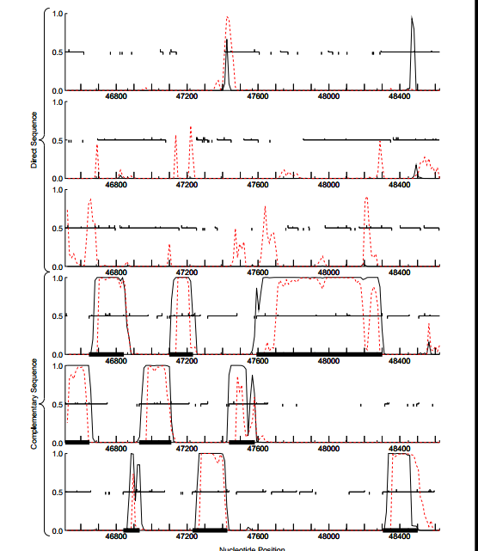

**Figure 287: Feature 87, GeneMark Map**

No significant coding potential is present in the second direct sequence; therefore, the evidence does not support the existence of this gene.

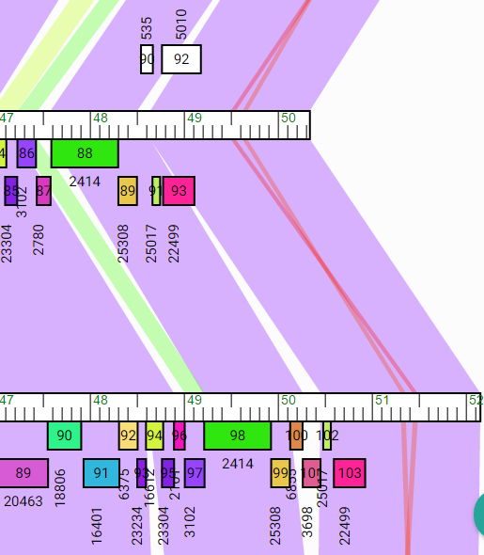

**Figure 288: Feature 87, JewelBug vs. VohminGhazi Phamerator Map**

Gene 90 (corresponding to Feature 87) is not supported by Phamerator as none of the non-draft genomes have genes running in the forward direction at the end of the genomes. Above is JewelBug (top) and VohminGhazi (bottom), one of the best matches for this region of the genome, illustrating the absence of forward running genes in this section.

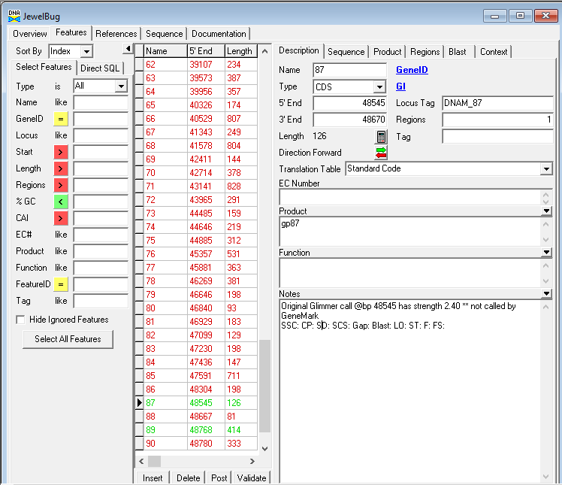

**Figure 289: Feature 87, Feature Window**

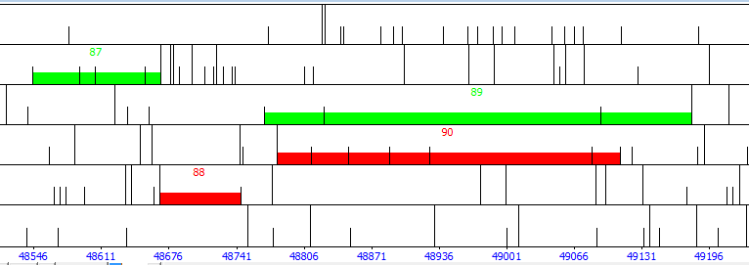

**Figure 290: Feature 87, Frame Window**

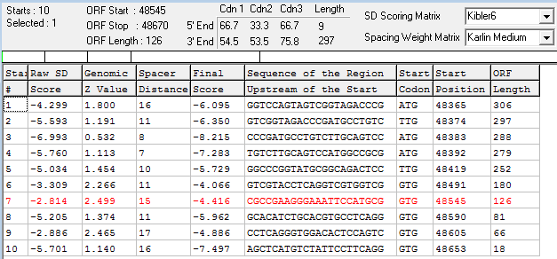

**Figure 291: Feature 87, Choose Start Window**

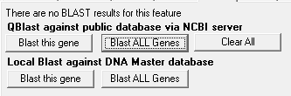

**Figure 292: Feature 87, HSP Data**

There are no BLAST results from DNA Master.

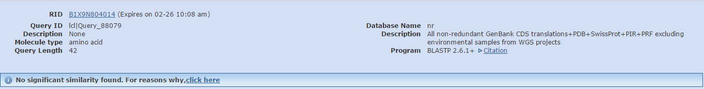

**Figure 293: Feature 87, BLASTp Hits Distribution Table**

NCBI BLASTp returned no matches.



**Figure 294: Feature 87, HHPred Distribution List**

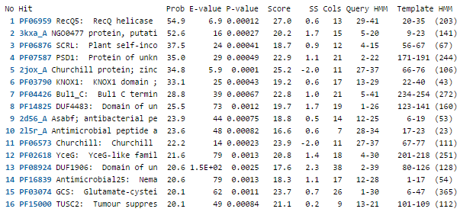

**Figure 295: Feature 87, HHPred Probabilities and Descriptions**

There are no significant matches as the best E-value is 6.9.

# Feature 88

**Table 23: Feature 88 Data**

|  |  |  |  |  |  |  |  |  |  |
| --- | --- | --- | --- | --- | --- | --- | --- | --- | --- |
| **Feature:** 88 | **3' End:** 48667 | **5' End:** 48747 | | | **Length:** 81 | | **Original Call:** | **Glimmer:** 48747 | |
| **GeneMark:** 48747 | |
| **Start / Stop Codon (SSC):** | | | | | | **Start:** GTG | | | |
| **Stop:** TAG; REV | | | |
| **Longest Open Reading Frame (LO):** 81 bp | | | | | | | | | Longest |
| **Shine Dalgarno (SD):** -2.814 / -3.571 | | | | | | | | | Highest |
| **Start Choice Source (SCS):** | | | | **Called by Glimmer:** Yes, 48747 | | | | | |
| **Called by GeneMark**: Yes, 48747 | | | | | |
| **Coding Potential (CP):** all covered | | | | | | | | | |
| **Gap / Overlap:** 33 bp gap following feature | | | | | | | | | |
| **BLASTp:** hypothetical protein PBI_CLOUDWANG_105 | | | | | | | | | |
| **Function (F):** No known function | | | | | | | | | |
| **Function Source (FS):** | | | **Phamerator:** no noted functions in similar phages | | | | | | |
| **BLASTp:** hypothetical protein | | | | | | |
| **HHPred:** no significant results found | | | | | | |
| **Comments:** Although this feature only has one BLAST result, evidence including coding potential in the GeneMark Map and similarity between other phages in the Phamerator Map supports this small protein’s existence. | | | | | | | | | |

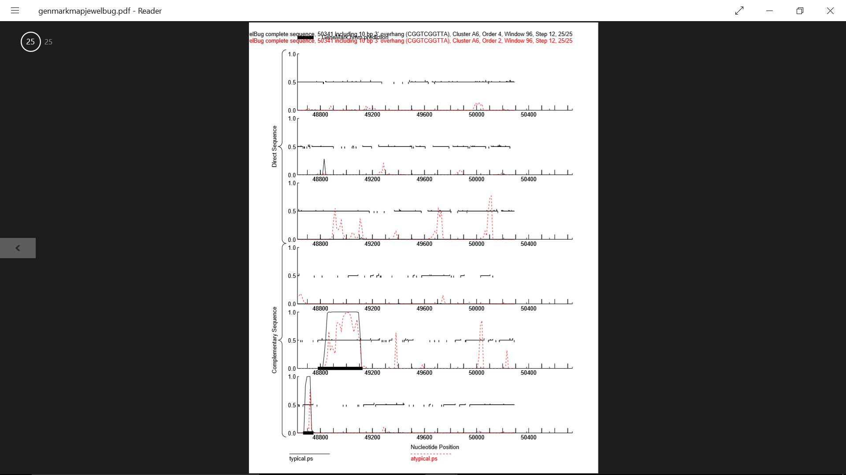

**Figure 296: Feature 88, GeneMark Map**

The bottom left corner (complementary sequence 3) shows a small spike of coding potential in the area in which feature 88 is called.

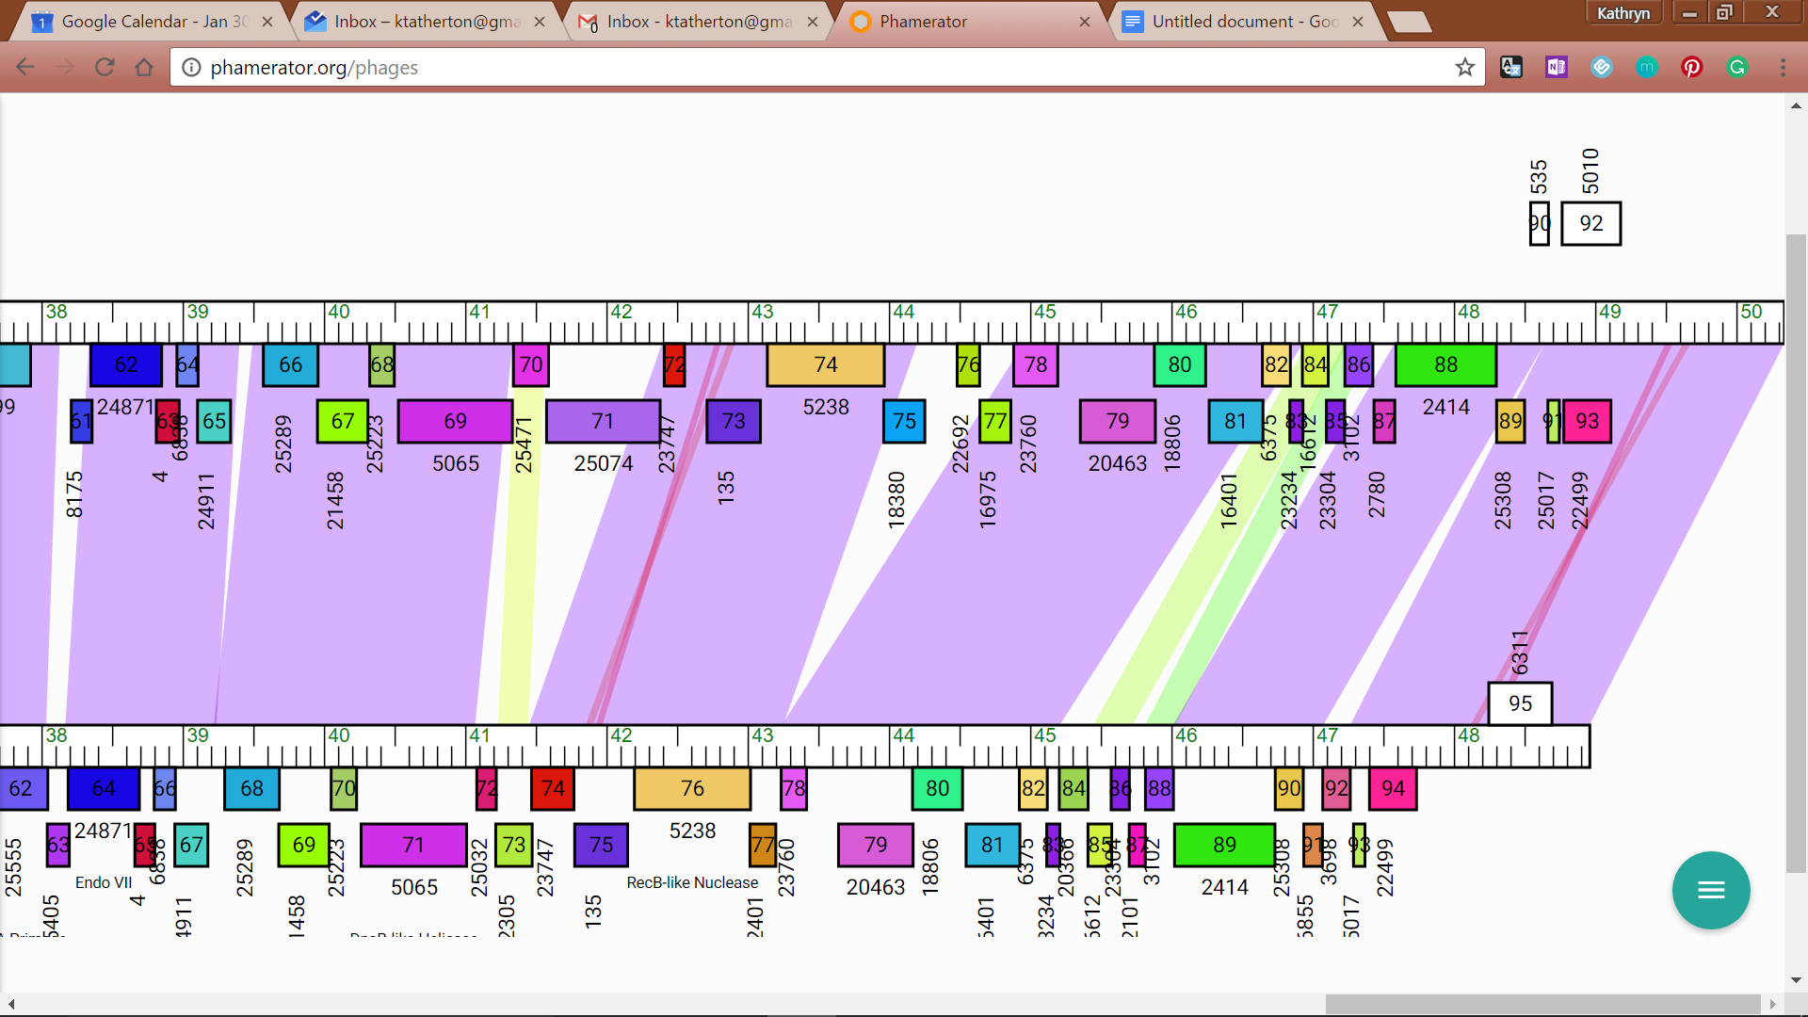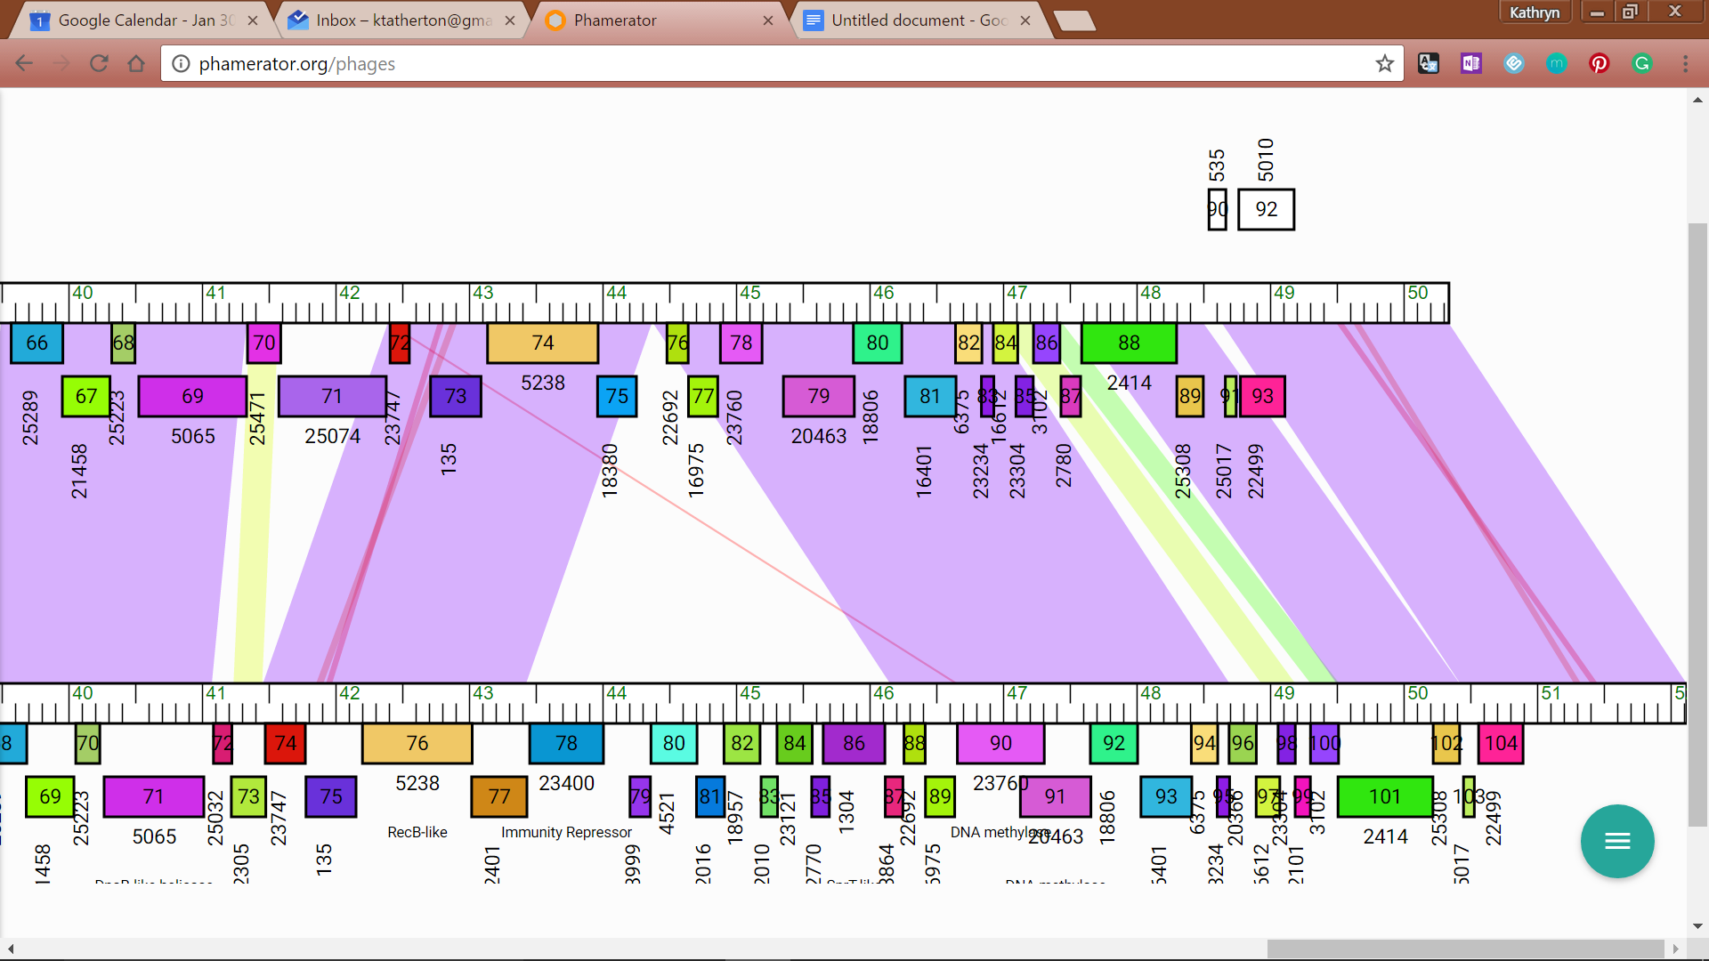

**Figure 297: Feature 88, JewelBug vs. JeffaBunny and Zaka Phamerator Map**

JewelBug’s 91st feature in Phamerator (top line in both) shows a nearly perfect match with JeffaBunny (left) and Zaka in this area. This gene may be comparable to JeffaBunny’s 93rd feature and Zaka’s 103rd feature.

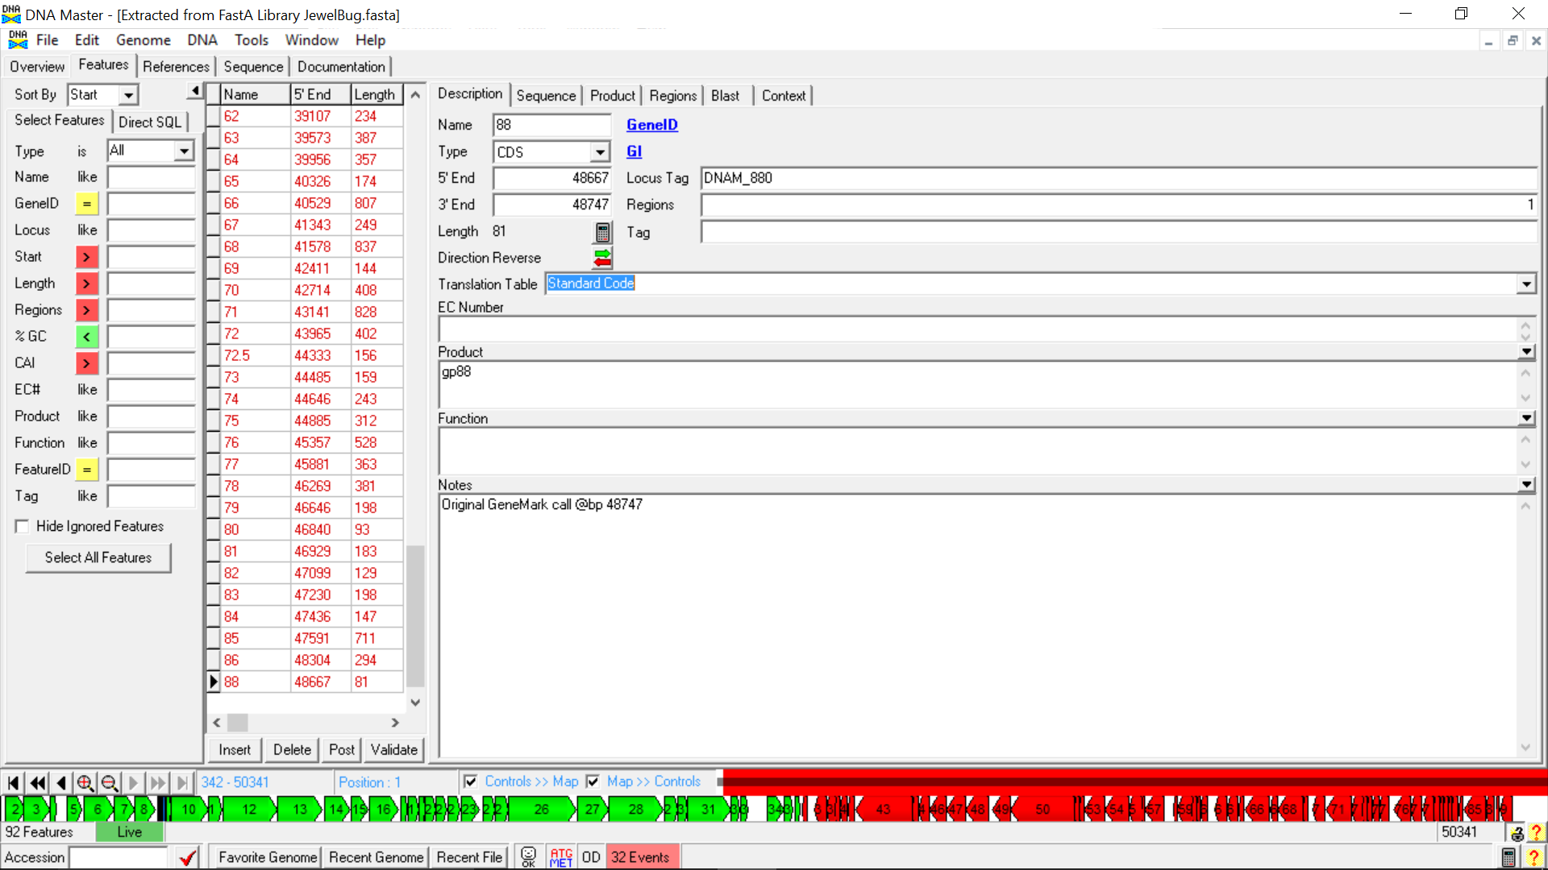**Figure 298: Feature 88, Feature Window**

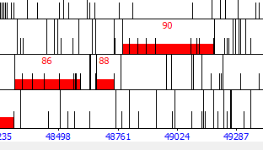

**Figure 299: Feature 88, Frame Window**

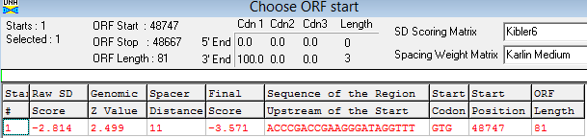

**Feature 300: Feature 88, Choose Start Window**

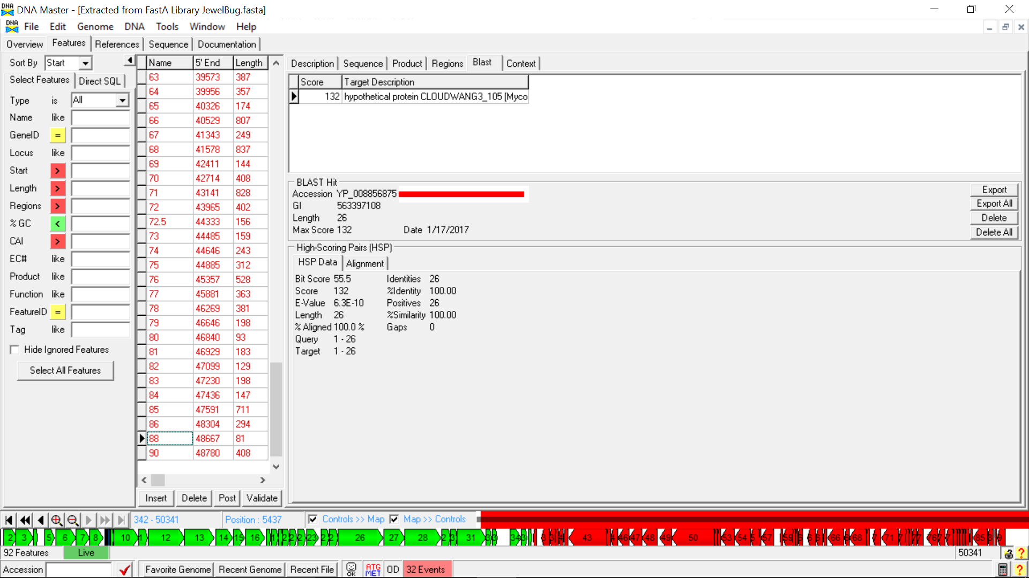

**Figure 301: Feature 88, HSP Data**

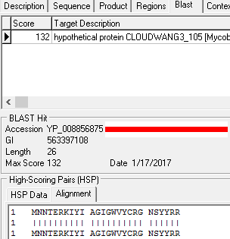

**Figure 302: Feature 88, Alignment**

Though there is only a single BLAST result, the Alignment, Identity, and Similarity all are 100%, making the evidence for this gene strong for only having one BLAST.



**Figure 303: Feature 88, Conserved Domain**

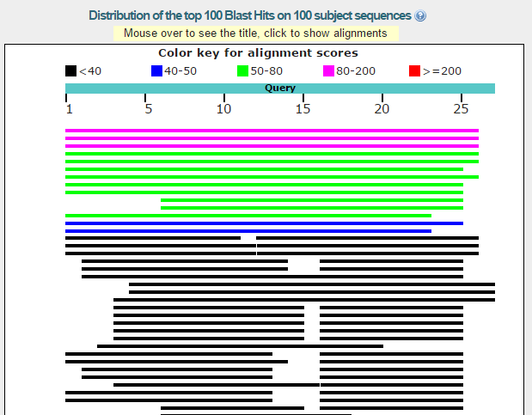

**Figure 304: Feature 88, BLASTp Hits Distribution Table**

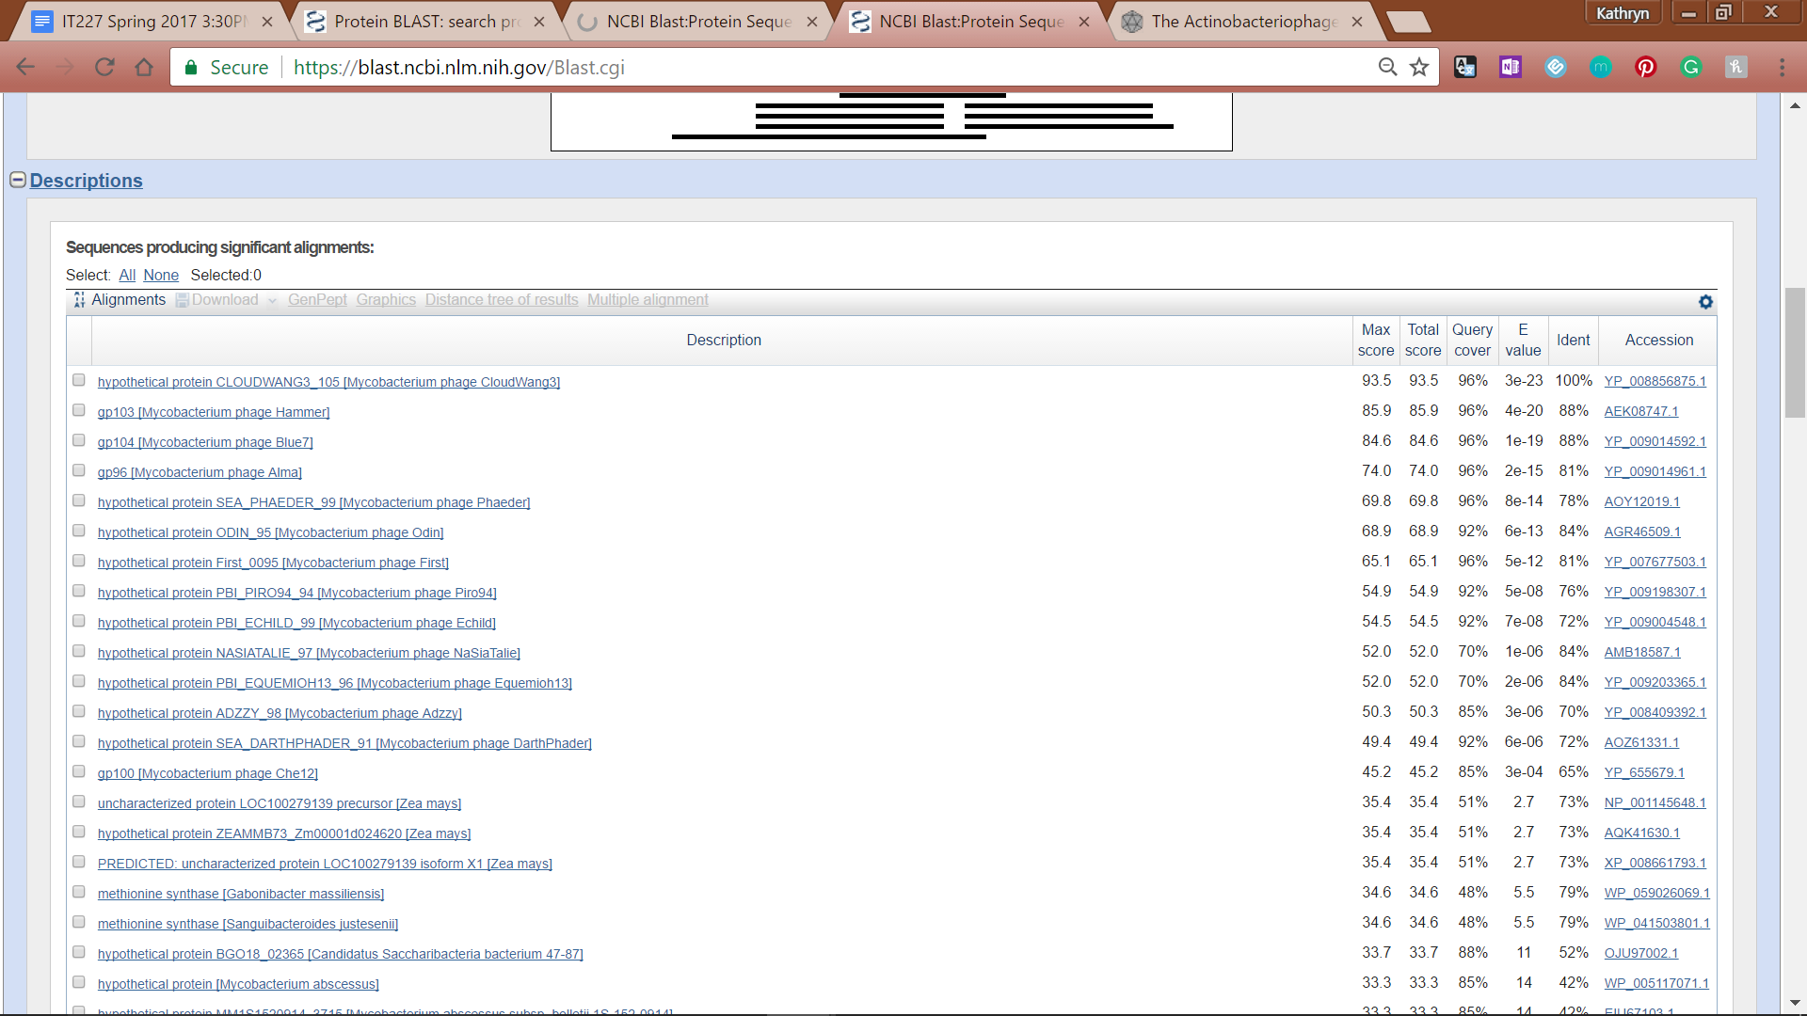

**Figure 305: Feature 88, BLASTp E-Values**

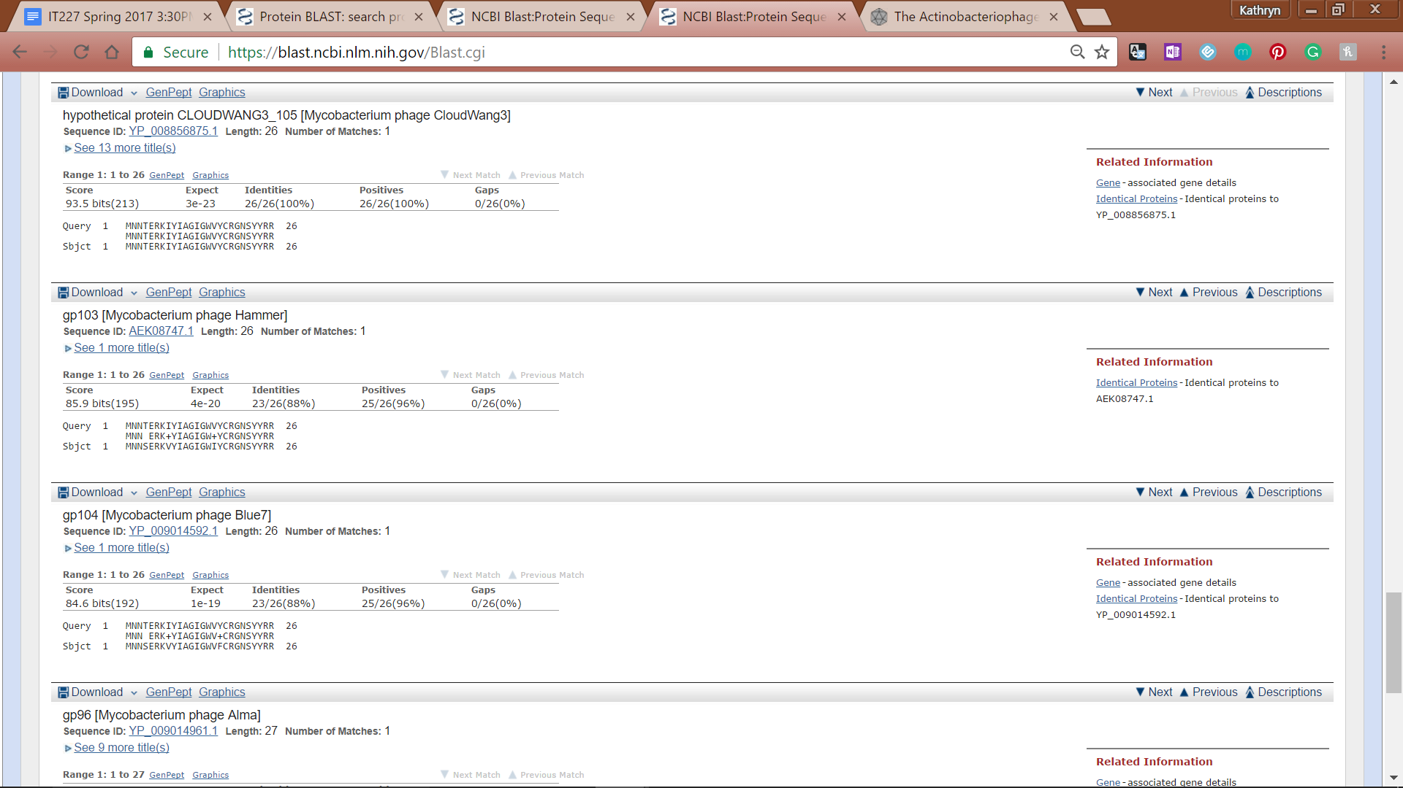

**Figure 306: Feature 88, BLASTp Alignments**

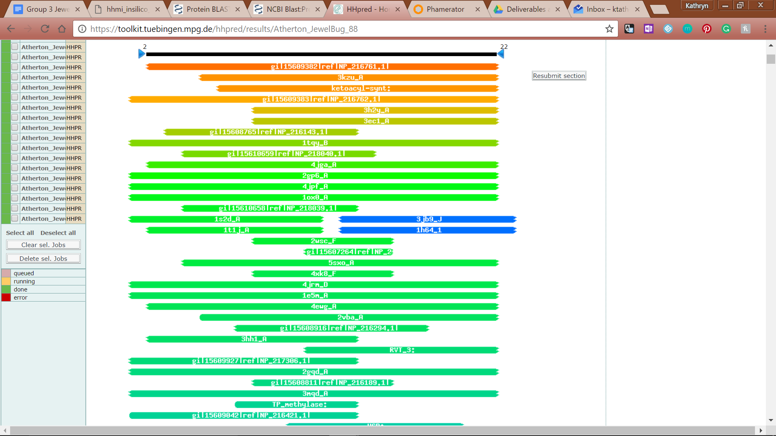

**Figure 307: HHPred Distribution List**

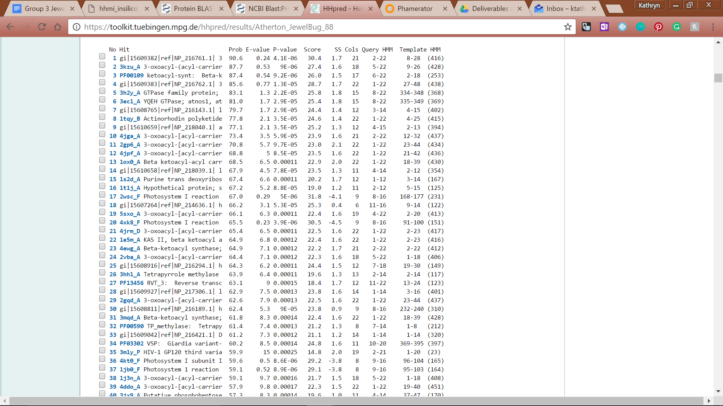

**Figure 308: HHPred Probabilities and Descriptions**

# 

# 

# Feature 89

**Table 24: Feature 89 Data**

|  |  |  |  |  |  |  |  |  |  |
| --- | --- | --- | --- | --- | --- | --- | --- | --- | --- |
| **Feature:** 89 | **3' End:** 48768 | **5' End:** 49181 | | | **Length:** 414 | | **Original Call:** | **Glimmer:** 48768 | |
| **GeneMark:** N/A | |
| **Start / Stop Codon (SSC):** | | | | | | **Start:** GTG | | | |
| **Stop:** TGA; REV | | | |
| **Longest Open Reading Frame (LO):** 546 bp | | | | | | | | | Not Longest |
| **Shine Dalgarno (SD):** -6.188 / -7.932 | | | | | | | | | Not Highest |
| **Start Choice Source (SCS):** | | | | **Called by Glimmer:** Yes, 48768 | | | | | |
| **Called by GeneMark**: No | | | | | |
| **Coding Potential (CP):** no coding potential in the corresponding ORF | | | | | | | | | |
| **Gap / Overlap:** N/A | | | | | | | | | |
| **BLASTp:** DUF4440 domain-containing protein [Nitrosospira briensis] | | | | | | | | | |
| **Function (F):** N/A | | | | | | | | | |
| **Function Source (FS):** | | | **Phamerator:** N/A | | | | | | |
| **BLASTp:** N/A | | | | | | |
| **HHPred:** N/A | | | | | | |
| **Comments:** Feature 89 will be deleted because there is no coding potential in GeneMark, poor BLAST results, and no 50 bp gap before the start on complementary strand | | | | | | | | | |

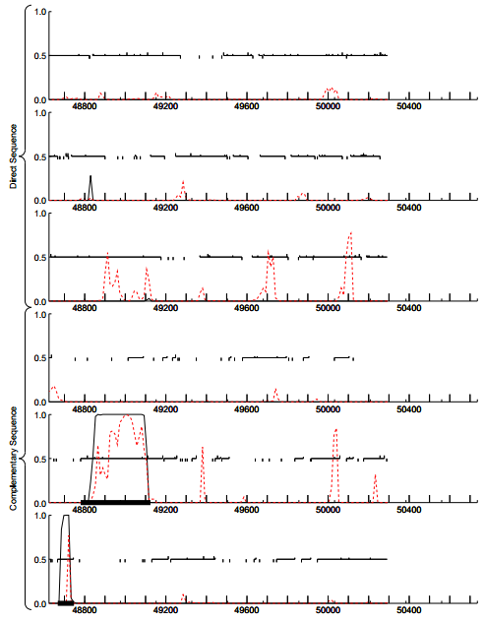

**Figure 309: Feature 89, GeneMark Map**

No significant coding potential is present in the third direct sequence; therefore, the evidence does not support the existence of this gene.



**Figure 310: Feature 89, JewelBug v.s VohminGhazi Phamerator Map**

Gene 92 (corresponding to Feature 89) is not supported by Phamerator as none of the non-draft genomes have genes running in the forward direction at the end of the genomes. Above is JewelBug (top) and VohminGhazi (bottom), one of the best matches for this region of the genome, illustrating the absence of forward running genes in this section.

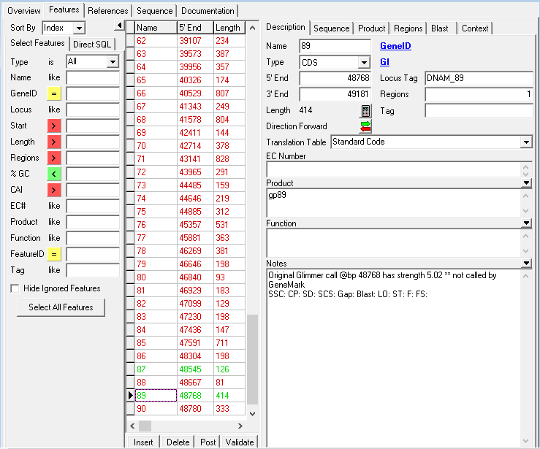

**Figure 311: Feature 89, Feature Window**

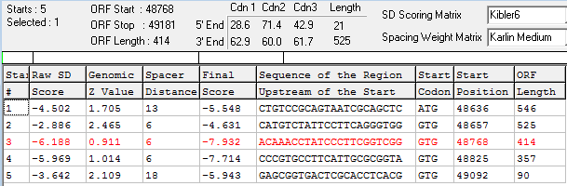

**Figure 312: Feature 89, Choose Start Window**

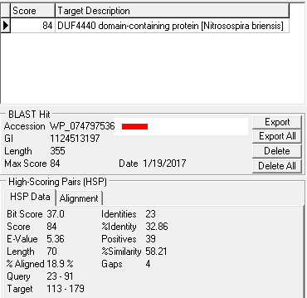

**Figure 313: Feature 89, HSP Data**

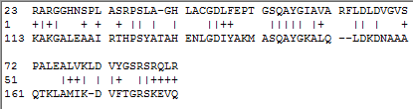

**Figure 314: Feature 89, Alignment**

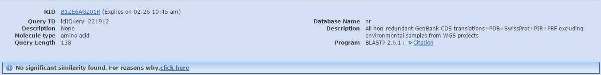

**Figure 315: Feature 89, BLASTp Hits Distribution List**

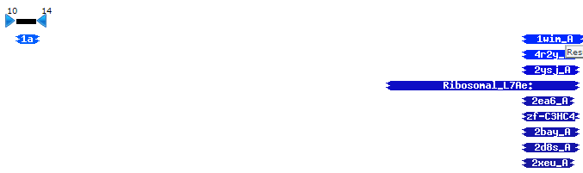

**Figure 316: Feature 89, HHPred Distribution List**

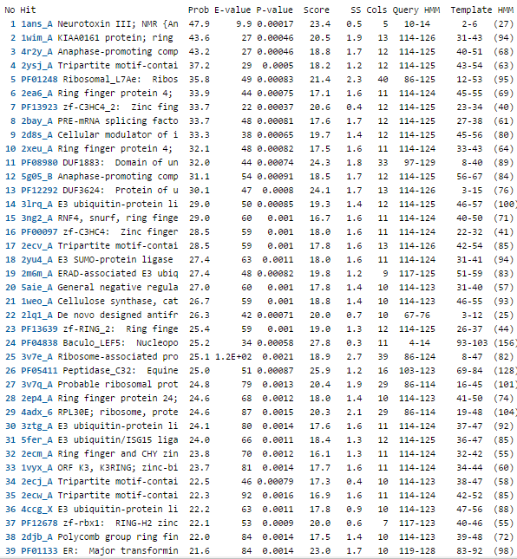

**Figure 317: Feature 89, HHPred Probabilities and Descriptions**

No significant matches are returned via NCBI BLASTp nor HHPred.

# Feature 90

**Table 25: Feature 90 Data**

|  |  |  |  |  |  |  |  |  |  |
| --- | --- | --- | --- | --- | --- | --- | --- | --- | --- |
| **Feature:** 90 | **3' End:** 48780 | **5' End:** 49112 | | | **Length:** 333 | | **Original Call:** | **Glimmer:** 49112 | |
| **GeneMark:** 49112 | |
| **Start / Stop Codon (SSC):** | | | | | | **Start:** ATG | | | |
| **Stop:** TGA; REV | | | |
| **Longest Open Reading Frame (LO):** 408 bp | | | | | | | | | Not Longest |
| **Shine Dalgarno (SD):** -4.027 / -4.712 | | | | | | | | | Not Highest |
| **Start Choice Source (SCS):** | | | | **Called by Glimmer:** Yes, 49112 | | | | | |
| **Called by GeneMark**: Yes, 49112 | | | | | |
| **Coding Potential (CP):** all captured and extending beyond | | | | | | | | | |
| **Gap / Overlap:** 1229 bp gap following gene | | | | | | | | | |
| **BLASTp:** gp100 [Mycobacterium phage EricB] | | | | | | | | | |
| **Function (F):** No known function | | | | | | | | | |
| **Function Source (FS):** | | | **Phamerator:** no noted functions in similar phages | | | | | | |
| **BLASTp:** gp100 mycobacteriophage Eric B (unknown function) | | | | | | |
| **HHPred:** no significant results found | | | | | | |
| **Comments:** Agree with GeneMark and Glimmer. The ORF can be extended quite a bit, but this changes the alignment by about 26 amino acids for the worst for the call when extended. | | | | | | | | | |



**Figure 318: Feature 90, GeneMark Map**

In the second complementary frame, a large spike in coding potential is seen. It is in this area that Glimmer and GeneMark called feature 90.



**Figure 319: Feature 90, JewelBug vs. JeffaBunny Phamerator Map**

JewelBug Phamerator Map (top line). In the JewelBug vs. JeffaBunny comparison, Jewelbug’s feature 93 shows nearly perfect similarity to JeffaBunny’s feature 94. In all other comparisons, there is a gene similar to JewelBug’s feature 93, but there are gaps in similarity within the comparable features.

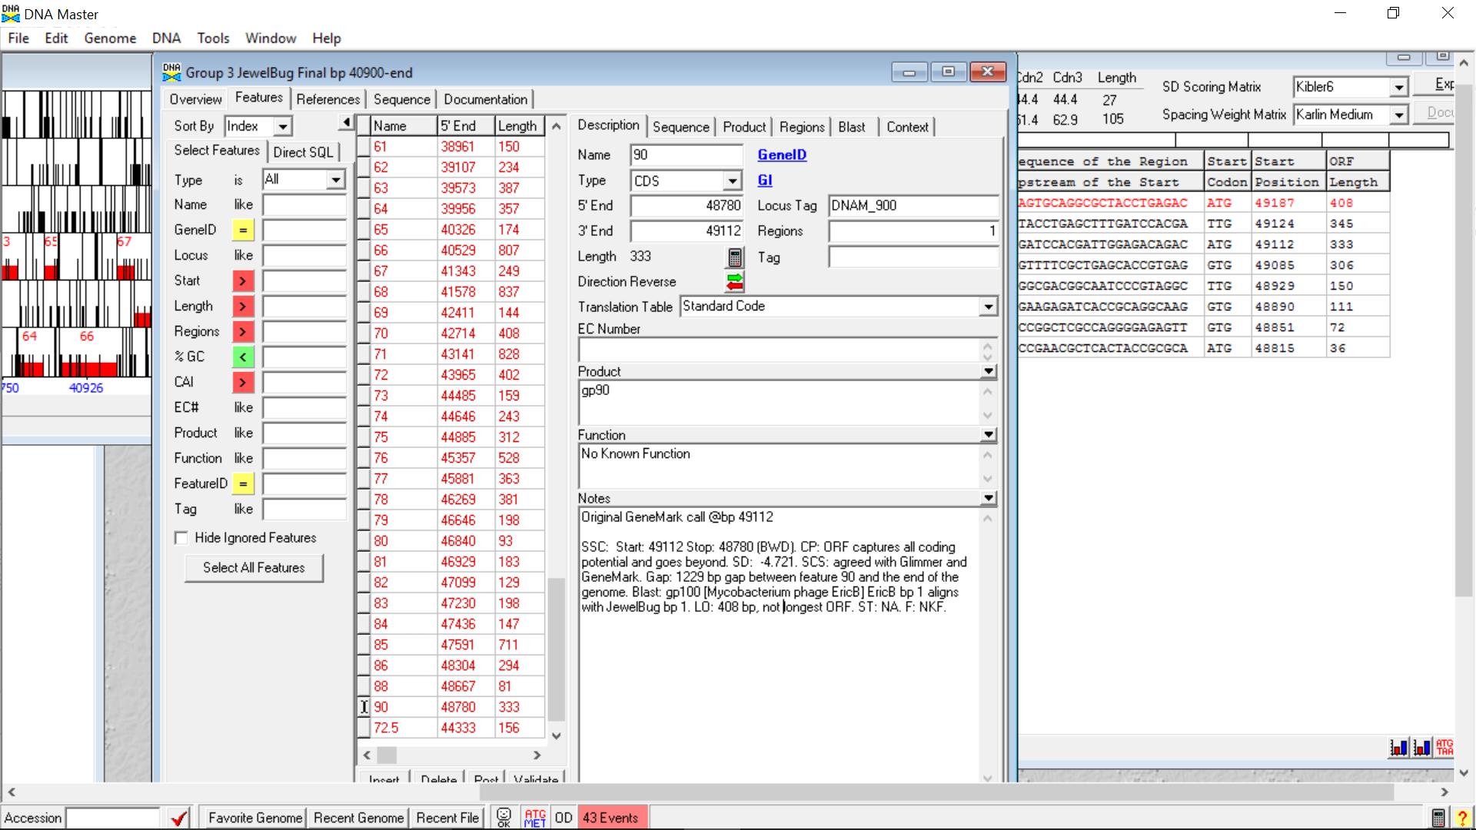

**Figure 320: Feature 90, Feature Window**

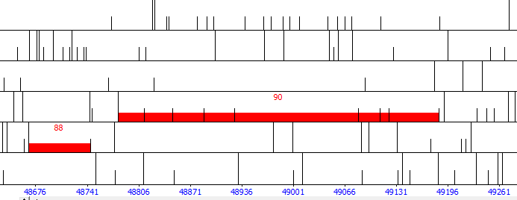

**Figure 321: Feature 90, Frame Window**

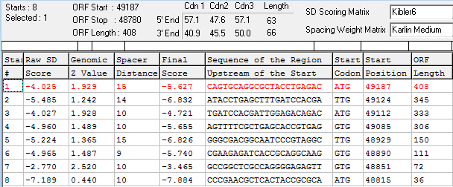

**Figure 322: Feature 90, Choose Start Window**

Eight possible start sites were found. Four were investigated: the original call, the two calls longer than the original, and the call with the highest SD score). The other calls both shortened the ORF and lowered the SD score of the gene, which goes against the guiding principles.

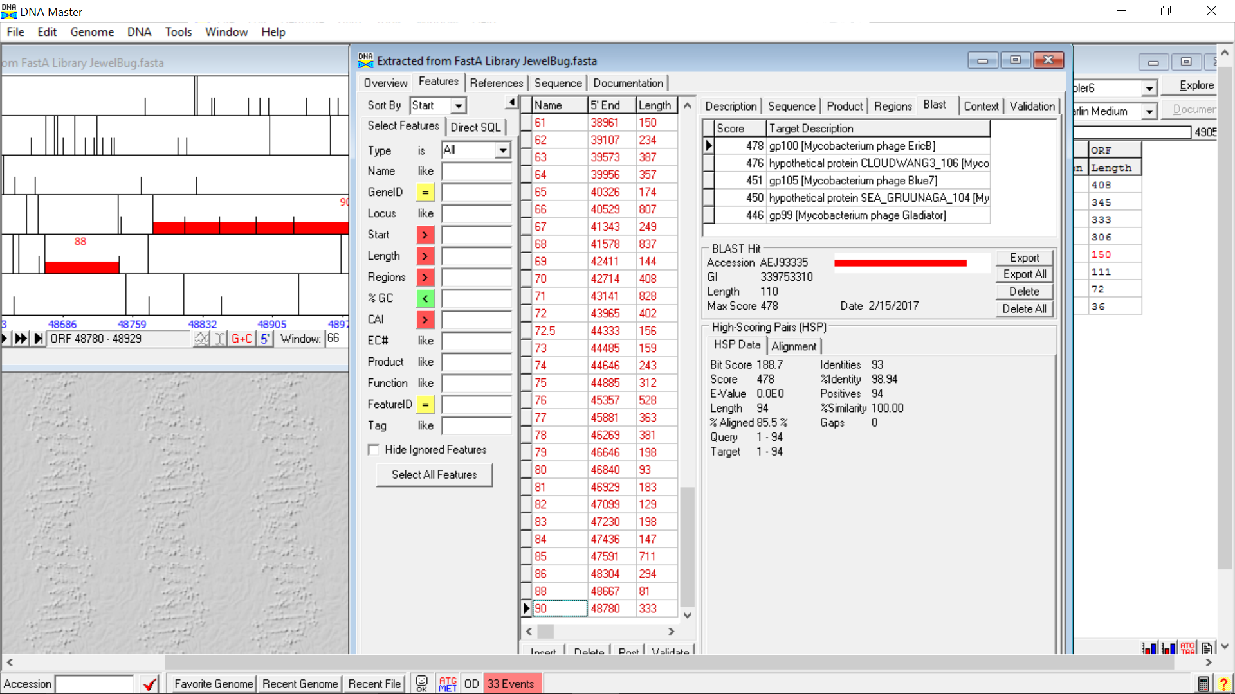

**Figure 323: Feature 90, HSP Data at Original Call**

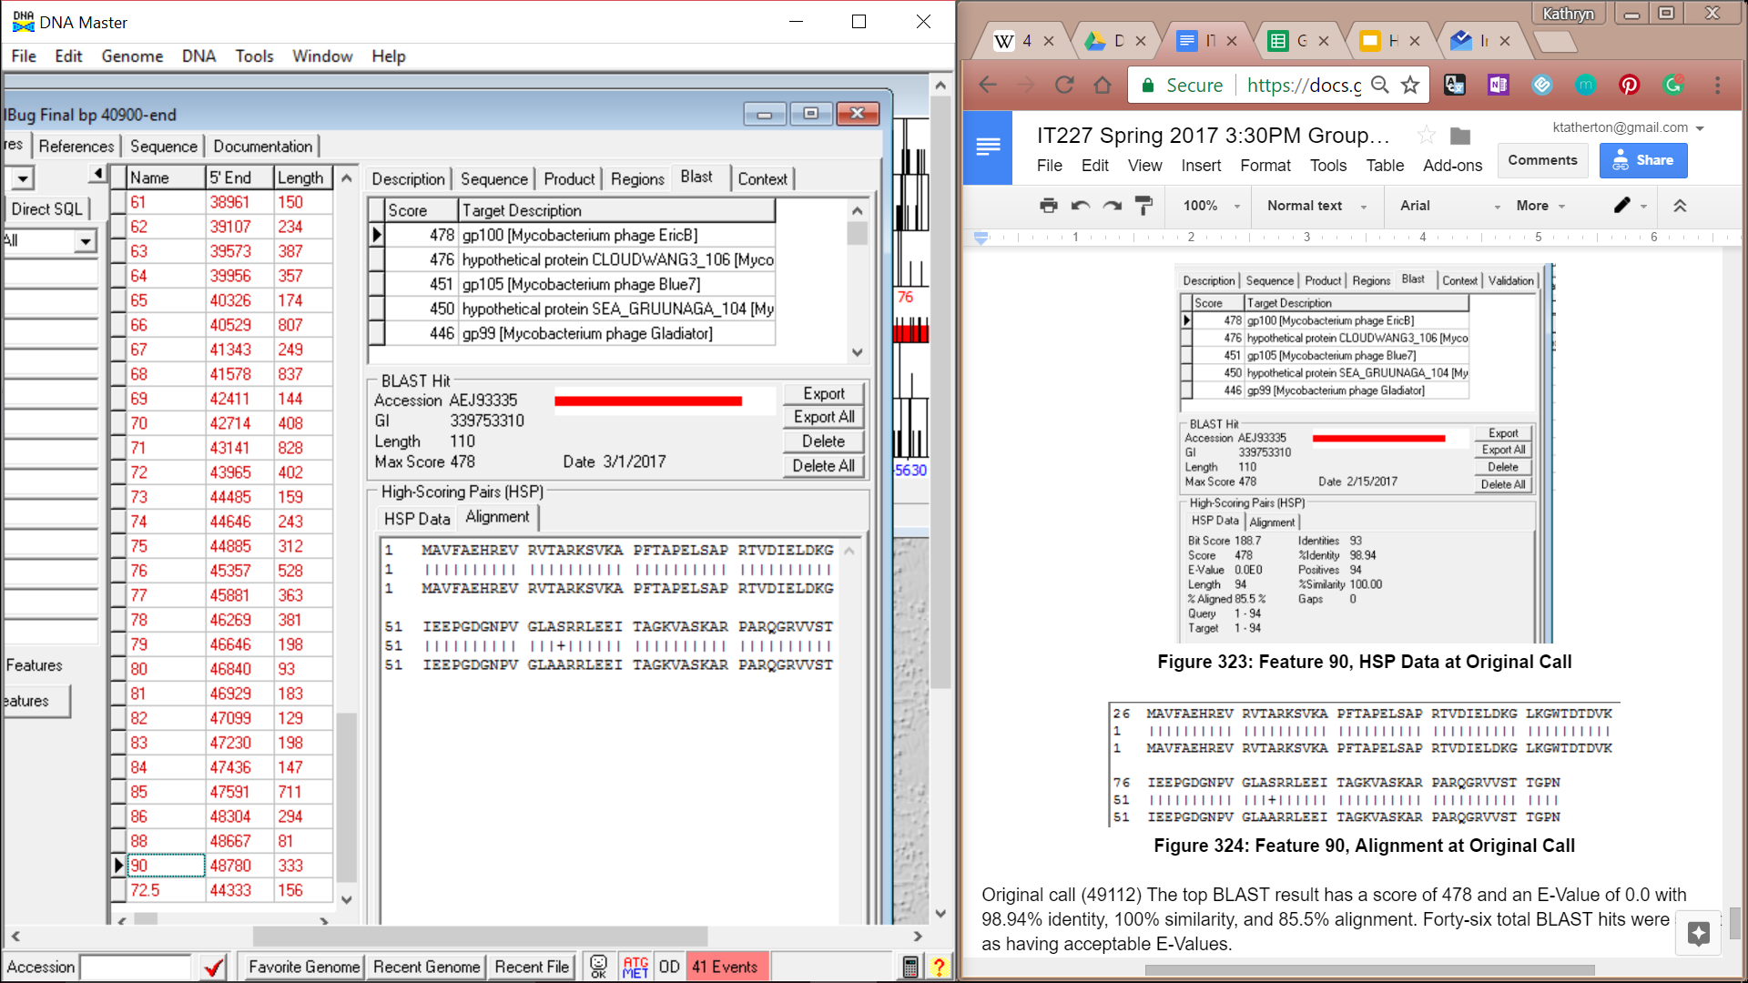

**Figure 324: Feature 90, Alignment at Original Call**

Original call (49112) The top BLAST result has a score of 478 and an E-Value of 0.0 with 98.94% identity, 100% similarity, and 85.5% alignment. Forty-six total BLAST hits were selected as having acceptable E-Values.

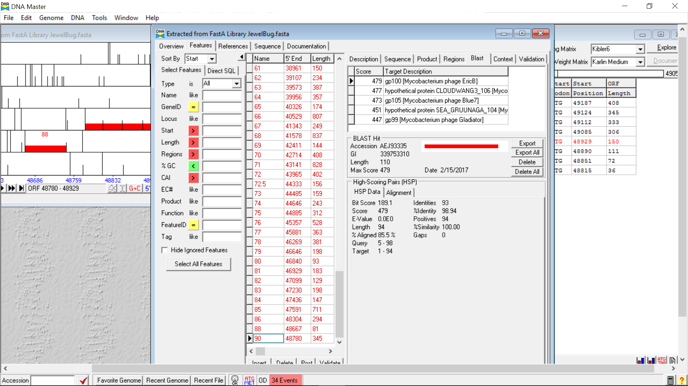

**Figure 325: Feature 90, HSP Data at Second Call**

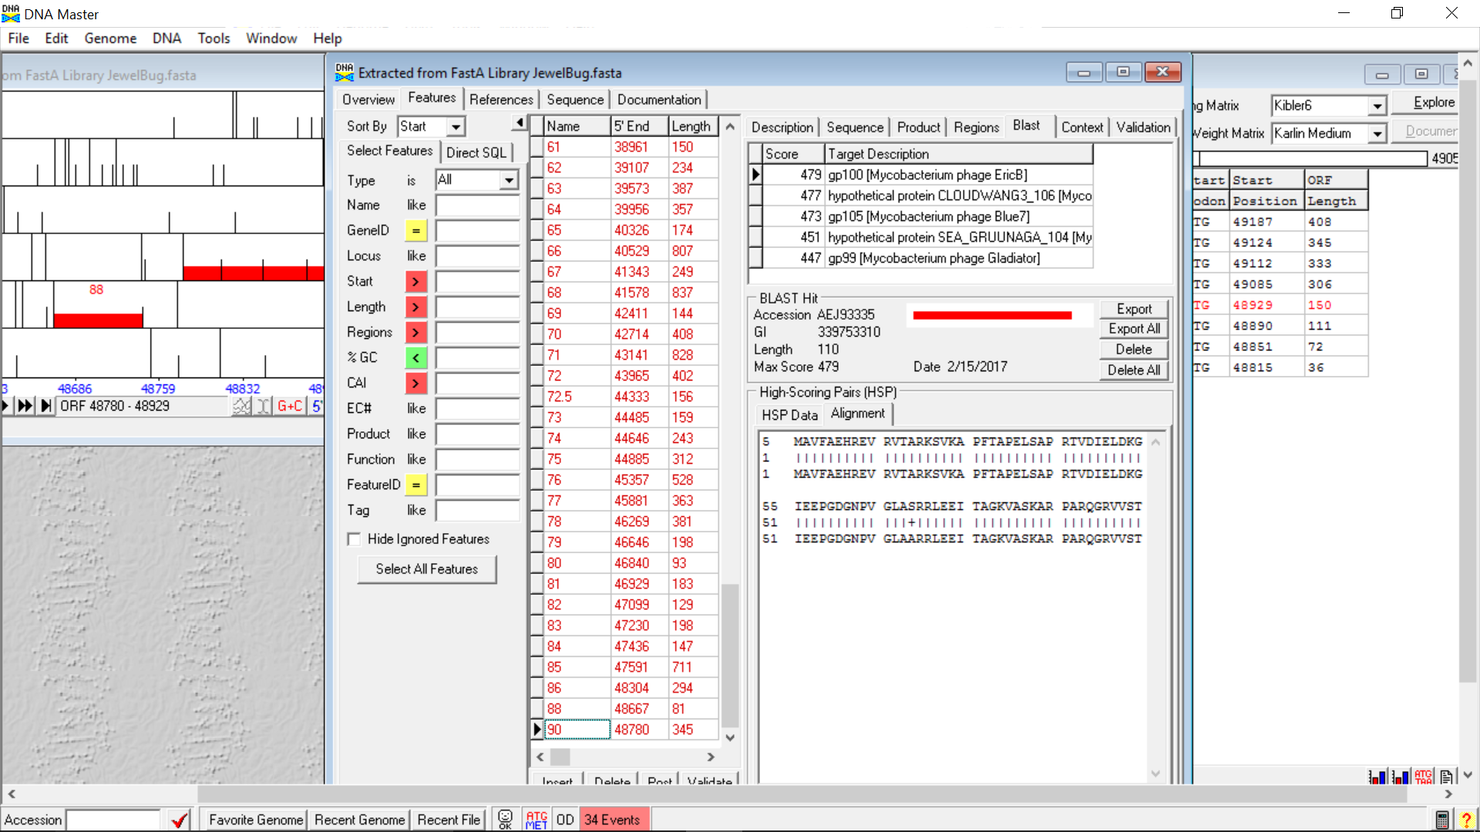

**Figure 326: Feature 90, Alignment at Second Call**

The top BLAST result has a score of 479 and an E-Value of 0.0 with 98.94% identity, 100% similarity, and 85.5% alignment. Forty-six total BLAST hits were selected as having acceptable E-Values.

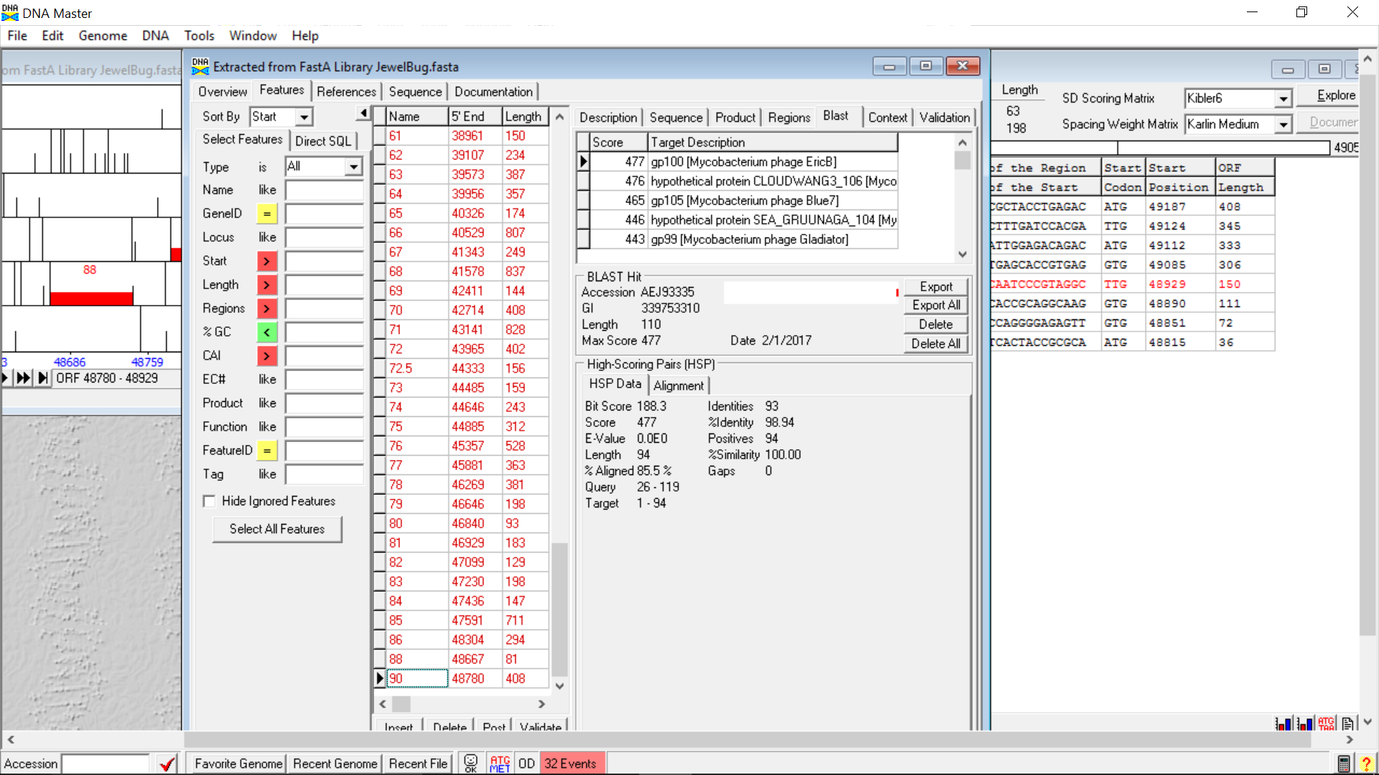

**Figure 327: Feature 90, HSP Data at Longest Call**

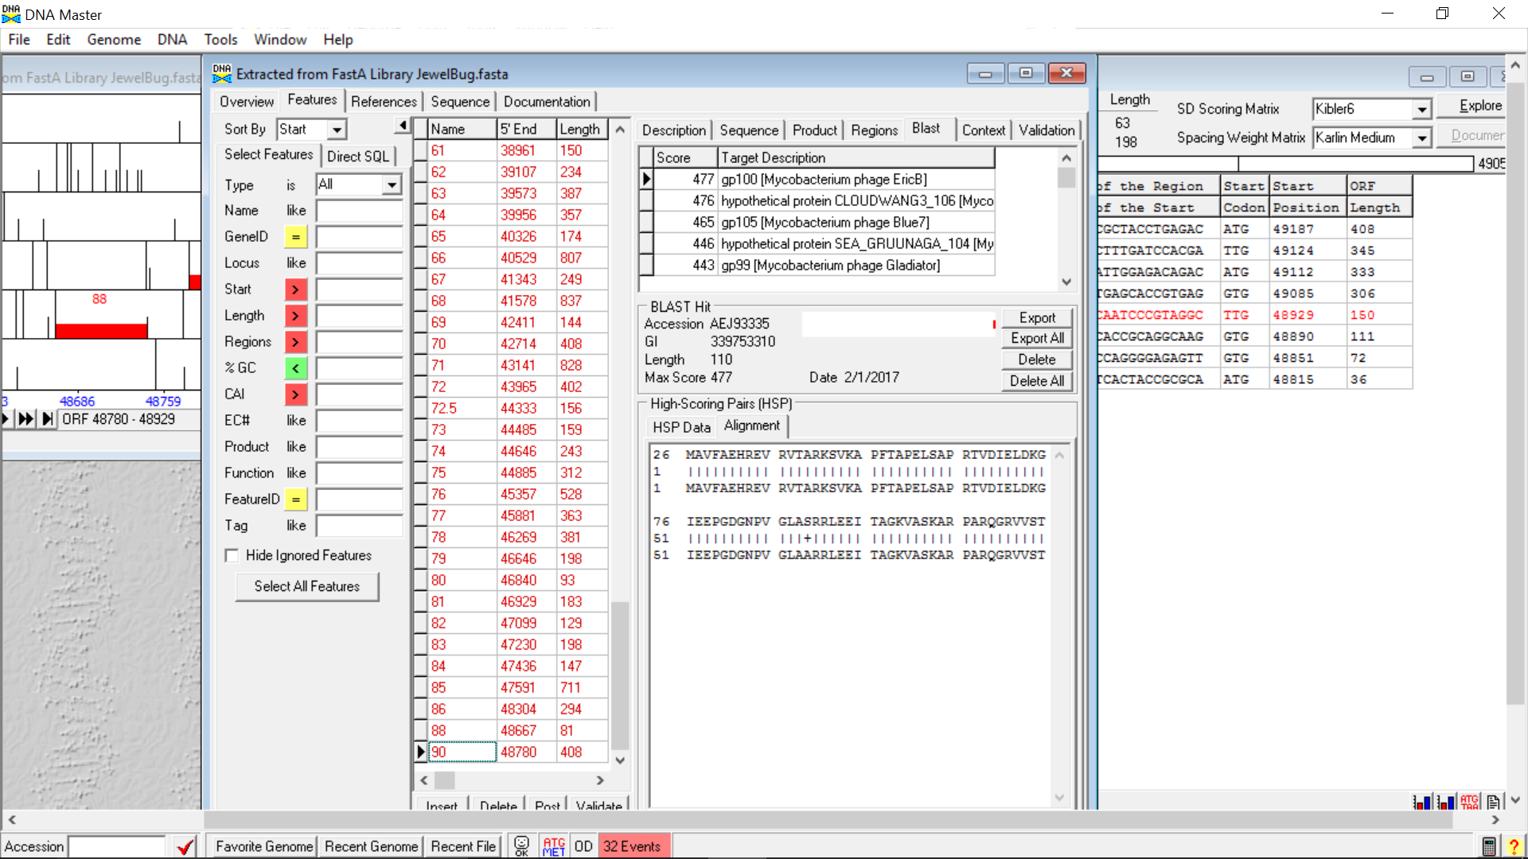

**Figure 328: Feature 90, Alignment at Longest Call**

The top BLAST result has a score of 477 with a 98.94% identity, 100% similarity, and 85.5% alignment. Forty-six total BLAST hits were selected as having acceptable E-Values.

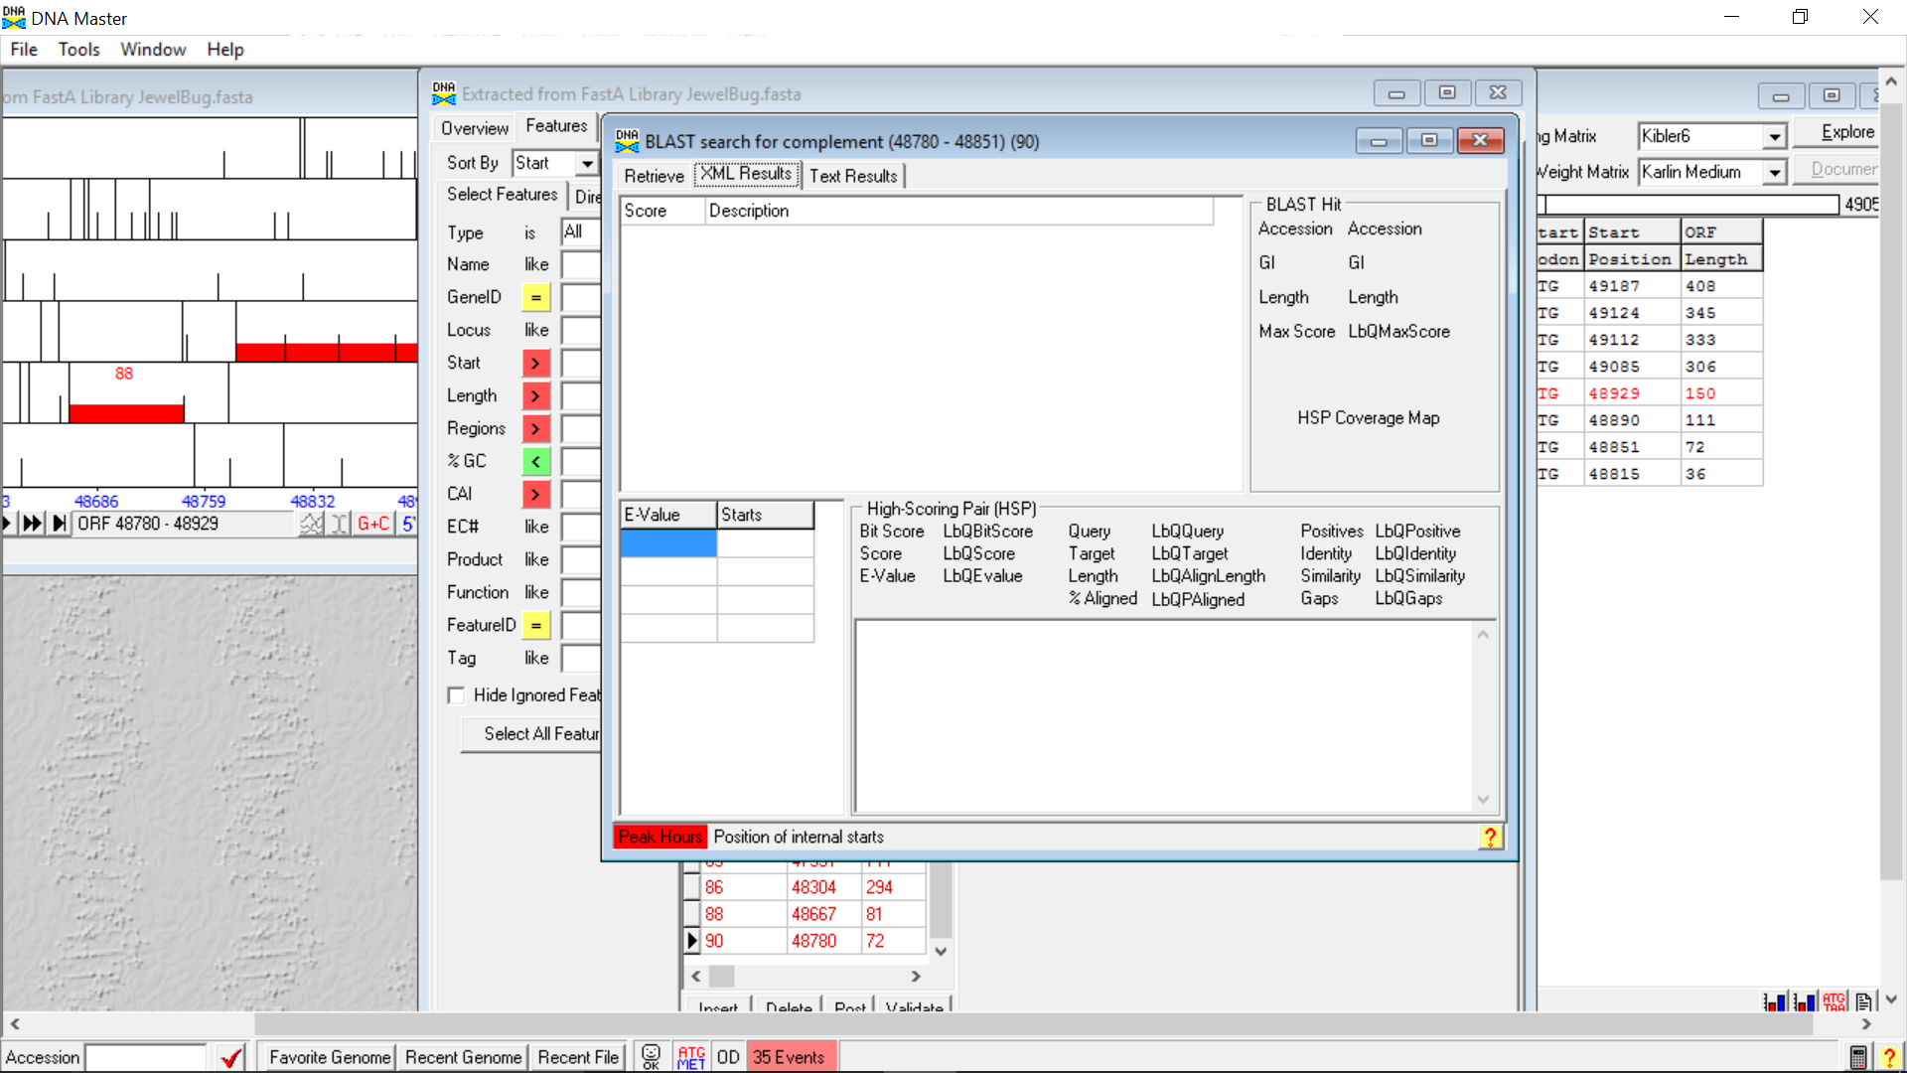

**Figure 329: Feature 90, HSP Data and Alignment at Call with Highest SD Score**

No BLAST results were found for this call.

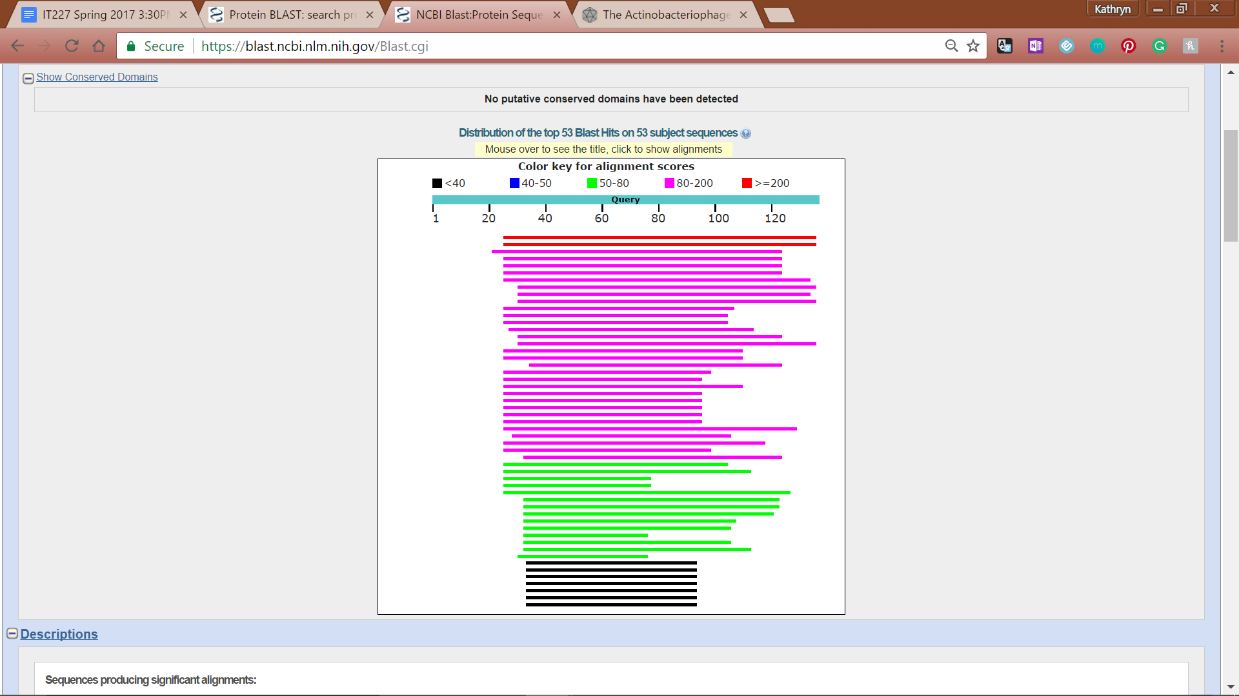

**Figure 330: Feature 90, Conserved Domain**

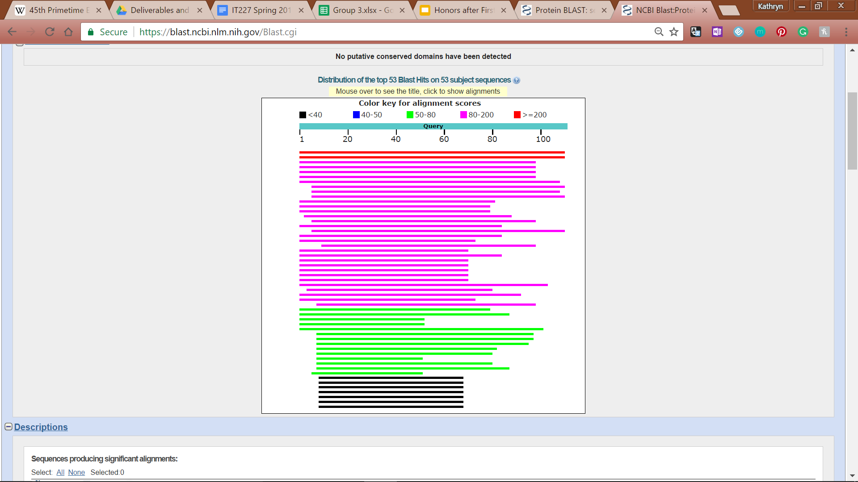

**Figure 331: Feature 90, Hits Distribution Table**

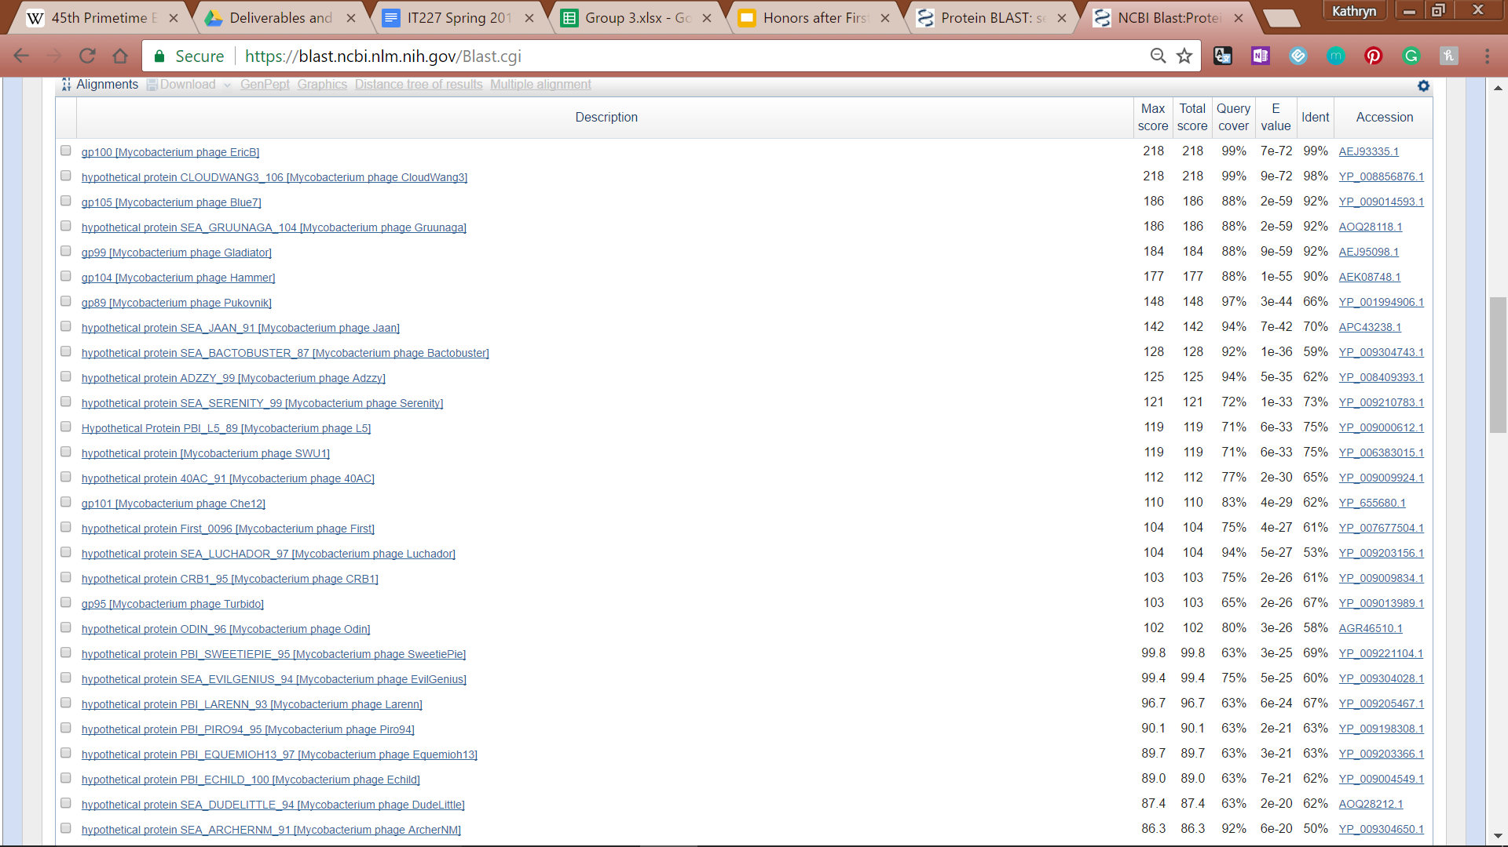

**Figure 332: Feature 90, NCBI BLAST E-Values**

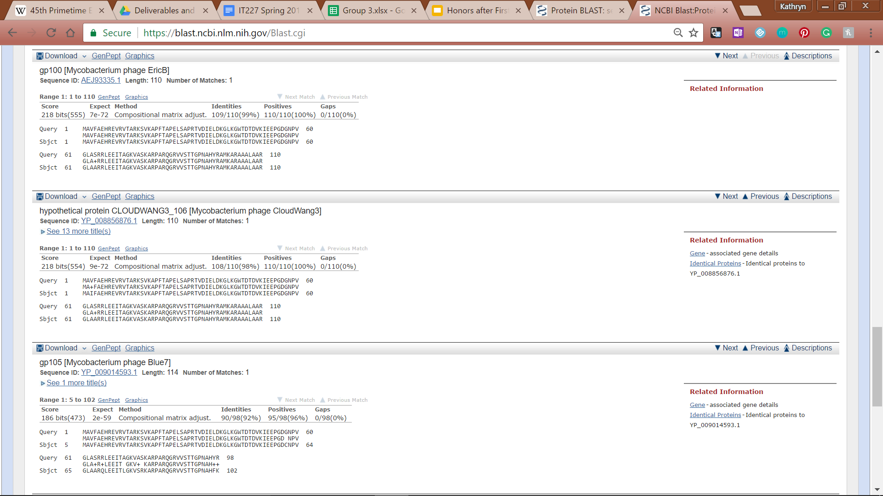

**Figure 333: Feature 90, NCBI BLAST Alignments**

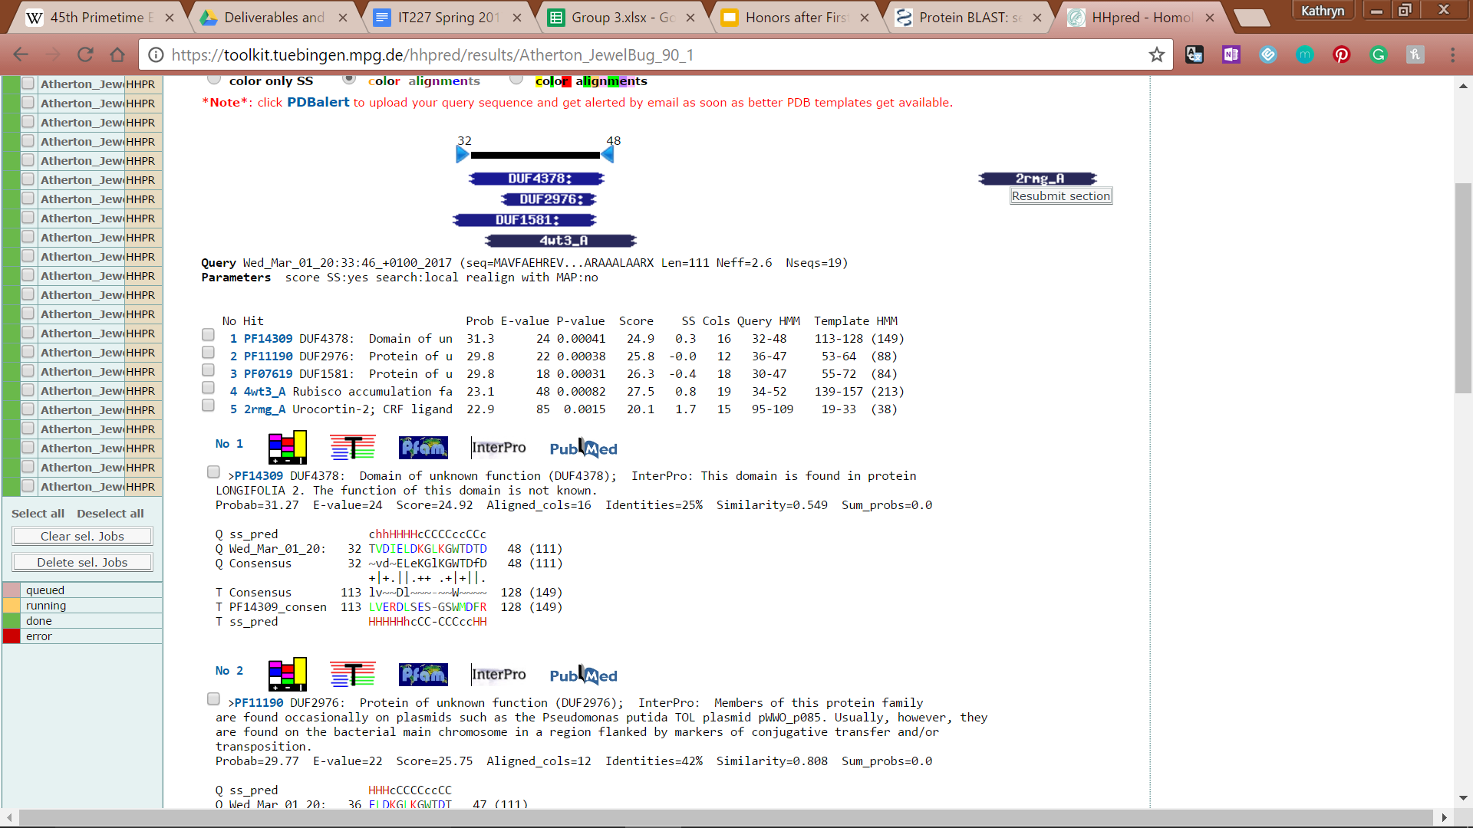

**Figure 334: Feature 90, HHpred Distribution List**



**Figure 335: Feature 90, HHpred Probabilities**